# Social Media Posts

*If possible, we’d like the social media post wording to be posted in both English and Spanish.*

***January 1st:***Do you have a Medicare Advantage plan (an HMO or PPO plan) but aren’t sure if it’s the best fit for you? Now is your opportunity to make a change! The Medicare Advantage Open Enrollment Period runs January 1 – March 31. Compare your options at [Medicare.gov/plan-compare](http://medicare.gov/plan-compare).

***February 15th:***Do you have a Medicare Advantage plan (an HMO or PPO plan) but aren’t sure if it’s the best fit for you? Now is your opportunity to make a change! The Medicare Advantage Open Enrollment Period runs January 1 – March 31. Compare your options at [Medicare.gov/plan-compare](http://medicare.gov/plan-compare).

***February 26nd:***



***March 15th:***Do you have a Medicare Advantage plan (an HMO or PPO style plan) but aren’t sure if it’s the best fit for you? Now is your opportunity to make a change! The Medicare Advantage Open Enrollment Period ends March 31. Compare your options at [Medicare.gov/plan-compare](http://medicare.gov/plan-compare).

***April 1st:*** Fill your free time with joy and purpose by becoming a SHIP volunteer. [dhs.wi.gov/medicare-help](https://www.dhs.wisconsin.gov/benefit-specialists/medicare-counseling.htm)

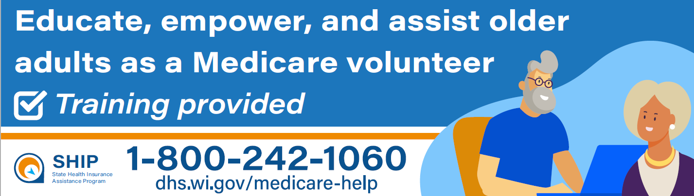

***May 1st:***

In addition to one-on-one meetings, SHIPs hold in-person and online workshops and enrollment events. These events provide information to help you select coverage plans and understand what your Medicare covers. Check with your local SHIP for a schedule of upcoming events. You can find your SHIP's website at [dhs.wi.gov/medicare-help](https://www.dhs.wisconsin.gov/benefit-specialists/medicare-counseling.htm) .

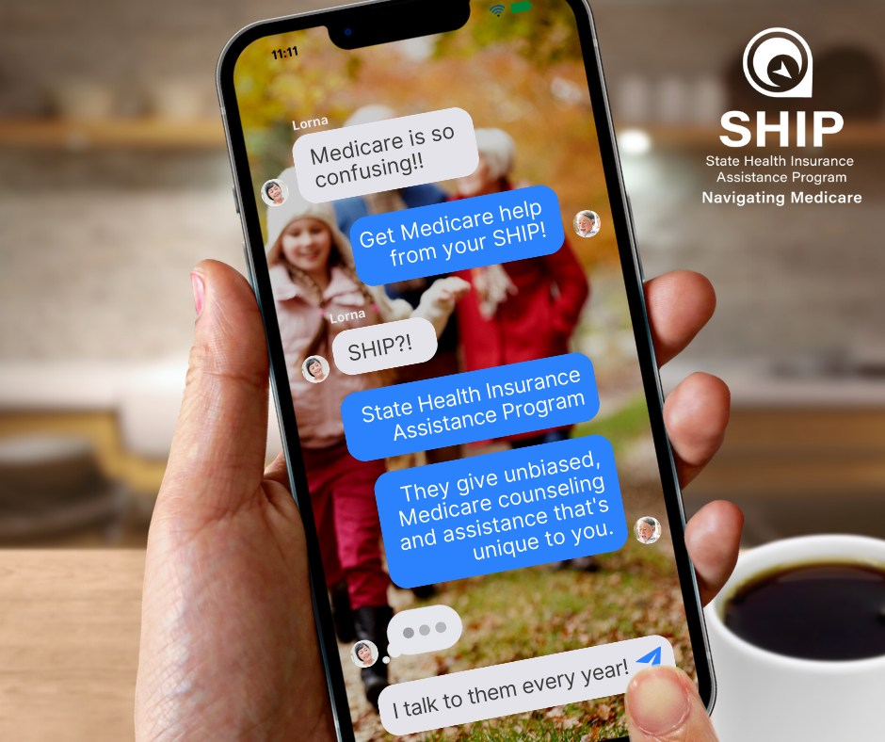

***June 1st:***

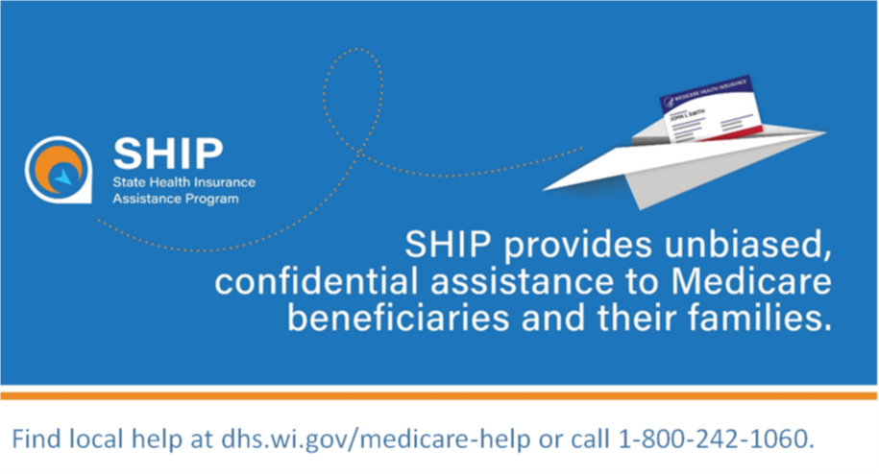

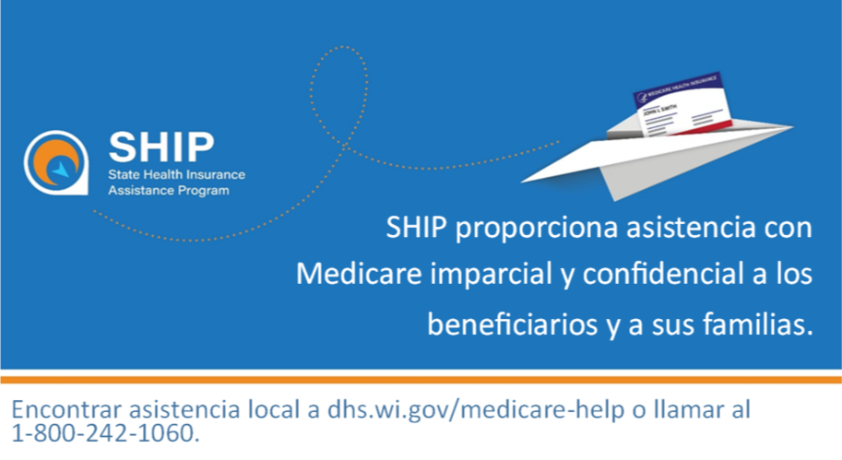

***August 1st:***

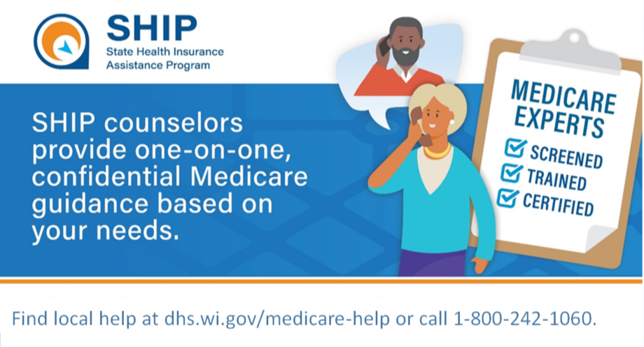

***August 8th:*** Fill your free time with joy and purpose by becoming a SHIP volunteer. [dhs.wi.gov/medicare-help](https://www.dhs.wisconsin.gov/benefit-specialists/medicare-counseling.htm)

**

***September 1st:***

**Medicare Helps to Fight the Flu!**

The best way to protect against contracting and spreading the seasonal flu is with the flu vaccine. Medicare covers the flu shot when it’s given by doctors or health care providers who accept Medicare. Don’t wait! Protect yourself and your loved ones by scheduling your flu shot today. For more information visit [Medicare.gov/coverage/flu-shots](https://www.medicare.gov/coverage/flu-shots). Find a local Medicare counselor [dhs.wi.gov/medicare-help](https://www.dhs.wisconsin.gov/benefit-specialists/medicare-counseling.htm).

***October 1st:***



***October 15th:***

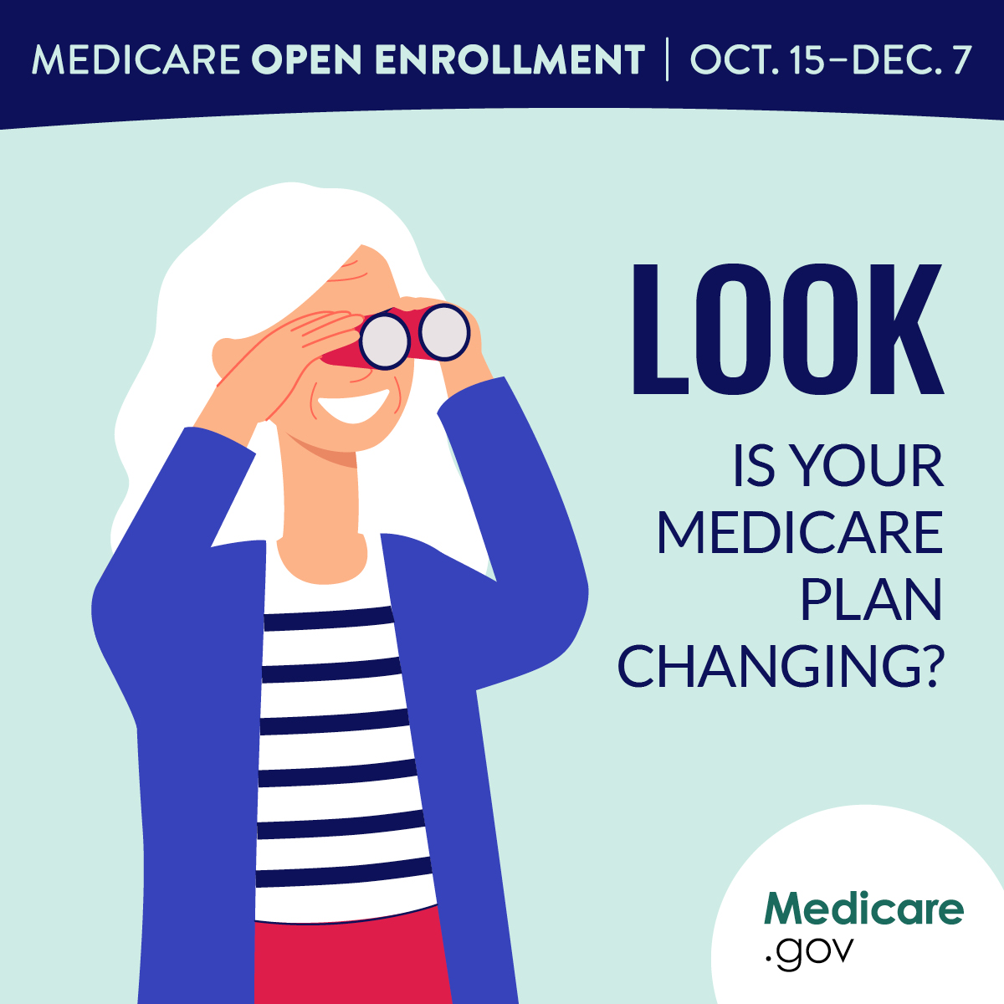

***November 1st:***

Medicare counselors are available, at no charge to you, to provide you with personalized assistance through the State Health Insurance Assistance Program (SHIP). These programs provide no-obligation, one-on-one guidance and counseling regarding Medicare options to eligible beneficiaries and their family members. [dhs.wi.gov/medicare-help](https://www.dhs.wisconsin.gov/benefit-specialists/medicare-counseling.htm) or call 1-800-242-1060

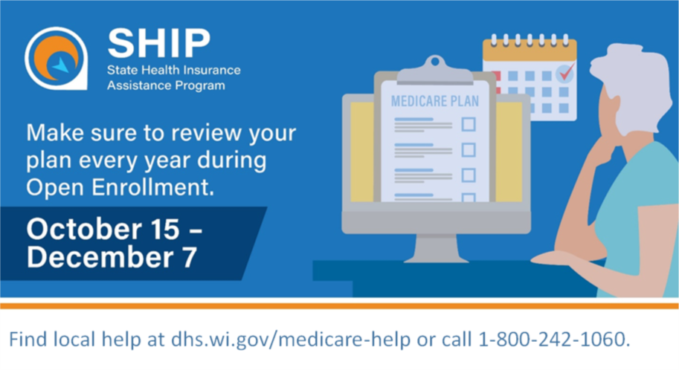

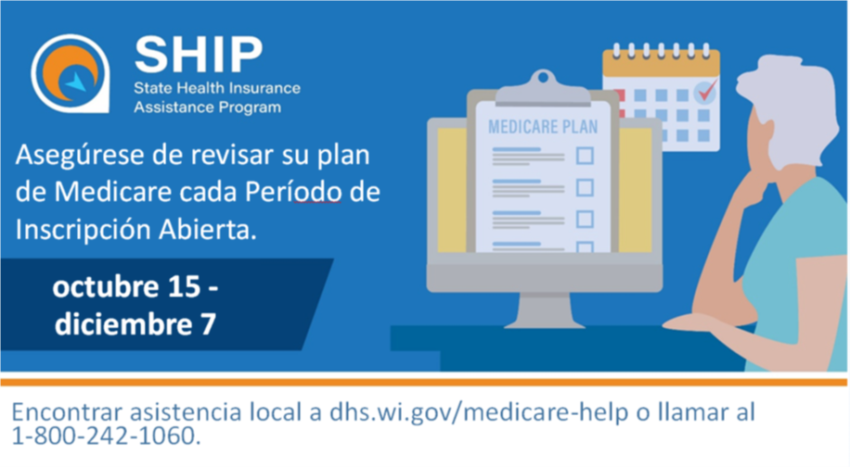

***December 1st:***

Medicare counselors are available, at no charge to you, to provide you with personalized assistance through the State Health Insurance Assistance Program (SHIP). These programs provide no-obligation, one-on-one guidance and counseling regarding Medicare options to eligible beneficiaries and their family members. [dhs.wi.gov/medicare-help](https://www.dhs.wisconsin.gov/benefit-specialists/medicare-counseling.htm) or call 1-800-242-1060

