Medicare Outreach Idea of the Month
June 2024

Collaborative Outreach: Supporting Medicare Beneficiaries and Elder Abuse Awareness in June

For successful outreach, it's essential not only to consider your events but also to align with other events that share the mission of supporting Medicare beneficiaries. In June, there are two significant events you could collaborate with. These events may have in-person components near you, or you can share information through various media channels such as press releases, agency newsletters, websites, and social media.

3rd Annual Medicare Fraud Prevention Week (June 3-9, 2024)
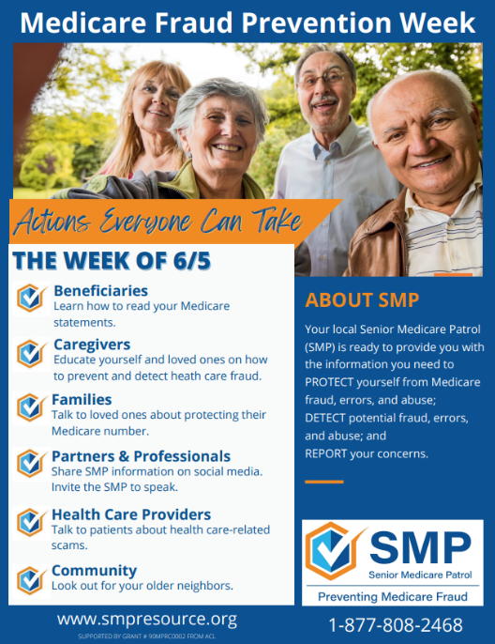
The Wisconsin Senior Medicare Patrol (SMP) will be recognizing the 3rd Annual Medicare Fraud Prevention Week (MFPW) with SMP programs across the country from June 3 - June 9, 2024. A radio campaign will run between May 27 - June 9, featuring a 30- second public service announcement (PSA) discussing Medicare fraud and the SMP program mission. Additionally, there will be Facebook posts throughout the week focusing on MFPW and how everyone can help protect people from Medicare-related fraud.

Consider following the Wisconsin SMP on Facebook (@WisconsinSeniorMedicarePatrol) and sharing their posts on your page. While sharing the SMP message, you can also highlight your involvement with the SHIP program, emphasizing your role in providing unbiased Medicare assistance, along with your contact information.

Wisconsin Senior Medicare Patrol (SMP) Resources:
- View the press release
- Download the flyer
- Wisconsin SMP website
- Wisconsin SMP on Facebook

World Elder Abuse Awareness Day (June 15, 2024)
Join the elder abuse network in Wisconsin in recognizing World Elder Abuse Awareness Day (WEAAD) on June 15. Many of the county lead elder abuse agencies, providers, and other organizations around the state will hold events for WEAAD. This is an excellent opportunity to partner with elder abuse advocates in your area to reach a similar audience.

Numerous awareness materials are available for community outreach. These materials can be shared via press releases, agency newsletters, and on your website, alongside information about the SHIP mission and your contact details.
World Elder Abuse Awareness Day (WEAAD) Resources:
- National Center for Elder Abuse (NCEA): Offers downloadable materials, including social media content. Visit the NCEA site for their WEAAD resources.
- Consumer Financial Protection Bureau (CFPB): Provides resources to educate consumers on avoiding financial exploitation. Agencies can order CFPB materials for distribution, such as placemats for dining sites and bookmarks for program participants. Visit the CFPB site for more information.

For additional information on elder abuse, please contact your local lead elder abuse agency or email Jayne Mullins directly at Jayne.mullins@gwaar.org.

Updates on the Medicare Outreach and Assistance Resources webpage:
- Brochures and Posters for Outreach
  - EBS/SHIP Outreach Posters
    - SHIP Poster with Tear off card
- Trainings – Medicare Outreach and Assistance
  - Upcoming Optional SHIP Trainings – Medicare Outreach updated.
- Dual Special Needs Plans (D-SNPs)
  - 2024 Justice in Aging Issue Brief: What Advocates Need to Know About D-SNPs added.
  - 2024 Justice in Aging Webinar: D-SNPs – What Advocates Need to Know added.
  - 10/2022: D-SNP Default Enrollment Updates and Resources Training – Slides added.
  - 10/2022: D-SNP Default Enrollment Updates and Resources Training – Recording added.
- Plan Finder Tools
  - Medicare Plan Finder New Features Coming May-June 2024 added.

For assistance with your Medicare outreach questions, please contact Alyssa Kulpa, Medicare Outreach Coordinator. She can be reached at (608) 228-8098 or via email at Alyssa.Kulpa@gwaar.org. Alyssa is available to provide guidance and support for all your outreach efforts, ensuring effective communication and engagement with Medicare beneficiaries.

By the GWAAR Medicare Outreach Coordinator

Upcoming Optional Wisconsin SHIP Trainings

Utilizing Medicare Minutes to Educate, Engage, and Empower!
- Date: Wednesday, June 26, 2024, from 11a.m.–12 p.m.
- Zoom link; Outlook event
- Intended audience: SHIP counselors and supervisors looking to enhance their utilization of Medicare Minutes provided by the SHIP TA Center.
- Objectives:
  - Learn about the SHIP TA Center and Medicare Minutes.
  - Explore strategies for integrating Medicare Minutes into consistent Medicare outreach efforts.
  - Understand how Medicare Minutes can be used to educate, engage, and empower SHIP counselors, Medicare beneficiaries, and other professionals within your community.
Growing Partnerships: Senior Medicare Patrol (SMP)
- Date: Wednesday, August 7, 2024, from 11a.m.–12 p.m.
- Zoom link; Outlook event
- Intended audience: SHIP counselors and supervisors seeking to enhance their understanding of the Senior Medicare Patrol (SMP) program and its potential for partnership in Medicare outreach efforts.
- Objectives:
  - Gain insight into the Wisconsin Senior Medicare Patrol (SMP) program.
  - Explore the expanded SMP Volunteer team and their role in advancing mission delivery.
  - Learn when to refer to and partner with SMP for successful Medicare outreach in Wisconsin.
Continuing Education Hours (CEH) Opportunity
DHS has partnered with the University of Wisconsin-Stevens Point to issue Continuing Education Hours/Units (CEH/CEU) to SHIP training participants. You must attend LIVE trainings to be eligible for CEHs/CEUs. Your attendance is verified using Zoom attendance reports and completion of the survey after the live event. Please email Alyssa Kulpa, GWAAR Medicare Outreach Coordinator, at alyssa.kulpa@gwaar.org with any questions regarding the trainings and please email Pam Watson, MIPPA Grant Coordinator, at pamela.watson@dhs.wisconsin.gov with any questions regarding the Continuing Education Hours (CEH) Opportunity.

