“To-Not-Do” List

A not-to-do list is a list of things you're deciding not to do, EVER. These are the tasks that don't match your goals, drain your energy, or do not serve you.

Ingredients:

* Provide the template for personal use
* Post it notes or paper and tape for those that want to share publicly
* Poster boards with headings

Instructions:

* **Complete personal template individually and at your own pace.**
* **Publicly post not-to-do’s that you want support for or just want to share or model.**

Paper Chain

Ingredients:

* Strips of construction paper (1" wide by 8" long).
* Prompting Question: **“W*hat connects you to this***

***work, to your community, to humanity?”***

* Markers or pens
* Stapler.

Instructions:

* **Using a ruler, measure and cut strips of paper that are even in length and width. Write a short answer to prompt.**
* **Paste, tape, or staple the ends of the first strip together to form a loop with the words on the outside.**
* **Place the second strip of paper through the newly made loop.**
* **Continue until you have reached the desired length.**
* **Grow your chain!**

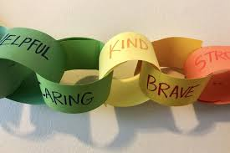



Can we get your autograph?

Ingredients:

* Poster board
* Markers

Instructions:

* **Sign your name on the wall of fame.**
* **Include a signature message:**
  + **What is that line, quote or saying that is uniquely yours?**
  + **Imagine your first book signing – what line will you add to your soon to be bestseller?**

Lego Love

Ingredients:

* Thank God, you didn’t throw them away!
* Raid your grown child’s storage in the basement

and have other staff donate Legos no longer in use.

Instructions:

* **Find a spot in your office to store your supplies and create.**
* **Start building!**

**Variations:**

**Contests, Theme weeks (build your best life, dream vacation, etc.), Challenges (solve for world hunger), and Imaginings (what does your bedroom look like if you were born on another planet?)**

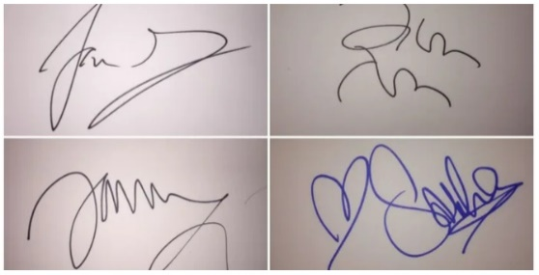

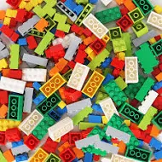

What a Pair

This game is meant for larger groups (at least 52)

Ingredients:

* Decks of Cards (as many decks as you anticipate players)

Instructions:

1. **TAKE A CARD**
2. **Find your match (card denomination and deck). The numbers or face should match and if using more than one deck the artwork on the back should match.**
3. **Take a selfie with your match and post with a hashtag**
4. **Use the pictures for a staff meeting or other event.**

LOGO MURAL

The act of coloring is more than just a fun break from the stress of daily life, it can be very beneficial for your mental and emotional health. In fact, psychologist Carl Jung even prescribed it to some of his patients.

Ingredients:

* Provide coloring page (any image that is meaningful)
* Crayons, markers or colored pencils
* Enlarged image that could be posted and team colored

Instructions:

* Provide a space to have markers, and logo/image (enlarged or separate coloring sheets)
* Color as the spirit moves (or needs)
* Post where the art can be shared and celebrated!

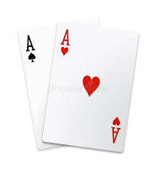



A Note of…

Ingredients:

* A variety of note cards – thank you, thinking of you, congratulations, etc.
* Pens

Instructions:

* **Have note cards available for staff to use to celebrate, honor, thank their peers or others.**

**Variations:**

**For those who are creatives, you could have a card making session or just have blank card stock with markers, colored pencils, etc. for staff to create their own.**

Sing. Sing a Song. Sing it Quietly

‘Cause there’s people all around. Don’t worry if it’s not good enough for anyone else to hear. Just sing. Sing a song.

Ingredients:

* Various lyrics and song books

Instructions:

* **Finding a space where this activity won’t disrupt others will likely be your biggest challenge. In the nice weather, outside may be your best bet.**
* **The important thing is that people have the resources and permission they need.**

Music making exercises the brain as well as the body, but singing is particularly beneficial for improving breathing, posture, and muscle tension.



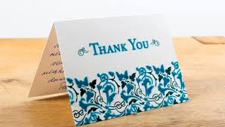

WIHA

.

Ingredients:

* .

Instructions:

Map Your Past and Future

Traveling opens our minds, hearts, and spirits. Use the map to find out where others have travelled or lived and share your story including where you hope the future will take you!

Ingredients:

* Continental Maps as up to date and detailed as possible.

Instructions:

* Have maps available in your break room or other spaces.
* Encourage people to share their travels and their dreams for such.
* Can be used as a meeting ice breaker as well – *“Where have you been”* or *“Where do you want to go?”*

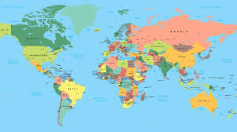

Laughter IS the best medicine!

Not only does laughing make you feel good, but it triggers healthy physical and emotional changes in your body. Laughing increases the brain’s production of endorphins – the natural way your body relieves pain, reduces stress, and boosts mood. And laughing increases your intake of oxygen-rich air and blood flow and circulation, which can improve brain health.

Ingredients:

* **Joke books**
* **Suggested video links**
* **Funny people with good jokes**

Instructions:

* **Let go and laugh. Laugh alone. Laugh with others. Just laugh!**



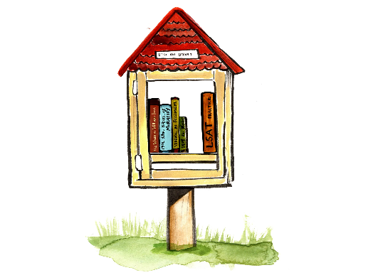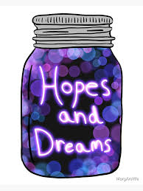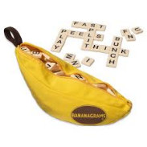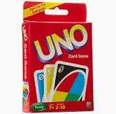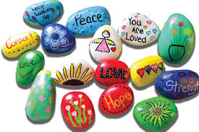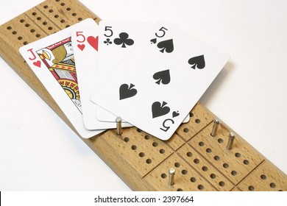

Little Free ADILN Library

Ingredients:

* A diverse genre of donated books

Instructions:

* **Find a spot for staff to donate and take out books from the Little Library.**
* **Offer recommendation bookmarks**

**to inspire more connection.**

* **Read!**
* **Return!**
* **Repeat!**

Painted Rocks

Ingredients:

* Collect a variety of rocks (perhaps another

team building exercise itself).

* Have staff donate paint, paint brushes and permanent markers or buy what you need at the dollar store.

Instructions:

* **Find a space to store supplies and a space for the activity.**
* **Clarify guidance about use (i.e. responsibility for cleaning space and materials).**
* **Get creative!**
* **Make a rock for yourself (positive affirmation), a colleague (gratitude) or for clients (encouragement) to take when they come into the office.**

ADILN Hopes & Dreams

Ingredients:

* Pieces of paper
* Time capsule container
* Thoughts, dream, wishes, wonderings, insights, musings and more…

Instructions:

* **Write down your hopes and dreams for your organization, the people we serve, or your community throughout the year and place in container.**
* **Compile and share at a leadership retreat, staff meeting, celebration, etc.**

Game Station

Ingredients:

* Identify a space for people to play.
* Collect a variety of games.
* Create some hold tickets (“Game in session with ” do not move pieces) so that longer games can be played over time.

Instructions:

* **Understand and share the case**

**for renewal, down time, and relationship building.**

* **Give people permission to play.**
* **Play.**