Medicare Outreach Idea of the Month
April 2024

Be Powered by Connection for Older Americans Month!

May is Older Americans Month (OAM), a time when the nation celebrates the contributions and resilience of older adults. Led by the Administration for Community Living (ACL), this year's OAM theme is "Powered by Connection." The theme highlights the profound impact that meaningful relationships and social connections have on the health and well-being of older Americans. Research shows that strong social connections can improve mental health, cognitive function, and overall quality of life.
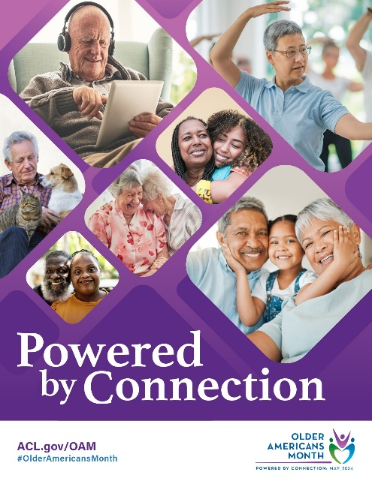
As we observe OAM, it's a great opportunity to get involved in your community. Local Senior/Community Centers and libraries often host events to celebrate older Americans. Consider reaching out to these organizations to see how you can participate or contribute. You could offer a presentation on topics like Medicare, low-income assistance, or the services provided by a SHIP counselor.

Another way to get involved is to partner with other organizations that serve the older adult population. Collaborating with these groups can help you reach a wider audience and educate other professionals about your services. It's also a chance to connect with the community and build relationships that can benefit older adults in your area.

ACL offers a wealth of resources to promote OAM on their Older Americans Month 2024 webpage. Be sure to check out these materials and follow #OlderAmericansMonth and #PoweredByConnection for the latest updates and ideas from ACL and others planning OAM events.

Let's make this Older Americans Month a time of connection, celebration, and support for our older adults. Together, we can create a more connected and inclusive community for people of all ages.

Updates on the Medicare Outreach and Assistance Resources webpage:
- SHIP Volunteer Resources/Basic SHIP Counselor Training
  - April 8-19, 2024: Registration Instructions for Basic SHIP Counselor Trainings added.
- Tools for Professionals
  - 2024 Health Savings Accounts (HSAs) and Medicare updated.
  - 2024 Special Enrollment Period (SEP) Chart updated.
  - 2024 Medicare Premiums & Costs Chart NCOA updated.
  - 2024 Part D Cost Sharing Chart NCOA updated.
- Partnership Toolkit
  - Partnership Outreach - Tip Sheet updated.
  - Food Pantry Outreach - Tip Sheet updated.
- Other Printable Outreach Materials
  - 2024 Table Tent MSP/LIS/SeniorCare updated.

By the GWAAR Medicare Outreach Coordinator

Upcoming Optional SHIP training:

Partnerships and Professional SHIP Volunteers
- Date: Thursday, April 4, 2024, from 1–2 p.m.
- Zoom link; Outlook event
- Intended audience: SHIP counselors and supervisors interested in expanding their partnerships and/or identifying when it is advantageous to invite partners to become SHIP volunteers.
- Objectives:
  - Identify how to maximize the impact of a partnership
  - Learn when and how to refer prospective professional SHIP volunteers
  - Review conflict of interest rules regarding professional partnerships
Continuing Education Hours (CEH) Opportunity
DHS has partnered with the University of Wisconsin-Stevens Point to issue Continuing Education Hours/Units (CEH/CEU) to SHIP training participants. You must attend LIVE trainings to be eligible for CEHs/CEUs. Your attendance is verified using Zoom attendance reports and completion of the survey after the live event.
Please email Alyssa Kulpa, GWAAR Medicare Outreach Coordinator, at alyssa.kulpa@gwaar.org with any questions regarding the trainings and please email Pam Watson, MIPPA Grant Coordinator, at pamela.watson@dhs.wisconsin.gov
with any questions regarding the Continuing Education Hours (CEH) Opportunity.

