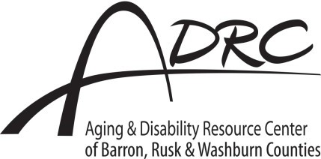
We need your help to best serve older adults!
Good health and quality of life are important to living as independently as possible. The more people we hear from, the better we’ll understand how to support the older adults in our communities.
Please complete and return it to the ADRC. Drop it off, or to mail it, fold on the dotted lines, tape shut in two spots & add a first class stamp.

- Our rural communities can be great places to age well. What does your community offer to support people to age well?

- Please choose the top three needs or issues facing Barron County’s older adults today:
Brain health/dementia
Caregiving
Eating well
4. Please select the top three resources most important when caring for someone:
Assistive equipment (walker, Lifeline, shower chair, etc.)
Dementia support
Financial assistance
In-home care
Meal preparation
Respite (short period of rest or relief)
Self-care
Support groups
Technology (internet, computer, etc.)
Training for caregiving
Transportation

Elder abuse (physical, financial, etc.) Other
Grandparents raising grandkids

Healthcare
Housing
In-home care
Isolation
Scams
Retirement/finances
Transportation
Understanding legal documents (wills,
power of attorney, etc.)
Understanding public and private benefits (Medicare, insurance, etc.)
Understanding technology, internet access
Other

3. What are the top three health concerns you have as you age?
Addiction
Arthritis
Brain health/dementia
Bowel and bladder health
Caregiver support
Dementia
Diabetes
- How can the ADRC make services more inclusive and accessible for underserved and minority groups in Barron County?

- What would you need to help you feel confident about communicating with your elected officials about aging issues?

Your responses below will help us determine if we’ve met our goal of getting feedback from a broad range of community members. Please select all the options that apply to you.

Barron County Employee/volunteer

Eating well
resident
serving older adults

Exercise 60 years old or An elected official

Heart health
Mental health
older A person of color
Caregiver of a A person with a

Preventing falls
family member
disability

Other
or friend A member of

Health care professional
the LGBTQ+ community

Thank you for your help! If you have any questions or would prefer to respond by phone, call 888-538-3031. This survey is anonymous, but if you’d like to stay in touch please provide contact information here:

Tape here

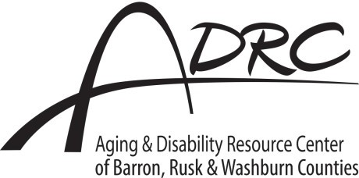

ADRC
335 E Monroe Ave, Room 100 Barron, WI

54812-1478
Tape here

Place first class postage here

Fold on this line.

You also have the option to complete this survey online!
Visit www.ADRCBarronCounty.com to take this survey and share ideas about some of the specific programs and services we offer.

And one last thing…
Please encourage your family and friends to take the survey! If they’d like a print version like this, they can call 888-538-3031.

Fold on this line.

