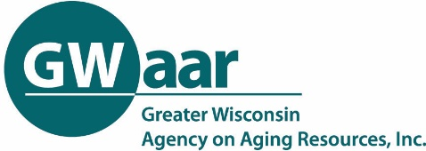
Involving Board Members in Community Engagement
Chapter 5.5.2 of the OAA Policy Manual states that the aging unit’s policy-making body and advisory committee should take ownership of the plan and participate in its development. Asking board members to conduct interviews is one way of involving both older people and board members. The following is a suggested way to have your board members conduct interviews.
- Explain the aging plan development process to the board and emphasize the importance of getting input from the community when creating the plan. You can include information from Chapter 5 of the OAA Policy Manual to show that their participation is important.

- Ask for volunteers to interview community members including:
  - Anyone who is currently or will soon be eligible for OAA services
  - Caregivers of older people
  - People who are already using your programs – meal participants, support group members, healthy aging class participants, etc.
  - Agency volunteers
  - Members of various coalitions (I-team, caregiver coalition, etc.)
  - Any other agency or person who works closely with your programs

When choosing interviewees, remember it is important to include the following:
  - People from all parts of the county or tribe
  - People with all levels of independence, including those who are home bound
  - People from minority and underserved populations

- Ask board members to inform you of their interest to help. You can allow members to choose who they want to interview, or you can suggest people to them.

- Create a script for the interviewers that educates people about your agency and services and briefly explains the three-year plan. Explain why their thoughts and ideas are important in creating the plan. (“The State requires a three-year plan that describes the unique composition of each county as well outlines goals of the aging unit in the upcoming three years. Input is needed from a wide range of community members to ensure that the aging unit’s services are meeting the needs of older people in the community and their caregivers.”)

- Compile a list of questions to be used by all the interviewers. Keep it short – 3-5 questions. You may choose questions from the document, Community Engagement Questions (found on the GWAAR website, Technical Assistance, Plans/Amendments/Assessments), or create your own. Open-ended questions allow for the person’s true concerns, thoughts, and ideas to be discovered.

- Create a Survey Monkey, Google Form or other place where the answers to the interview questions can be recorded and compiled. Log the name of interviewer, date of interview, the name of the person being interviewed and their contact information so follow-up can occur. Board members can record their own information, or a staff person can enter it for them.

