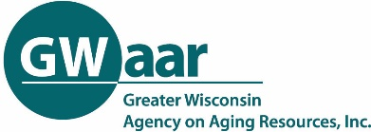
Community Engagement Report
Complete one worksheet for each separate method used to elicit input from the community. i.e. 12 interviews conducted can be compiled on one sheet. At least two methods must be used.

Your County or Tribe: | Date/s of Event or Effort:
Target audience(s): | Number of Participants/ Respondents:
Describe the method used including partners and outreach done to solicit responses:

Describe how the information collected was used to develop the plan:

What were the key takeaways/findings from the outreach?

