Medicare Outreach Idea of the Month

Begin Your Outreach for Medicare’s Annual Open Enrollment Period!

August 2023

While we continue to enjoy the beautiful Wisconsin summer, fall is just around the corner and that means Medicare’s annual open enrollment period (OEP) will soon be here! All of you certainly understand the importance of reviewing a Part D plan each year, but many Medicare beneficiaries do not. Now is the time to review your outreach plan and the tools you have to prepare for OEP!

Consider looking through the resources in the Open Enrollment Toolkit, download materials and customize them with your local contact information.

Opportunities to start sharing your message include:
- Customize the articles for your agency newsletter and share with local senior centers, local papers, and on your website.
- Distribute customized flyers, placemats, and table tents to pharmacies, senior housing, libraries, churches, and other community partners.
- Share the Plan Finder Guide with customers as appropriate or use as a quick reference for yourself.

One option to spread the word about the annual open enrollment period is with the article below. Include it in your agency newsletter, share it on your website and link to it from your Facebook page or other social media.

It is also important to make sure people in your community know where to get help with all their Medicare-related questions. For other options to promote your services, visit the Brochures and Posters page for more customizable documents.

To view all the GWAAR Medicare Outreach and Assistance Resources, follow the link to our webpage:
https://gwaar.org/medicare-outreach-and-assistance-resources
By the GWAAR Medicare Outreach Coordinator
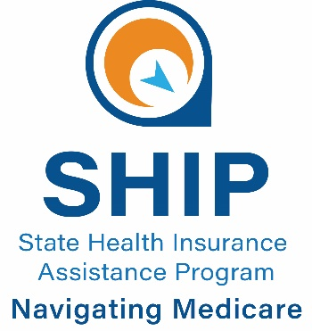
This project was supported by the Wisconsin Department of Health Services with financial assistance, in whole or in part, by grant number 90SAPG0091, from the U.S. Administration for Community Living, Department of Health and Human Services, Washington, D.C. 20201. Grantees undertaking projects with government sponsorship are encouraged to express freely their findings and conclusions. Points of view or opinions do not, therefore, necessarily represent official ACL policy.
Get Ready for the Medicare
Annual Open Enrollment Period

The Medicare annual open enrollment period is just around the corner and now is the time to start thinking about your options. Do you have a Medicare Prescription Drug (Part D) plan? Each year these plans can change the list of prescription medications they will cover. The plans’ premiums, deductibles, and co-pays can also change each year. That means even if you are taking the same medications, the amount you pay for your medications may change in 2024!
What can people do about this? Anyone with a Medicare Part D Plan should check their coverage each year during Medicare’s annual open enrollment period which runs October 15th through December 7th. This is the time of year to find out if your current plan will cost you more, or less than other Part D plans in 2024. If it is no longer the best plan for your medications, this is the time to make a switch to a Part D plan that will suit you better.
Make sure you will have appropriate prescription drug coverage in the new year. You can compare plans on the official Medicare website at Medicare.gov. Medicare beneficiaries in <XYZ County> can also receive free, unbiased assistance with plan comparisons from the <Benefit Specialist(s)/SHIP counselor> at the <Insert YOUR AGENCY NAME HERE>.
Do not let this opportunity pass you by! Go to Medicare.gov to find and compare plans online or for local assistance call the <YOUR CONTACT INFO HERE>.
Assistance is also available through the following resources:
- 1-800-MEDICARE or www.medicare.gov
- Wisconsin Medigap helpline: 1-800-242-1060
- Wisconsin Medigap Prescription Drug Helpline: 1-855-677-2783
- Disability Rights Wisconsin Medicare Part D Helpline: 1-800-926-4862 (if under age 60)

