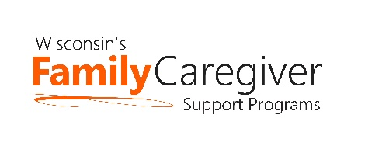

Wisconsin Caregiver Support Community Statewide Webinar
July 25th, 10 am to 11 am
Join on your computer, or mobile app Click here to join the meeting
Meeting ID: 277 046 844 800 • Passcode: TWHNtX
Or call in (audio only) at 1-608-338-1382 • ID: 964 362 803#

10:00 – 10:10 am Advocacy Update – Janet Zander, GWAAR

10:10 – 10:20 am State DHS and GWAAR Updates – Lynn Gall, DHS, and Bryn Ceman, GWAAR
- Independent Living Supports Pilot
- Proposed Update to Older Americans Act Regulations – Comment period
10:20 – 10:30 am – UW-Extension – Kristin Litzelman, Ph.D., Associate Professor
- “Pre-caregiving” content and how Caregiver Coordinators can assist.
10:30 – 11 am OAA Title III D and III B – Angie Sullivan Health Promotion Specialist, and Nick Musson Transportation Specialist
- IIID and Family Caregiving
- Transportation and Family Caregiving

Next Meeting Date: Tuesday, August 22^{nd,} 10 – 11 am. This is an ad hoc meeting to discuss the end of ARPA funding related to the family caregiver grant programs. UPDATE!! We will hold an in-person meeting on September 26th from 10 am to 2 pm. A light lunch will be provided. The location is the ADRC of Portage County: 1519 Water Street, Stevens Point, WI 54481. Thank you to Cindy Piotrowski for hosting us!

- Agendas will be forthcoming and posted on the GWAAR website along with the recordings, notes, and other meeting documents following each meeting.
- Please feel free to email Bryn at: bryn.ceman@GWAAR.org and/or Lynn at: Lynn.Gall@dhs.wisconsin.gov with NFCSP/AFCSP meeting topics or guest speaker ideas.

