Medicare Outreach Idea of the Month
Outreach Through Your Local Nutrition Program
May 2023
Over the past few years of the pandemic, your local nutrition program has been essential in serving your community. Similar to many programs, it was necessary to adapt to the changing circumstances, transitioning from offering congregate meal sites to providing pick-up or home delivered meals. However, as the Public Health Emergency (PHE) nears its end, the program rules are changing, and will now resume in-person assessments and congregate meals at physical sites once again. Collaborating with your local nutrition program provides a unique opportunity to extend your outreach efforts and inform the community about the services you offer.

Advertising your services and the help you can provide is important in reaching out to Medicare beneficiaries effectively. The Local SHIP Flyer – Customizable is an excellent resource to inform Medicare beneficiaries about the SHIP program and the unbiased resource that is available to them locally. Additionally, you can utilize the Table Tent featuring MSP, LIS and SeniorCare or insert your agency contact information into these Brochures and Posters to distribute at meal sites and provide to program volunteers.

Many more resources are located on the Medicare Outreach and Assistance Resources webpage under “Other Printable Outreach Materials” to use in collaboration with nutrition programs, like Medicare placemats. Also newly added to the page are SHIP Logos and media graphics you can use in your outreach efforts.

NOTE: Updates to the Medicare Outreach and Assistance Resources webpage:
https://gwaar.org/medicare-outreach-and-assistance-resources
- “Basic SHIP Counselor Training” Section added under Resources with Basic Training materials and Video that Ginger Rogers (DRW) presented late March-early April 2023.
- SHIP Logos and Social Media Graphics added under “Grantee Reporting Information”
- Guide to the Medicare Plan Finder under “Plan Finder Tools”

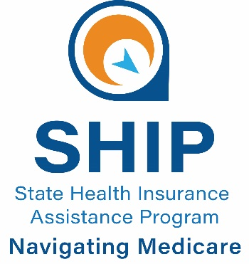
By the GWAAR Medicare Outreach Coordinator

This project was supported by the Wisconsin Department of Health Services with financial assistance, in whole or in part, by grant number 90SAPG0091, from the U.S. Administration for Community Living, Department of Health and Human Services, Washington, D.C. 20201. Grantees undertaking projects with government sponsorship are encouraged to express freely their findings and conclusions. Points of view or opinions do not, therefore, necessarily represent official ACL policy.

