Explore Updated Materials on the “Medicare Outreach and Assistance Resources” Webpage for Improved Outreach Efforts in 2023
April 2023
As an Elder Benefit Specialist working under the SHIP grant, one requirement is to conduct regular outreach to the public regarding Medicare-related topics such as Medicare enrollment, low-income assistance programs, and preventive services. The Medicare Outreach and Assistance Resources webpage serves as an essential tool to aid in this outreach. The Medicare Outreach Coordinator, Alyssa Kulpa, maintains and updates the resources on this page.
In recent months, numerous resources have been updated and additional ones have been added to enhance support for outreach initiatives. As you navigate the page, you'll find an array of options to help you provide outreach to your community. It's worth noting that the webpage is public, and you're encouraged to share it with your clients or other professionals in your area.

GWAAR Medicare Outreach and Assistance Resources Webpage
https://gwaar.org/medicare-outreach-and-assistance-resources

Screenshot of Webpage Sections | Updates & Resources for Outreach
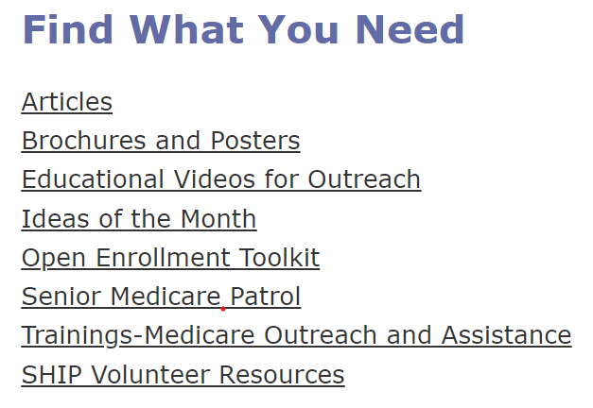 | “Find What You Need” Section These links will take you to separate webpages.  Articles: Customizable articles to use for outreach.  Brochures and Posters: Material updated with 2023 FPL numbers. Many customizable options!  Educational Videos for Outreach: Updated Welcome to Medicare PowerPoint & Recordings.  Ideas of the Month: BenSpectrum Medicare Outreach articles are here.  Open Enrollment Toolkit: Use to get ready for OEP in the fall! Fall Medicare Training materials here.  Senior Medicare Patrol: Link to SMP website.  Trainings-Medicare Outreach and Assistance: Archive of training for Medicare Outreach.  SHIP Volunteer Resources: Volunteer resources on recruitment, training, and management of SHIP volunteers.
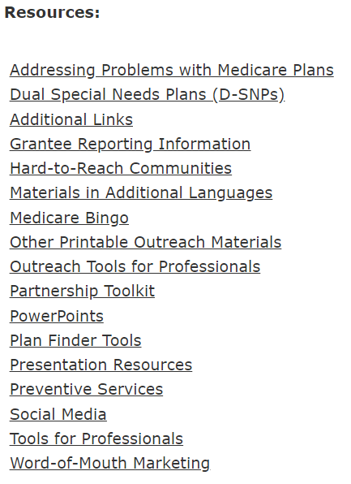 | “Resources” Section When selecting a topic, it creates a drop-down menu of resources.  Addressing Problems with Medicare Plans: Video, article, and handout to use in SHIP outreach about issues with Medicare plans.  Dual Special Needs Plans (D-SNPs): Info regarding D-SNPS from WI DHS.  Additional Links: Links to helpful websites.  Grantee Reporting Information: Information about reporting requirements with printable forms.  Hard-to-Reach Communities: Resources for Hispanic, Hmong, Native American, LGBTQ+ and rural communities.  Materials in Additional Languages:  Spanish brochure insert updated with 2023 FPL changes.  Newly added in 9 languages: SeniorCare, Time to Review Your Medicare, and What is Medicare?  Medicare Bingo: Educate & outreach with Bingo!  Other Printable Outreach Materials: Sample ads, HDM flyers, placemats, and table tents for outreach.  Outreach Tools for Professional: Updated eligibility quick check and MIPPA resources with 2023 FPL changes.  Partnership Toolkit: Ideas for outreach partnerships, sample emails/letters/flyers for partners.  PowerPoints: Customizable PowerPoints.  Plan Finder Tools: Updated 2023 Plan Finder Instructions!  Presentation Resources: Tools to make your presentations more effective.  Preventive Services: Materials to use in MIPPA preventive services outreach.  Social Media: Graphics and tips to using social media.  Tools for Professionals: This section is LOADED with helpful tools for EBS, HIGHLY recommend checking out these updated resources!  Word-of-Mouth Marketing: Sample postcards/letters.

Please reach out to Medicare Outreach Coordinator, Alyssa Kulpa, if you need assistance with outreach or have any questions at Alyssa.Kulpa@gwaar.org or (608) 228-8098.
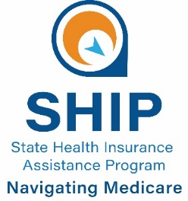
This project was supported by the Wisconsin Department of Health Services with financial assistance, in whole or in part, by grant number 90SAPG0091, from the U.S. Administration for Community Living, Department of Health and Human Services, Washington, D.C. 20201. Grantees undertaking projects with government sponsorship are encouraged to express freely their findings and conclusions. Points of view or opinions do not, therefore, necessarily represent official ACL policy.

