Medicare Outreach Idea of the Month
Promoting Cost-Saving Programs during the “unwinding” of the COVID-19 Public Health Emergency (PHE)
March 2023
As you prepare your outreach plans for the ending of the COVID-19 Public Health Emergency (PHE), consider materials on the GWAAR Medicare Outreach and Assistance Resources page that promote low-income benefit programs. Those in your community will be struggling as the pandemic emergency allotments for FoodShare end and costs continue to rise. This is a great time to reach out to people in your community about Medicare Savings Programs (MSP), Extra Help Part D low-income subsidy (LIS) and SeniorCare to help them stretch their budgets!
During this time, organizations that supply food and income support will welcome information to provide to their consumers about programs that can help their budgets. There are many updated outreach materials such as posters, brochures, and brochure inserts, on the Brochures and Posters for Outreach page of the GWAAR website. These outreach materials promote low-income benefit programs you help with, as well as materials to promote the Elder Benefit Specialist and SHIP programs. Consider using outreach materials at different community partners like tax clinics, libraries, senior centers, grocery stores, churches, and income maintenance agencies. Download and customize any outreach materials with your local contact information.
This outreach opportunity is a wonderful way to not only educate community partners about low-income programs but also your services as an Elder Benefit Specialist. Many people in your community do not know of all the services that EBS provide to help people navigate the maze of benefits in an unbiased and client focused way!
To view all the GWAAR Medicare Outreach and Assistance Resources, follow the link to our webpage:
https://gwaar.org/medicare-outreach-and-assistance-resources
To view information on the ending of the COVID-19 PHE, follow the link to the “Unwinding” Partner Toolkit for BadgerCare Plus and Wisconsin Medicaid Programs”:
https://dhs.wisconsin.gov/covid-19/unwindingtoolkit.htm
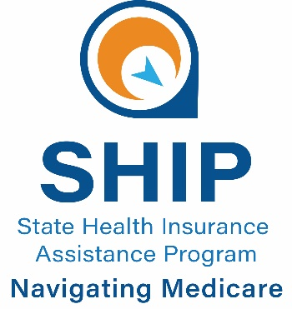
By the GWAAR Medicare Outreach Coordinator

This project was supported by the Wisconsin Department of Health Services with financial assistance, in whole or in part, by grant number 90SAPG0091, from the U.S. Administration for Community Living, Department of Health and Human Services, Washington, D.C. 20201. Grantees undertaking projects with government sponsorship are encouraged to express freely their findings and conclusions. Points of view or opinions do not, therefore, necessarily represent official ACL policy.

