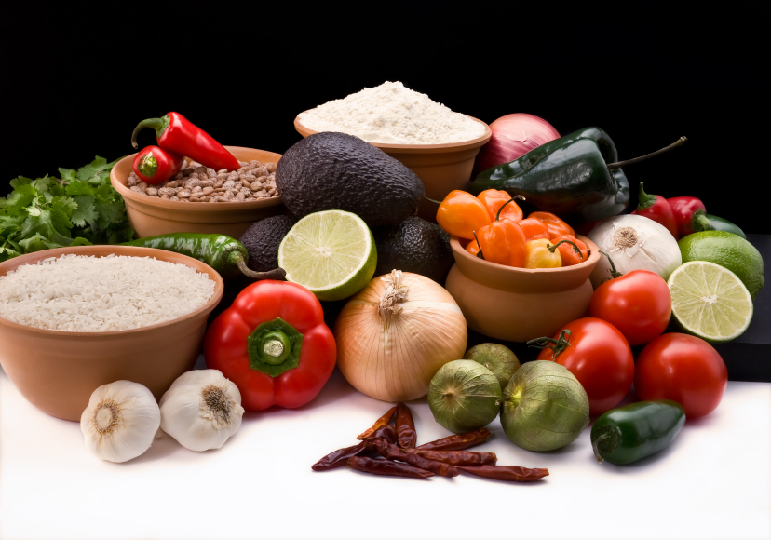
Recipe for: Dole Fruity Breakfast Burrito
2 – 8” flour tortillas
2 tsp sugar
¼ tsp ground cinnamon
2 tsp strawberry jam
2 medium bananas

Place tortillas on baking sheet. Sprinkle sugar and cinnamon evenly over tortillas. Broil tortillas one minute or until hot and lightly browned. Spread jam down center of tortillas. Place banana over center of each tortilla and roll up. Serve immediately.

www.dole.com/bananas

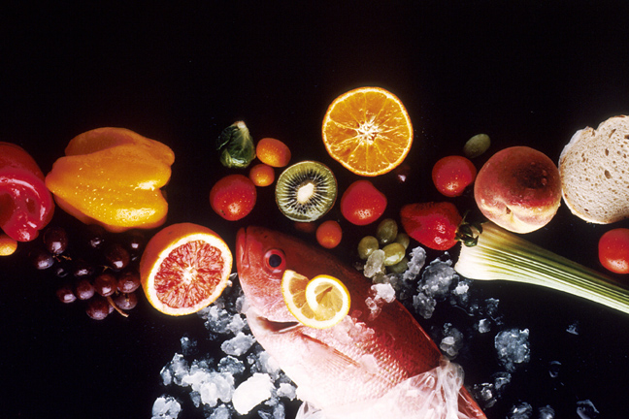
Recipe for: Chiquita Banana Breakfast Cookie
1 cup whole wheat flour1 cup oatmeal
½ tsp baking soda1 tsp cinnamon
½ tsp nutmeg¼ tsp salt
½ cup softened butter¾ cup brown sugar
1 egg½ cup shredded carrots
1 tsp vanilla extract2 whole bananas, fully ripe w/ some brown spots
1/3 cup raisins1/3 cup chopped walnuts

Preheat oven to 350. In large mixing bowl, beat sugar, butter, bananas, egg and vanilla until smooth. Stir in carrots. Gradually add all dry ingredients until batter is firm. Stir in raisins and walnuts and stir for 10 seconds. Drop 2 tablespoons of batter per cookie on baking sheet and press down lightly to flatten. Bake for 12 minutes, remove from oven, allow to cool 5 minutes before serving.
www.chiquitabananas.com

Recipe for: Easy Banana Oat Bars
2 cups quick cooking rolled oats
½ cup shredded coconut
½ cup dried cranberries
¼ cup chopped walnuts or pecans
2 large ripe bananas, mashed
¼ cup unsweetened applesauce

Preheat oven to 350. Mix all ingredients in large bowl until well combined. Press into 9 x 9 baking pan and bake for 30 minutes. Cool then cut into bars!

www.chiquitabananas.com

Recipe for: Grilled Plantains
4 fresh, ripe plantains (yellowish-black to black peels)
¼ cup brown sugar
½ teaspoon cinnamon
1 tablespoon honey

Score plantain from stem to tip. Cut off stem and tip. Grill on medium-high heat until peel cracks, approximately 10-15 minutes. Serve sprinkled with brown sugar, cinnamon, and honey. Of course, any sweet topping is delicious. Scoop out of peel and enjoy!

www.chiquitabananas.com

