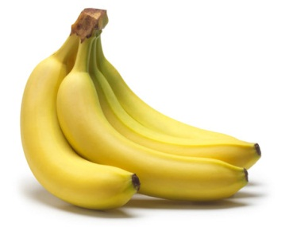

Beneficial Bites:
Bananas are the most popular fruit in America! And for good reason…

In addition to the Potassium they are best known for, bananas are rich in antioxidants Vitamin C and Manganese.

“A banana a day keeps the doctor away!” Compared to an apple, a banana provides 4 times the protein, 3 times the phosphorus, and 5 times the vitamin A and iron.

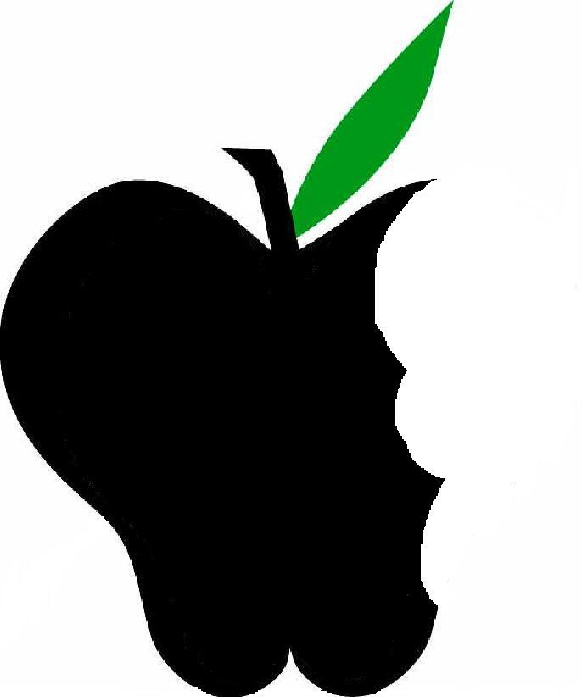

Did you know?
Bananas weren’t always called bananas. Throughout their history, they have been called banna, ghana, and funana, receiving a new name each time a group of people was introduced to them.

Bananas have been called the “Fruit of the Wise Men”. According to legend, Indian wise men meditated under the shady green leaves of banana plants.

More than 500 varieties of bananas are grown around the world! Florida’s climate supports several dooryard varieties, such as the Apple Banana and the Dwarf Cavendish.

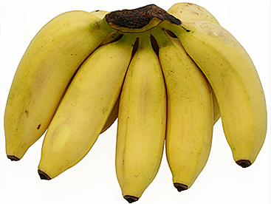

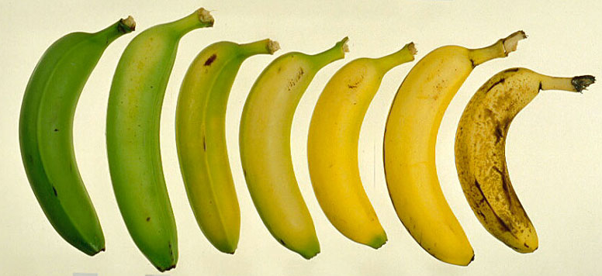

Food for thought:
Bananas are often green, or under-ripe, at the grocery store but best eating quality is reached when the skin reaches a solid yellow color.

Overripe bananas, like the one on the far right above, will give off a strong odor and have a higher sugar content.

Once ripe, bananas will store in the refrigerator for 3 to 5 days. The peel may turn brown but the fruit itself will not change.

Just like apples, bananas will turn brown after being cut. To prevent this, squeeze a little orange, lemon, or lime juice on your sliced banana and enjoy some extra Vitamin C!

