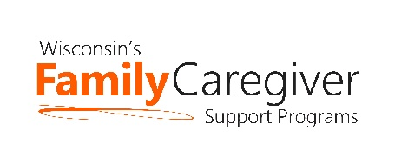

Wisconsin Caregiver Support Community Statewide Webinar
July 26th – 10:00-11:00 am
AGENDA
Join on your computer or mobile app
Click here to join the meeting
Or call in (audio only)
608-338-1382
ID: 468 991 500#

Advocacy Update – Janet Zander, GWAAR

State DHS and GWAAR Updates – Lynn Gall, DHS, and Bryn Ceman, GWAAR

Trualta – Kunal Parikh and Laura Jane Ward
- eLearning presentation; refresher for some & new to other CG staff
  - Ongoing support during each CG Support webinar in 2022

Our Family, Our Way – Jennifer Heston-Mullins, PhD LISW Associate Director of Research, Senior Research Scholar, Scripps Gerontology Center, Adjunct Assistant Professor, department of Sociology & Gerontology Miami University

REMINDER: Trualta training following call at 11:15 am for those who would like to attend. If you cannot make it, we’ll be sure to post the training to our July’s Caregiver Support Community Statewide call.

Next Meeting Date:
- Tuesday, September 27th from 10 am to 11 am
  - Live discussion to share successes from around the state and creative uses of caregiver grant dollars. We have heard of success from Brown, Kenosha, Sawyer Counties and more. Please contact Bryn at bryn.ceman@gwaar.org if you’d like to share a story, a success, or ideas. If we plan accordingly, we can ensure as many folks as possible get to share!
- Agendas will be forthcoming and posted on the GWAAR website
- Please feel free to email Bryn at: bryn.ceman@GWAAR.org and/or Lynn at: Lynn.Gall@dhs.wisconsin.gov with NFCSP/AFCSP meeting topics or guest speaker ideas

