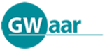
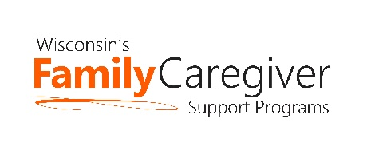

Wisconsin Caregiver Support Community Statewide Webinar
May 24th – 10:00-11:00 am
AGENDA
Join on your computer or mobile app
Click here to join the meeting
Or call in (audio only)
877-565-2671
Phone Conference ID: 468 991 500#

Advocacy Update – Janet Zander, GWAAR

State DHS and GWAAR Updates – Lynn Gall, DHS, and Bryn Ceman, GWAAR

Trualta – Kunal Parikh and Laura Jane Ward
- eLearning presentation; refresher for some & new to other CG staff
  - Ongoing support during each CG Support webinar in 2022

United Way 2-1-1 – Rachel Brightman, and Deanna Schuette

Next Meeting Date:
- Tuesday, July 26th from 10 am to 11 am
  - Jennifer Heston-Mullins, PhD, LISW (she/her), Research Scholar, Scripps Gerontology Center, Adjunct Assistant Professor, Department of Sociology & Gerontology, Miami University. Will share about Our Family, Our Way resources for families in the caregiving role: Miami’s Scripps Gerontology Center provides free resources for families navigating caregiving decisions | News at Miami University (miamioh.edu)
- September – Share successes from around the state
- Agendas will be forthcoming and posted on the GWAAR website
- Please feel free to email Bryn at: bryn.ceman@GWAAR.org and/or Lynn at: Lynn.Gall@dhs.wisconsin.gov with NFCSP/AFCSP meeting topics or guest speaker ideas

