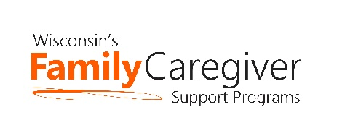

Wisconsin Caregiver Support Community Statewide Webinar
March 29th – 10:00-11:00 am
NOTES
Brief introduction of new OAA Consultant

Advocacy Update – Janet Zander, GWAAR
- Wisconsin Caregiver Support Community Statewide Meeting Advocacy Update - March 29, 2022 (handout)
- Voting Rights Action Alert (handout)

State DHS and GWAAR Updates – Lynn Gall, DHS, and Bryn Ceman, GWAAR
- Lynn – out; Bryn – GWAAR Weekly Newsletter to provide staff / GC Professional updates; “Thank You” notes offered by the first lady; take the Core Competencies Survey; CG monthly articles, publications & links can be found on GWAAR website; reminder to follow & share WI Family CG Support Programs FB Page.
Trualta – Kunal Parikh and Laura Jane Ward
- Learning presentation; refresher for some & new to other CG staff
  - Ongoing support during each CG Support webinar in 2022
- Support Group Training on 4/13/22 @ 12 pm
- Spanish Translation materials now available
- Wisconsin Local Resources soon to be available
- Guest, Margaret Ricchio (Kenosha) – “How To” tips on getting caregivers registered with Trualta.
- Interactive e-leaning content; audio play features

Dementia Care Specialist Program – Andrea Garr, DHS
- January, 2022 each county granted a Dementia Care Specialist (DSC); not all will be fulltime, some positions split. Recruitment still occurring.
- DCS and CG staff / professional relationship encouraged. Find your local DCS here: https://www.dhs.wisconsin.gov/adrc/consumer/index.htm -- within your local ADRC. Or, Tribal ADRC Services: https://www.dhs.wisconsin.gov/adrc/consumer/tribes.htm.
  - Kinship Coordinator collaboration also encouraged. Find your local Coordinator here: https://dcf.wisconsin.gov/map/kinship
- Feel free to invite DCS to CG Support Community Statewide Webinars.

Next Meeting Date:
- Tuesday, May 24th from 10 am to 11 am
  - Hosting Rachel Brightman and Deanna Schuette, United Way 2-1-1
- Agendas will be forthcoming and posted on the GWAAR website
- Please feel free to email Bryn at: bryn.ceman@GWAAR.org and/or Lynn at: Lynn.Gall@dhs.wisconsin.gov with NFCSP/AFCSP meeting topics or guest speaker ideas

