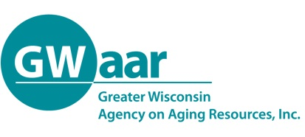

When Will Payments Begin?

If you can enroll in a Medicare Savings Program, please allow at least two months for payments to begin. This is the time that is needed for payments to be adjusted by Wisconsin Medicaid, Medicare and the Social Security Administration.

When Medicaid starts paying your Medicare costs, your Social Security check will increase, and you will get a notice from the Social Security Administration. The Social Security Administration will give you a refund for any payment you made after the date you were enrolled in a Medicare Savings Program.

How to Apply for a Medicare Savings Programs

You can apply online at access.wi.gov, over the telephone or in person with your local agency.

To find the address or phone number for your agency, go to dhs.wi.gov/em/CustomerHelp or call Member Services at 1-800-362-3002. They can also send you an application and answer any questions you may have about the application or these programs.

What If You Get Denied?

Applicants and recipients of MSPs have a right to appeal any negative decision related to initial eligibility, reduction, or termination of benefits. To file an appeal, the applicant/recipient or authorized representative must request a Fair Hearing from the Wisconsin Department of Administration’s Division of Hearings and Appeals within 45 days of the negative decision. Contact your County’s Benefit Specialist for representation and assistance with these appeals as soon as you receive a negative decision.

To sign up for a Medicare Savings Program, contact your county Aging & Disability Resource Center (ADRC) or the local Income Maintenance Consortium.

To find local, unbiased Medicare assistance:
dhs.wi.gov/medicare-help

<insert your information>

Medicare Savings Programs: Reducing Your Medicare Costs


<insert your logo/information>

This project was supported by the Wisconsin Department of Health Services with financial assistance, in whole or in part, by grant number 90SAPG0091, from the U.S. Administration for Community Living, Department of Health and Human Services, Washington, D.C. 20201. Grantees undertaking projects with government sponsorship are encouraged to express freely their findings and conclusions. Points of view or opinions do not, therefore, necessarily represent official ACL policy.
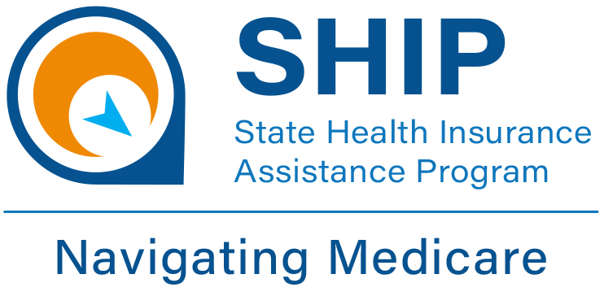

How Can the Medicare Savings Program Help Me?

There are three programs within the Medicare Savings Program that can save you money on Medicare costs:

Qualified Medicare Beneficiary (QMB)
pays your:
- Medicare Part A premium,
- Medicare Part B premium,
  - 2024 - $174.70
- Medicare Part A deductible,
- Medicare Part B deductible, and
- Medicare Part B 20% coinsurance

Specified Low-Income Medicare Beneficiary (SLMB) pays your:
- Medicare Part B premium
  - 2024 Part B Premium -$174.70/month

Specified Low Income Medicare Beneficiary Plus (SLMB+) pays your:
- Medicare Part B premium
  - 2024 Part B Premium -$174.70/month

Registration Information

Who Qualifies for MSPs?

2024 Asset Limits:
$9,430 for an individual
$14,130 for a married couple

Assets include things like bank accounts, retirement accounts, life insurance policies, cash on hand, etc.

Certain assets do not count toward the asset limits, such as the following:

- your primary homestead property,
- one vehicle,
- household goods and furniture,
- personal property,
- farm property,
- business assets, and
- most burial assets.

2024 Income Limits

QMB = Income at or below 100% of the FPL
SLMB = Income between 100% and 120% of the FPL
SLMB+ = Income between 120% and 135% of the FPL

2024 Federal Poverty Guidelines (FPL)

Household Size 100% FPL
1 $1,255.00/mo
2 $1,703.33/mo
120% FPL
1 $1,506.00/mo
2 $2,044.00/mo
135% FPL
1 $1,694.25/mo
2 $2,299.50/mo

Non-Financial Eligibility
In addition to asset and income limits, there are non-financial eligibility requirements for MSPs. Check with your County Benefit Specialist to see if you qualify.

