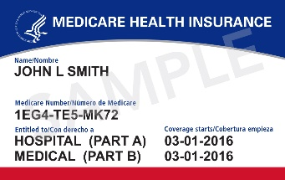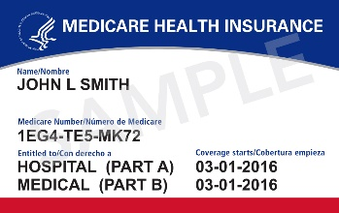

**Medicare Open Enrollment**

**October 15 – December 7**

**Time to review your Medicare Part D Prescription**

**Drug Plan!**

*Remember, every year insurance companies can change their formularies, premiums and deductibles.*

**For assistance with Plan Comparisons contact:**

**<YOUR CONTACT INFORMATION HERE>**

**Medicare Open Enrollment**

**October 15 – December 7**

**Time to review your Medicare Part D Prescription**

**Drug Plan!**

*Remember, every year insurance companies can change their formularies, premiums and deductibles.*

**For assistance with Plan Comparisons contact:**

**<YOUR CONTACT INFORMATION HERE>**