**Medicare Outreach Idea of the Month**

**January 2021**

As you prepare your outreach plans for the new year, consider including outreach posters that promote the low-income benefit programs. This can be a great way to educate people in your communities about Medicare Savings Programs (MSP), Extra Help Part D low-income subsidy (LIS) and SeniorCare.

There are several posters available that promote the same low-income benefit information, but feature different photos reflecting the diverse target populations for your outreach. There is also a version of the poster in Spanish. All the posters are available on the Medicare Outreach and Assistance [Brochures and Posters](https://gwaar.org/brochures-posters-for-outreach) page of the GWAAR website. Download the posters and customize with your local contact information.

Talk with your community partners, such as local clinics, churches and grocery stores, to see if they would be willing to hang a poster on their bulletin boards or in other prominent locations. Consider other places such as libraries, coffee shops, hardware stores and laundromats. If there are other locations in your community that may regularly serve Medicare beneficiaries, be sure to include them in your outreach plans.

A sample of the posters is included below. (More can be found on our webpage.)

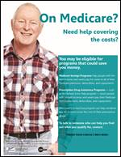  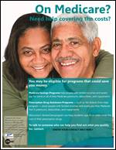   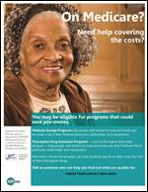

**To access the posters and** **to view all the GWAAR Medicare Outreach and Assistance Resources, follow the link to our webpage:** <https://gwaar.org/medicare-outreach-and-assistance-resources>.

By the GWAAR Medicare Outreach Team