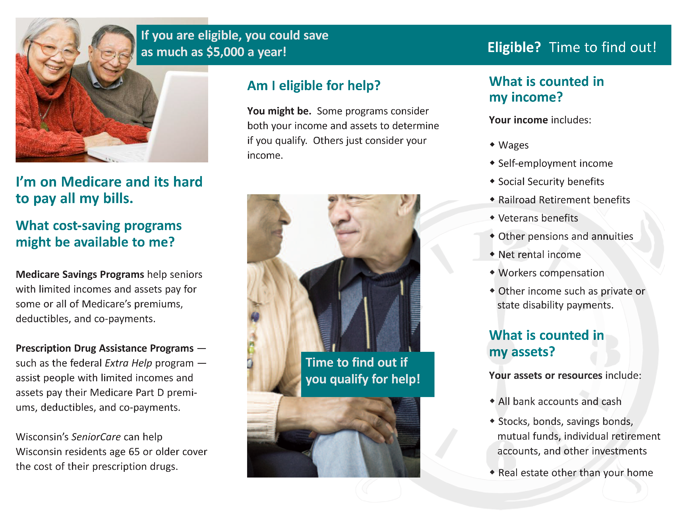

ADD YOUR

CONTACT INFO HERE