Coconut and Carrot High Protein Muffins

Adapted from Denise Bustard’s recipe:
https://sweetpeasandsaffron.com/high-protein-coconut-carrot-lentil-muffins/
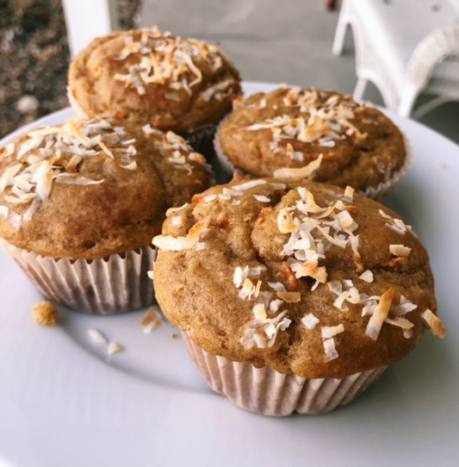
Ingredients:
- ½ cup dry red lentils (yields ¾ cup cooked)
- 1 ½ cup water
- 2 large eggs
- ½ cup unsweetened applesauce
- 1 teaspoon vanilla
- ½ cup plain yogurt (full fat)
- ½ packed brown sugar
- 1 cup gluten-free flour
- 1 teaspoon cinnamon
- 1 teaspoon baking soda
- 1/8 teaspoon baking powder
Photo by Ellie Magnuson
- 2 carrots, finely shredded (about 1 cup)
- ¼ cup shredded coconut

Instructions:
- Preheat the oven to 350 F.
- Line a standard-sized muffin tray with paper or parchment liners, or spray to non-stick cooking spray and set aside.
- To cook lentils, at ½ cup dry lentils and 1 ½ cup water to a pot. Bring to a boil, then turn down the heat and let simmer for 10-15 minutes, or until lentils are soft. Yields ¾ cup cooked lentils.
- Add lentils to a food processor and blend until smooth. Alternatively, mash lentils by hand with a fork.
- Add mashed lentils, eggs, applesauce, vanilla, yogurt, and brown sugar to the bowl and mix well.
- Add in flour, cinnamon, baking soda, and baking powder. Mix until just combined (do not over-mix).
- Fold in the carrots.
- Spoon the mixture into the muffin liners, filling just to the top. Sprinkle with coconut.
- Bake for 20-25 minutes, or until a toothpick comes out clean.

Store in a sealed container in the fridge for up to 4 days.

Serving size: 1 muffin |Calories: 124 kcal |Protein: 5 g |Total Fat: 2 g | Sugar: 10 g
Total Carbohydrate: 22 g |Dietary Fiber: 2 g |Sodium: 76 mg |Potassium: 116 mg

