**Medicare Open Enrollment**

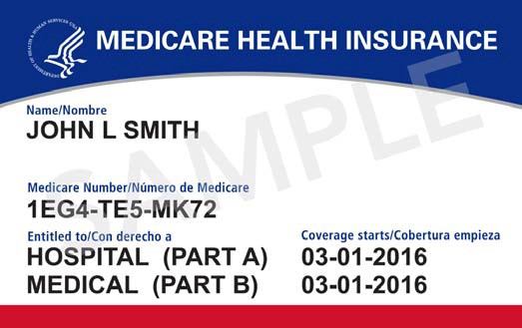**October 15 – December 7**

*Time to review your Medicare Part D Prescription Drug Plan!*

**

 

*Every year insurance companies can change their formularies, premiums, deductibles and copays so ALL Medicare Part D plans should be reviewed every year!*

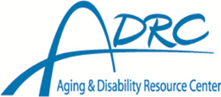

**Four Reasons to Check Your Prescription Drug Plan:**

1. **Your plan may cost more next year** *due to changes in deductibles, premiums and co-pays.*
2. **Your plan may no longer cover all your medications** *because insurance companies change their formularies.*
3. **Your plan may have added restrictions for some of your medications** *such as preauthorization, quantity limits and step therapy.*
4. **You may be taking different medications now.**

This project was supported by the Wisconsin Department of Health Services with financial assistance, in whole or in part, by grant number 90SAPG0091, from the U.S. Administration for Community Living, Department of Health and Human Services, Washington, D.C. 20201. August 2021

Go to **www.medicare.gov** to check your plan using the Medicare Plan Finder. *For free, unbiased assistance contact:*

* **<YOUR LOCAL CONTACT**

**INFO HERE>**

* Prescription Drug Helpline

1-855-677-2783

* Medigap helpline

1-800-242-1060

