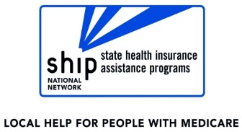
THANK YOU!

Thank you for coming in for a review of your Medicare prescription drug coverage.

We appreciate the opportunity to provide you with the plan options available to you in 2022. We hope this will be valuable information in making your final selection.

Do you know other people with Medicare that could benefit from Part D counseling? Please tell them about this ADRC service.

Appointments can be made by calling <YOUR AGENCY CONTACT INFORMATION HERE>.

THANK YOU!

Thank you for coming in for a review of your Medicare prescription drug coverage.

We appreciate the opportunity to provide you with the plan options available to you in 2022. We hope this will be valuable information in making your final selection.

Do you know other people with Medicare that could benefit from Part D counseling? Please tell them about this ADRC service.

Appointments can be made by calling <YOUR AGENCY CONTACT INFORMATION HERE>.

