

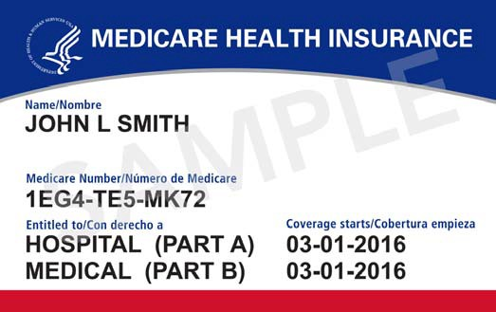
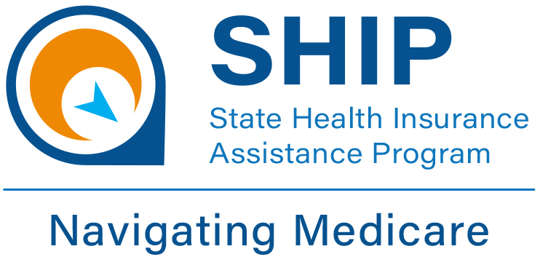

Medicare Annual
Open Enrollment Period

October 15 – December 7
Medicare Part D and Medicare Advantage Plans can change their premiums, covered drugs, and other plan details each year! Be sure to review your plan and make any changes by December 7th !
This is also a great time to find out if you are eligible for a Medicare Savings Plan (pays your Part B Premium) or Extra Help (Can save you money on your medications by reducing premiums, copays and deductibles!)
Qualification is based on income and assets below:

Call (262) 548-7848

Medicare Savings Plan
Income: $1,694/month or less for single ($2,299/month for couple)
* * * * * * * * * *
Assets: $9,430 or less for single ($14,130 couple)
Extra Help
Income: below $1,903/mo for single
($2,575/mo for couple)
* * * * * * * * *
Assets: below $15,720 for single ($31,360 couple)

For more information or assistance with plan comparisons,
please contact the
Elder Benefit Specialists
at the

<YOUR AGENCY INFO HERE>
(XXX) XXX-XXX
This project was supported by the Wisconsin Department of Health Services with financial assistance, in whole or in part, by grant number 90SAPG0091, from the U.S. Administration for Community Living,
Department of Health and Human Services, Washington, D.C. 20201.. Sept 2024

