Types of Grief
Understanding Helps Us Get Through It
No two people grieve a loss in exactly the same way. Grief can even be experienced when a family member is still physically alive but in a state of cognitive decline due to Alzheimer's disease or dementia.
Ambiguous Loss
Ambiguous loss can be categorized into two types of loss: physical or psychological. Physical loss and psychological loss differ in terms of what is being grieved for, generally the loss of the physical body or the psychological mind.
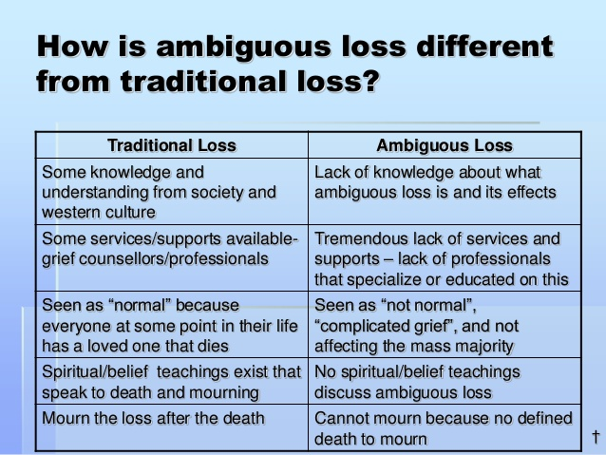
Disenfranchised Grief
Disenfranchised grief is when there has been a loss and others don’t recognize the depth of the relationship that existed. It could be the loss of a:
- Friend
- Ex-spouse
- Partner/lover
- Co-worker
- Client/Therapist/Patient
- Caregiver
- Teacher/Coach
- Celebrity
- Health care workers that you no longer see
Anticipatory Grief
The following are common signs of Anticipatory grief that one may feel, although it’s perfectly normal to experience just a few or all of them.
- Forgetfulness
- Fatigue
- Emotional Numbness
- Fear
- Guilt
- Depression
- Anxiety
- Anger
- Sadness or quick to cry
- Loneliness

