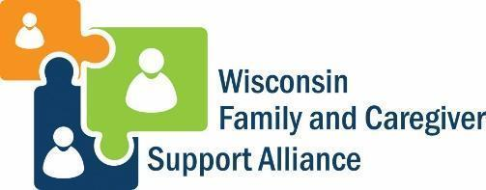
Mr./Ms. XXXXXX
Company Name
Address
City, State Zip
Dear Mr./Ms. XXXXXXX
The Wisconsin Family and Caregiver Support Alliance is requesting input from employers by helping us distribute an Employed Family Caregiver Survey to your employees. Data collected through this UW Extension survey will be used to develop free and low-cost supports for working caregivers that can help employers overcome common barriers to attracting and retaining employees.
One out of every five American adults provides care to a person other than their own children, and this number is growing. The 2021 report Healthy Workers, Thriving Wisconsin revealed just how much caring for family members impacted employers and employees of all types before and during the COVID-19 pandemic. We believe that partnerships with Wisconsin employers is key to accurately understanding challenges that Wisconsin businesses and workers face, and that employers are positioned to be the drivers of building a more stable workforce as our state recovers from the pandemic.
All responses to this 10-minute survey will remain anonymous so that no single employer or employee will be identifiable. Data collected will increase our collective knowledge of how family caregiving is impacting businesses and workplaces by:
♦ revealing the nature and prevalence of family caregiving responsibilities across the state
♦ providing statewide data needed to develop free or low-cost business solutions
♦ identifying what we can do together to implement changes that fit today’s workforce
We hope you will accept our invitation to partner with us on this initiative by encouraging your employees to participate in our working caregiver survey. Together we can find solutions that benefit us all.
Sincerely,

