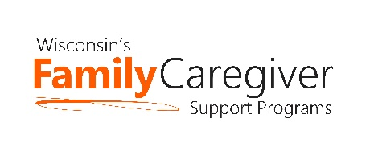
Wisconsin Caregiver Support Community Statewide Call
April 27, 2021 --- 10:00-11:00 a.m.
NOTES

- Welcome

- Advocacy Update – Janet Zander, GWAAR
Please see Advocacy Report for more details. Here are some important highlights.
- Please note that the deadline for submitting comments about the State budget has been extended to noon on Fri. 4/30
- Aging Advocacy Online: Janet is looking for more local hosts for the May 12th legislative visits. Hosts can be ADRCs/aging units, senior centers, or other aging network partners. Hosting involves setting up and facilitating a virtual meeting on May 12 from 1:00-2:00 p.m. If you are willing to serve as a host on May 12th, please send your name, agency name, email address, phone number, and the Senate district you wish to host to Janet Zander, Advocacy and Public Policy Coordinator at: janet.zander@gwaar.org
- Watch the GWAAR newsletter and Advocacy Alert emails from Janet to stay updated on advocacy issues.

- State and GWAAR Updates
- More focus on Relative Caregivers – With the removal of the 10% cap on spending, please have a plan for how to identify and serve grandparents/relative caregivers.
- New resource showing cross comparison of AFCSP, NFCSP and RCAW’s Caregiver Respite Grant Program – uploaded to the website. Look under Program Management Resources.

- National Family Caregiver Support Program – Policy Overview - Jane Mahoney, GWAAR
PowerPoint can be found here and supporting documents can be found here.

- Q/A and Sharing

