Talking Temps!
Meeting Invitees: Nutrition Directors
March 5, 2021, from 2 to 3 pm

Agenda:
Time: | Topic: | Discussion | Follow-up Items:
2:00 pm | Welcome | Thank you for joining the call today.  Agenda:  - Temperatures Challenges  - Peer Sharing and Best Practices  - Thermometers  - Documentation and review  - Staff and Volunteer Education, PowerPoint and Handouts  - Other items  - Save the Date: Menu and Recipe Sharing Peer Call (TBD) | Access the recording at this link
 | Temperature Challenges  From End of Year Reports | Arrival Temperatures  End of Route Temperatures  Taking all temperatures including cold  Overview of Key Concerns:  • Cold temps consistently not being taken, esp. cold salads, desserts, and milk.  • HDM Test trays not staying above 140 or below 41.  • Temp loss from the caterer to site
 | Peer Sharing  Best practices | Lori’s Overview of Nutri-System MOW Store also sells the boxes and they are great to work with! http://mowstore.com/product-category/meal-transporters/ This is the carrier several on the call recommended.  Hot Yellow and Orange Container. Advantages- keep hot esp. on long routes. The disadvantage, they are expensive and can take a long time to get them. They hold 14 meals so did you use more than 1 in a vehicle? Lori said yes, they had 2 in each car plus they also had the cold bag and insulated bag for frozen meals on Friday.  - ADRC-CW. Barb just ordered one and it will arrive in June.  The boxes have plugs that can be plugged into any outlet.  How heavy are they when the food is in them? Lori R. stated they are heavy when full per Lori. Lori said they had 2 drivers lift them onto carts and into the car and then the driver doesn’t need to lift again until it comes back empty.  Here are some other bulk food insulated carrier companies to check out:  - https://www.cambro.com/Products/insulated-food-transport/  - https://www.webstaurantstore.com/3513/insulated-food-carriers-and-beverage-carriers.html  - https://www.restaurantsupply.com/restaurant-food-storage-and-transport  - https://www.cooksdirect.com/storage-and-transport-food-and-beverage-transport-pan-carriers  - https://www.deiequipment.com/buy/carriers-for-food-pans  Lori F. Suggested bring all equipment in at night so they are not sitting in cold vehicles.  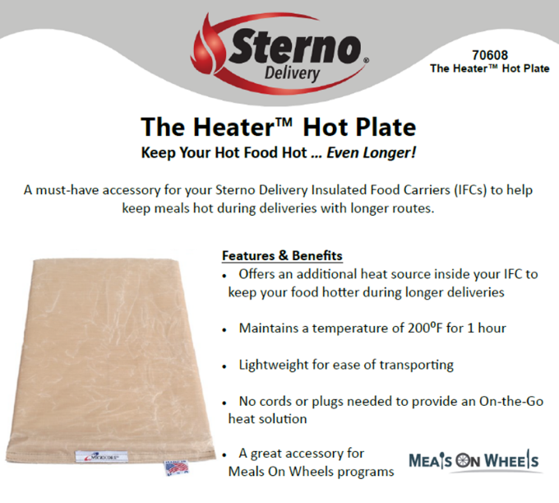  Sterno Heater Hot Plate. Goes in an insulated bulk delivery unit. Designed for Sterno Delivery Insulated Food Carries. Be sure to check with the company to see if this unit will work in your bags or carriers. You heat in the oven to 200 degrees. They are lightweight. You could use more than 1 per bag. She puts them on the side of the bags. The caterer was blowing a lot of fuses and this has been a nice alternative. The caterer drives 25 minutes to the site. Then 4 routes go out right way and no route is longer than an hour. Someone asked if they are too hot? The drivers are just handling the Oliver trays so they are not burning themselves. It is easy to clean and sanitize. Sue uses the Sterno Insulated Bags and this is what the insert is for. Check with the vendor which bags they accommodate.  Updated List of How to Keep Hot Food Hot and Cold Food Cold  Jean suggested asking the company if they could send a sample bag… doesn’t hurt to ask.  Cleaning Oliver Tray Sealing Machine tip from Kathy M: If anyone is having trouble with the film adhering to the tray we were told by Oliver to make sure to clean the inside of the machine with rubbing alcohol. One side of the film has adhesion and this builds up inside the machine and needs to be cleaned with rubbing alcohol. We clean with hot soapy water then the alcohol.  What kind of containers are you using:  - Several said, Oliver  - A few use the Metal/Foil Trays- someone did have an issue with someone put the metal tray in the microwave and started a fire. Some issues with cutting fingers on the edges as well. Others have reported meals staying hotter with the metal trays.  - Styrofoam for cold components  - Brown County asked if they used the Oliver for cold food . Yes, some do, and that works well.  - If you have issues with sealing Oliver Trays, it could be a training issue of holding it down too long but there are heavy-duty sealer/film that you can also order.  - You can use Oliver trays for cold items? Yes, cold items can be sealed and there are a variety of tray sizes and inserts for smaller cup containers. https://www.oliverquality.com/meal-packaging/market/senior-meals they also have short videos that show how to seal the tray. Usually, you just hold down ~3 seconds. If you hold it down too long the film can shred when the participant goes to open it.  - https://www.oliverquality.com/meal-packaging/product/speedseal-cx (scroll down to the bottom of the page to view the videos).  - Portage Cty stated they pay $62 for 250 metal trays or .248 cents each.  - What is the cost of the Oliver Trays?  - The cost of the OLIVER food trays (before their price increase Feb 2021) 2Compartment 26 ea; 3Compartment Deep .29 ea; 3 Compartment Shallow .27 and 3 Compartment Plastic .31 ea.  - Rusk Cty pays: Oliver 3 compartment shallow is .43 cents each  - How many trays come per Oliver Case?  - Dawn J. asked if anyone has gotten the new gigantic roles of the film? She said the smaller units with the smaller units were tricky to seal. Ronda said they have used the larger roles and she hasn’t had any negative feedback. Dawn said it took a bit to get used to them. Ronda said the staff like that they don’t have to change the roll as frequently.  - Ronda said Oliver prices increased 3% 2-2-21.  - Some had issues with the plastic Oliver trays not sealing as well and switched to the fiber and they are much better.  - Dawn in LaCrosse said they got sub’d a lot with black plastic Oliver trays. They switched back to the paper ones because when they froze the plastic ones. Ronda stated that there is another film that should be used with frozen meals but it costs more.  - Can GWAAR help secure better pricing? Jean said GWAAR will investigate group pricing. When you order from Oliver you can ask for the WAND discount. You also get a discount ordering over a certain amount.  - Black Oliver Tray plastic was very hot to handle  - Does the caterer do all of the sealing with the Oliver trays or do you seal at the nutrition site?  - Some do and some do not  - Barron stated that her staff liked the black plastic and the food looks nicer. They don’t freeze meals so this works well. The black plastic is oven-safe and recyclable FYI.  - Chippewa Cty has 5 different vendors, 3 seals, 1 brings bulk to Cornell and Bloomer has expanded from 18 to 50 and the staff there is in the middle of learning how to seal them. A special thank you to Barron to observe how to seal.  - Dawn in LaCrosse provided an overview of how they keep temps safe?  - She rode from the caterer in the van and did the whole journey and took temps at each site to identify problems. She bought their electrical heating unit, plugs into a cigarette lighter, and put 2 hot microcore in each bag along with the heater. Within 15 minutes of the meals being delivered the meals are put into bags for each route. Dawn did multiple ride alongs and identified where issues with temps dropping off were occurring and took corrective action. This is an important piece for local Nutr. coordinators to do.  - Winnebago had problems with temps coming from the caterer as well. So Dawn asked them to take temps before the meals left and the temps dropped 40-50 degrees. They were using surface and not stem thermometers and did education on how to calibrate and be sure the dimple is covered.  - Dawn reminded everyone that with all the new people coming in, little things were falling off so re-education is important and the staff will respect you more for being out there with them.  - Amelia in Marquette did a lot of education to her staff and it made a big difference. The ppt is too large to insert. You can access it at this link. If you are unable to open this link please contact your Nutrition team Rep. Jean Lynch jean.lynch@gwaar.org; Lori Fernandez lori.fernandez@gwaar.org ; Pam VanKampen Pam.VanKampen@gwaar.org  - The training helped them understand why and how to properly temp test trays. She also updated forms and started using new forms so helpful to do at the same time.  - Pierce Cty stated that another thing we tried is to have the office help people record the temps over the phone. We have older workers that by the time they take the meal out, temp one of the foods, record it, temp the next food, record, etc the meal temp has probably dropped significantly. So we had the driver call Lena on his cell phone and then as he temped each food item he verbally gave her the temp so he could just quickly temp everything and she recorded the numbers. This was Lena's idea and a pretty brilliant one I might add! I think for older workers with dexterity issues taking meal temps can take more time than we might think and in the winter the temps are dropping quickly as they test each food item.  - Someone asked if you have to track food waste and # meals on the temp logs? It’s not required per se, however, we are to monitor food waste and have procedures in place to evaluate and minimize the difference between the # of meals ordered/prepared and the number of meals served/delivered. (Sec. 8.4.23 Reducing Food Waste) So adding onto the daily sheet is one way to do this. It also helps control costs and tracks overages and underage’s from the caterer. If you use performance-based contracting this is a way to document.  - For HDM Tests: Door County uses unpaid volunteers and she is wondering when volunteers are delivering are they checking the temp after the last meal or when it comes back to the kitchen to be temped? Jean suggested it be after the last meal. Currently, it is coming back to the site to be temped. They temp once a month.  - Kim Loose said that they send a zip bag with all the supplies in it including a sealed fork/knife so they can enjoy the meal if they would like.  - 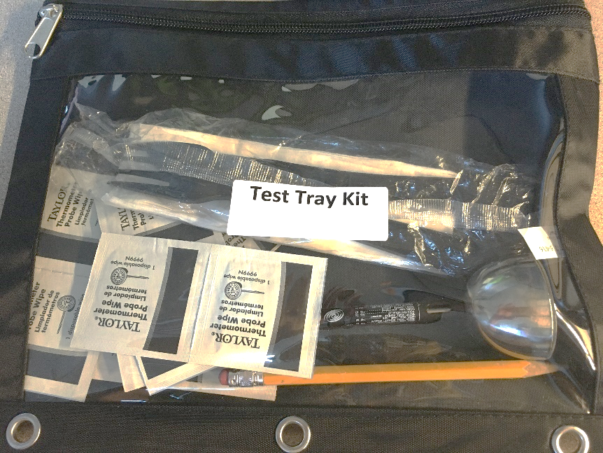  FYI: The GWAAR Nutr. Team will continue to ask for temps every few months, more details coming soon.
 | Thermometers | Recommended thermometers https://www.webstaurantstore.com/cooper-atkins-dpp400w-0-8-waterproof-digital-pocket-thermometer/273DPP400W08.html?utm_source=google&utm_medium=organic&utm_campaign=GoogleShopping&gclid=Cj0KCQjwoub3BRC6ARIsABGhnyZ7mRSajD2zp21jKi9TJUodFwlqMT4fbKR6ERNbzssLLrNsmZ3JVYQaAnMrEALw_wcB
 | Documenting Temperatures who reviews and who acts. | Reviewed Temperature Documentation Sheets. There are a variety of options for Temperature Documents that can be found in this folder. If unable to open contact your Nutrition team rep.  Kassy Heard from GLITC revised the form and they are great for training staff with new forms. (These are in the folder link noted above). Thank you Kassy!!  - Fillable forms with instructions on how to complete  - There are options, 1 side or 2, up to each program.  Cold Temps:  - Use ice packs, ice sheets, microcore (cold)
 | Staff and Volunteer Education, PowerPoint and Handouts | PowerPoint for staff and volunteers on Temps can be found at this link  Keeping Hot Food Hot and Cold Food Cold updated handout can be accessed here
 | Agenda Items for Next Call- Date TBD likely late March or Early April | - Can we talk about packaging items? How we are packaging them?  - Talk more about the process of temping...example stories/scenarios?  - Suggest picking a section of Ch 8 for review.  - Examples of issues or positives with catering company and what you did? Example waiting for temperatures before they leave?  - Cost of Packaging  - I would like to see if it would be possible to receive a WAND member discount on other food packaging items as we do with Oliver. We use NASSCO and Uline for other food packaging. Dawn Jorstead stated that We do get WAND discount with Oliver. You have to tell them you are a member. Can this be covered on the next call?
 | Closing | Upcoming Training/Meetings:  - Recipe and Menu Peer Sharing Call TBD  - WASC Spring Training March 12th (You need to be a WASC member to attend. If interested in Membership contact Oertel, Lori OertLor@sdmfschools.org )  - NANASP Virtual Conference May 12-14  - WI Aging Advocacy Day May 11 (Virtual)  - WIHA Virtual Conference (June 3-4)

