Talking Temps! Part 2
Meeting Invitees: Nutrition Directors
April 6, 2021 from 3 to 4 pm

Agenda:
Time: | Topic: | Discussion | Follow-up Items:
3:00 pm | Welcome | Thank you for joining the call today.  Agenda:  - Temperatures Challenges  - Peer Sharing and Best Practices  - Other topics | Access the recording at this link https://gwaar-my.sharepoint.com/:v:/g/personal/pam_vankampen_gwaar_org/EWfrlkxQ0zJCtfdv3SuR-tMBVaRveFbjsLfGvle8Q005rQ?e=axt2ti

 | Temperature Challenges |  | Recent Challenges:  Drivers not knowing how to take temps. Is anyone else struggling with this?  - Re-education would be good there. We have a ppt that folks can watch. You can find the ppt and other useful materials in this folder. https://gwaar-my.sharepoint.com/:f:/g/personal/pam_vankampen_gwaar_org/EpQYlCdPFzNKlDl-hQQ5-_EBCUlxeeMcZddcEJ9wC5bDqA?e=dF1GhP  - It is nice to review annually with all drivers.  - Jean added the most important piece is to figure out where the temp loss is happening is to go out and monitor the entire process from start thru the end of the route.  Managers taking temps back at the kitchen instead of drivers doing it out on the route.  - It is best to train the drivers how to take the temps right after they deliver the last meal.  - Jean asked if anyone once they looked at the process. Did they find that education was the issue, I.e. not knowing how to take the temps or how to calibrate the thermometers? Re-education helped.  - Can you use an infrared thermometer for foods? No because it only records surface temp and not the internal temp. You should use a stem thermometer.  Kristi Cooley shared that they have made some changes:  - Put the milk in the freezer for ~20 min before packaging.  - For the hot packing they are now using the soft sided Sterno bags and multiple heat sheets, 4 meals then another heat pack, and layering them and this has resulted in good temperatures. She said that this also helped.  - Barb from Lincoln County. They just received a large supply of hot sheets from Sterno and they are completely coming apart at the seams. They contacted Sterno and they never had this happen before. Shari Brunell from Calumet Cty shared that their Oven Tech hot plates have come apart at the seams in the last batch we purchased.  - . Kristi purchased hers last year and no problems to date.  - They heat max 20 minutes in the oven. They batch them and put a single layer at a time, 3 on 1 shelf, 3 on another. They stagger the time in the oven. Barb asked if they put them right on the rack or on a sheet. Kristi said they put them on a baking sheet and Barb said they were as well.  - Oneida County uses gel type microwavable, and they work well. She got them from Amazon.  - Barb in Lincoln said they had issues with microcore, and they leaked and ruined the bags.  - Winnebago cty had some issues as well.  - Kim from ADRC of the Lakeshore said that if they start to leak put them in a zip lock bag and just use for cold. Kathy Walthers said you could also put cardboard in-between.  - Missy from Washburn said they We also use gel packs for both hot and cold. We also place an electric heat plate on the bottom of our hot bags.  - Val from Waushara said they got some hot sheets from Oliver and they are also coming apart. One of the staff was trying to sew at home with heavy duty thread. They are following the directions.  - Heidi from Shawano said that they used cardboard in the past. Now they use sheet metal for the Heat Stones, and this works well. They don’t use the cardboard that comes with the heat stones. They had wooden trays made and then they cover it with sheet metal. They have used insulation with duct tape on the top of the bags and this works well. They worked with a local heating company and gave them the dimensions and they made them.  - Anyone having issues with the cords on the vehicles. Several have broken any recommendations. Some have frayed. Jean asked if they are under warranty? Extra training for staff to remove them carefully. Val from Waushara said that sometimes they have had issues with the plug-in bags and a fuse went out and that has been a simple fix, you can get the fuse at an auto store. Val said the warranty is usually for 1 year.  - Kim said they have so many microcores they keep in a hot all together in a MOW bag.  Cleaning and Sanitizing Thermometers:  - Kali from Outagamie Cty shared a product that she is going to buy and use with a disposable towel. She will send the information for ARRAY https://www.gfs.com/en-us/products/our-brands/array  - Eco lab has a ready-mix dispenser for sanitizers. The dispenser will mix the sanitizer and water at the correct concentration at every use. Usually the dispenser will fill bottles or pails. It makes it easier for employees to do the job right.  - Key is to look at your sanitizer, follow the directions and have the right concentration.  - Dawn from ADVOCAP said that when she worked in a NH, they also used Eco lab. They did a cup of sanitizer every night and let the thermometers sit in it overnight.  - Jean will check with Justin for Reinhart.  - Shari shared that Northwoods has some great products. She said that in the restaurant setting they are intended to be used together, I.e., handwashing, dish sanitizing, food services.  - Bleaches are different so you HAVE to use the test strips to know the ppm.  - Check out this slick product from Ecolab. The cost is only $10.25. https://foodsafety.ecolab.com/us/food-safety/thermometer-sanitizer-tank-40801-01-00  2 Biggest Challenges:  - Temps at the end of the route  - Cold temps not being taken.  Heidi from Shawano Cty shared what she did to help get temps to improve:  - The first year they worked with the new caterer it was a struggle. They previously used the aluminum 3 compartment trays. They wanted to change to Oliver as they are more Eco-friendly.  - They found that the caterer's food is extremely hot and there are many heat lights in the kitchen. This has helped a lot.  - They tried a variety of heat stones. They also tried the plug-in bags from the Oliver Store, but they have issues. They had a lot of issues with the cords. They have had them replaced and repaired and they don’t seem to last. They use the bags now for cold. They have transitioned to heat stones and they are working well.  - Worked a lot of caterer to keep the food hot and this is working well. The caterer is very committed to the program.  - There were some issues with staff not temping the cold foods. They needed to add another layer of cold packs and this resolved the issue. Sometimes site managers get into habits and it may take disciplinary action to resolve the issue.  - Her caterer closed thru COVID to the public but continued to provide meals for the program. This is to be commended!  Does anyone want to share a struggle they are having?  - Val from Waushara. They realized that when they used to take temp where it says temp at the beginning of the route and they were taking the temp as they were packaging the food but once they took the temp on the route it dropped significantly so this wasn’t a true picture of what the food started at. Once you take the temp of 1 individual meal there was a big drop off.
 | Equipment Resources |  | 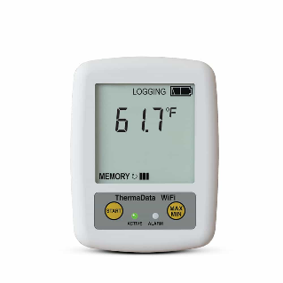Freezer/Refrigerator Thermometer with Alarm for out-of-range temperatures. Here is one example from Amazon. These thermometers will send an email or text to your phone if the freezer or refrigerator is out of range.  https://www.amazon.com/AcuRite-Refrigerator-Thermometer-Temperature-Customizable/dp/B004QJVU78  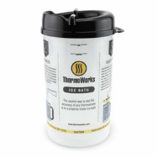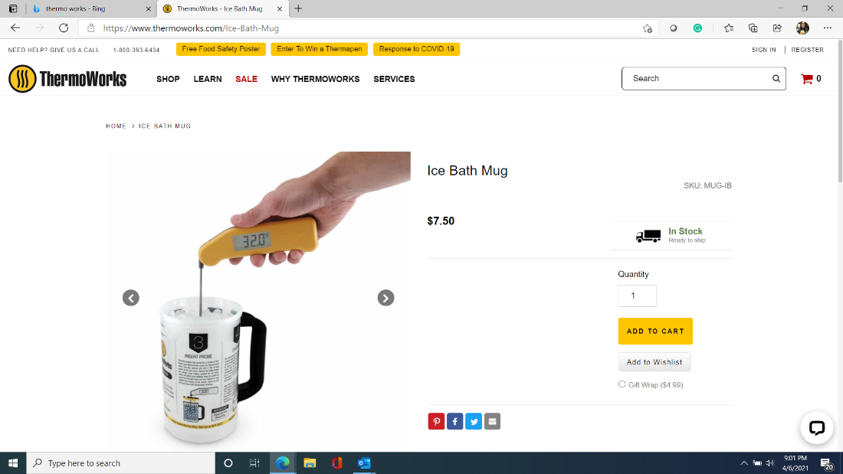  This is a mug you can use to calibrate thermometers. It is handy because instructions for calibration are printed on the cup. ThermoWorks - Ice Bath Mug $ 7.50
 | Thermometers |  | Recommended thermometers https://www.webstaurantstore.com/cooper-atkins-dpp400w-0-8-waterproof-digital-pocket-thermometer/273DPP400W08.html?utm_source=google&utm_medium=organic&utm_campaign=GoogleShopping&gclid=Cj0KCQjwoub3BRC6ARIsABGhnyZ7mRSajD2zp21jKi9TJUodFwlqMT4fbKR6ERNbzssLLrNsmZ3JVYQaAnMrEALw_wcB  Calibrating thermometers. There are some nice food safety handouts, newsletters and videos at this link https://www.publichealthmdc.com/environmental-health/food-safety/food-safety-newsletter-fact-sheets
 | Documenting Temperatures who reviews and who acts. |  | Temperature Forms and Documents can be found at this link.  https://gwaar-my.sharepoint.com/:f:/g/personal/pam_vankampen_gwaar_org/EpQYlCdPFzNKlDl-hQQ5-_EBCUlxeeMcZddcEJ9wC5bDqA?e=dF1GhP  - Fillable Weekly Temp Log (2-pages)  - Daily Food Temperature, Meal Verification, Food Waste, and Comment log  - Refrigerator and Freezer Temperature Log  - Safe Minimum Cooking Temperature Chart
 | Staff Education |  | How to temp lettuce | Temping Lettuce.mp4
 | Staff and Volunteer Education, Power Point and Handouts |  | The ppt for staff and volunteers on how to take and record temps that Pam recorded along with several other helpful documents can be found in this folder. https://gwaar-my.sharepoint.com/:f:/g/personal/pam_vankampen_gwaar_org/Eif4D0fFq-RMlJHzlPGVAYYBbU7CiSkbBCEHQHHlNThmnw?e=I1Cg2h
 | Topics for next Calls |  | - Reopening, restaurant model, volunteer engagement, Styrofoam trays, and meal packaging. | If you have more topics for calls, please let your nutrition team rep know.
 | Closing | Upcoming Trainings/Meetings:  - Nutrition Peer Sharing Calls: Email your nutrition team rep if you did not get the invite or if you cannot attend your region’s and want to attend another call. Thank you!  - 4/20 3 to 4 pm for TAUs Nutrition Programs (Kassy Heard moderating)  - 4/27 3 to 4 pm (Lori’s Region)  - 4/28 from 2- 3 pm (Pam’s Region)  - 4/29 from 3 to 4 pm (Jean’s Region)  - NANASP Virtual Conference May 12-14 http://nanasp.org/NANASP2021Conference  - WI Aging Advocacy Days:  - Mon., May 10th, 1:00—3:00 p.m. Training Day - Join us Virtually  Wed., May 12th, 1:00—2:00 p.m. Day of Action - Virtual Legislative Visit https://gwaar.org/aging-advocacy-online-2021  - WAND Spring Conference June 2 1:30 – 4:30. Save the date, more details coming soon.  - WIHA Virtual Conference (June 3-4) https://wihealthyaging.org/healthy-aging-summit

