Virtual Presentation
Welcome to Medicare

Wednesday August 12
2:00 – 3:00pm

Free and open to the public.

Presented by <YOUR AGENCY>
This presentation will provide objective Medicare information about the options available as well as programs that may help you save money, and more including:
- Enrollment in Medicare
- Medicare Basics
- Your Coverage Choices
- Help for People with Limited Income
- And more!

Click link to join meeting: ______________
*Include specific instructions as needed. If they need to call in separately, include that info as below.
Call: 800-123-4567
Enter Participant Code when prompted: _________

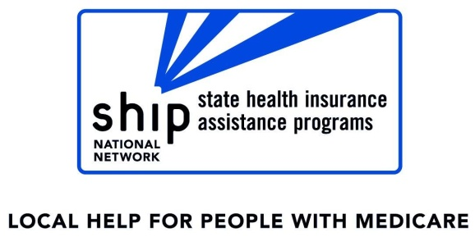
To download the presentation slides click here.
<YOUR AGENCY NAME AND CONTACT INFO HERE>

