Eat Well, Age Well
Volume 1 Cookbook

Mikayla Lenz
collaboration with Several Other UW stout dietetic students who Developed monthly Eat Well Materials & Pam VanKampen RDN, CD GWAAR Nutrition Team

University of wisconsin Stout student

Greater Wisconsin Agency on Aging Resources, Inc.

gwaar.org/nutrition-education-and-activities
https://gwaar.org/
Mission Statement: The mission of GWAAR is to deliver innovative support to lead aging agencies as we work together to promote, protect, and enhance the well-being of older people in Wisconsin.

Created: March 23, 2020 for the purpose that GWAAR will use this as an educational tool for those who are in need; including, but not limited to Older Americans Act Elder Nutrition Programs, nurses, dietitians, health care providers, and those who are at home looking for a quick, delicious meal.

Table of Contents
Breakfast 8
Blueberry and Spinach Smoothie 9
Spinach Smoothie 10
Strawberry Banana Smoothie 11
Green Breakfast Smoothie 12
Simple Green Smoothie 13
Gut Health Smoothie 14
Blueberry Hill Smoothie 15
Green Chia Smoothie or Pudding 16
Pineapple-Kale Smoothie 17
Fiber Starter Breakfast Bowl 18
Avocado Toast 19
Eggs, Kale & Sweet Potato Grits 21
Savory Bread Pudding with Kale and Butternut Squash 23
Quick Crustless Quiche 25
Roasted Squash Breakfast 27
10 Minute Oatmeal Blueberry Pancakes 29
Peanut Butter Pancakes 31
Lunch 33
Baked Meatballs 34
Avocado & White Bean Sandwich 36
Citrus Rice Pilaf 38
Black Bean and Rice 40
Dill-licious Chickpea Salad 42
Beet Detox Salad 43
Herbed Quinoa 45
Quinoa with Root Vegetables 47
Loaded Lunchtime Oatmeal 49
Three Pepper Oat Pilaf 50
Papaya Black Beans and Rice 51
Simple Tomato Basil Soup 54
Gazpacho 55
Split Pea Soup 57
Butternut Squash Soup 58
Potato, Black Bean & Kale Skillet 60
Garden Pasta Salad 62
Avocado and Shrimp Salad 64
Spring Lettuce with Avocado Dressing and Pistachios 66
Easy MIND Healthy Salad 68
Yogurt Dill Chicken Salad 69
Mayo-free Avocado Tuna Salad 70
Garden Fresh Sandwich 71
Peanut, Peach, and Pineapple Wrap 72
“Hobo” Wrap 74
Black Bean Quesadillas 76
Dinner 78
Stuffed Peppers 79
Cranberry Orange Chicken 81
Stuffed Chicken Breast 83
Breaded Chicken Breast 85
Meatloaf 87
Anti-Inflammatory Broccoli, Ginger, Leek & Turmeric Soup 89
Walnut Crusted Salmon Fillets 91
Salmon Baked in Foil 93
Spinach Baked Salmon 95
Asian Pan Seared Salmon Salad for One 97
Yes-You Can Black Bean Chili 99
Red Bean Veggie Soup 101
Snacks 102
Zucchini Pesto 103
Homemade Granola 105
Dessert 106
Applesauce Oatmeal Muffins 108
Sweet Potato Apple Cinnamon Muffins 110
Berry Frozen Yogurt 113
Greek Yogurt or Ice Cream with Chia Seeds 115
Olive Oil Zucchini Bread 116
Summer Squash Bread 118
Greek Yogurt Zucchini Bread 120
No-Bake Chocolate Cherry Oat Bars 122
Gluten-Free Hazelnut Brownies 124
Brownies with Dried Plums 126
Gluten-Free Black Bean-Zucchini Brownies 128
Gluten-Free White Chocolate Chip Peppermint Cookies 130
Molasses Cookies 132
Pumpkin Chocolate Chip Muffins 134
Bean Red Velvet Cupcakes 136
Raisin Pie 138
Raw Wild Blueberry Pie 140
Sides 142
Baked Sweet Potato Wedges 143
Spicy Roasted Broccoli 144
Healthy Cauliflower Rice 146
Green Bean Casserole 148
Summer Fruit Salad 150
Broccoli Apple Salad 152
Green Apple Salad 154
Anti-Inflammation 156
Easy Caprese Salad 157
Blueberry, Almond and Greens, Anti-Inflammatory Side Salad 158
Cinnamon Toast Pumpkin Seeds 160
Trail Mix 161
Cinnamon Cashew Butter 163
Honey-Roasted Cinnamon Chickpeas 164
High Fiber Bean Dip 165
Lime Cabbage Slaw 168
Simple Chia Pudding 170
Green Chia Smoothie or Pudding 172
Beet and Pear Puree 174
Dressing 176
Greek Dressing 177
Vinaigrette Salad Dressing 179
Greek Dressing 181
Creamy Herb Yogurt Dressing 183
This page is intentionally blank.

Breakfast

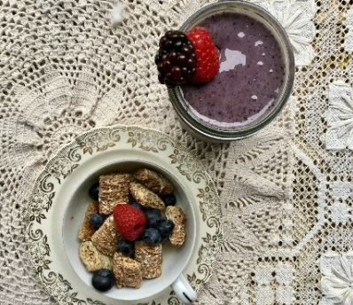
Blueberry and Spinach Smoothie
One Serving
Nutrition Information
per serving
Calories 399
Total Fat 3.9 g
Saturated Fat 0.4 g
Sodium (mg) 125
Fiber 9 g
Total Sugars 57 g
Protein 18 g
Photo by Lindsay VanKampen
Ingredients:
- 1 c blueberries (fresh or frozen)
- 1 whole overripe banana (fresh or frozen)
- 1 c fresh spinach
- $2/3$ c skim milk
- $1/3$ c plain Greek yogurt
- 1-2 tbsp honey or maple syrup
- 1 tbsp ground flax seed

Directions:
1. Place all ingredients in a blender, puree until smooth.
2. Top with strawberries, coconut shreds, granola, or any other of your favorite toppings!

Source: http://www.createkidsclub.com/superfood-smoothie/

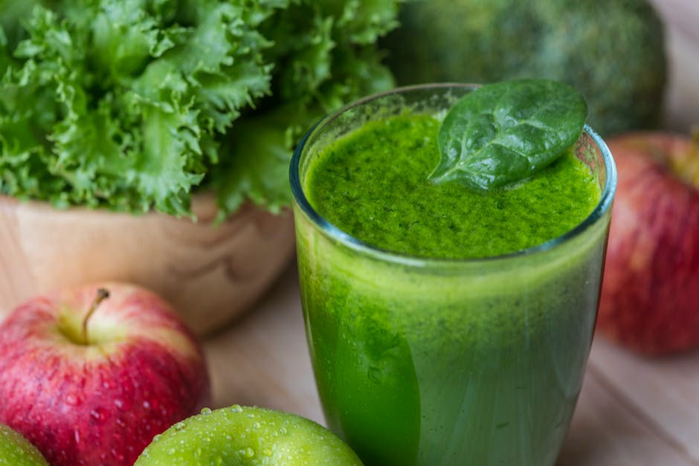
Spinach Smoothie
Photo courtesy rawpixel.com
One Serving
Nutrition Information
per Serving
Calories 262
Total Fat 10 g
Saturated Fat 2 g
Sodium (mg) 99
Fiber 3 g
Total Sugars 23 g
Protein 18 g
Ingredients:
- ½ frozen banana
- 1 c fresh spinach
- 1 tbsp peanut butter
- ½ c 1% milk
- ¼ c vanilla Greek yogurt

Directions:
1. Combine all ingredients into blender and mix until smooth
Source: https://damndelicious.net/2013/08/16/green-smoothie-with-peanut-butter-and-banana/

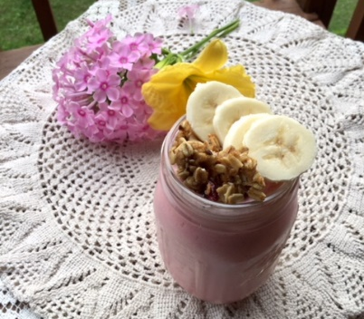
Strawberry Banana Smoothie
Two Servings
Nutrition Information
per Serving
Calories 322
Total Fat 4 g
Saturated Fat 2 g
Sodium (mg) 146
Fiber 8 g
Total Sugars 43 g
Protein 20 g
Photo by Lindsay VanKampen
Ingredients:
- 2 c frozen strawberries
- 1 frozen banana
- 1 tbsp honey
- 2 c milk
- ½ c plain Greek yogurt
- Granola (optional)
- Chia Seed (optional)

Directions:
1. Blend strawberries, banana, milk, and yogurt together
2. Mix in chia seeds (optional)
3. Top with granola or other fruit (optional)
Source: http://www.thedomesticgeekblog.com/strawberry-banana-smoothies/

Green Breakfast Smoothie

Ingredients:
- ½ c milk of your choice
- $1/3$ c Greek yogurt
- 1 cup green vegetables (spinach, kale, etc.)
- 1 medium banana
- ½ c fresh or frozen fruit chunks
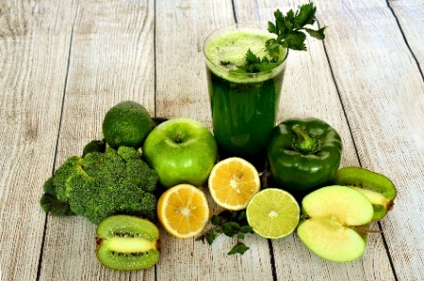
- 1 tbsp chia seeds (optional)
One Serving
Nutrition Information
Calories 307
Total Fat 5 g
Saturated Fat 1 g
Sodium (mg) 110
Fiber 9 g
Total Sugars 33 g
Protein 16 g
Photo courtesy pixabay.com
Directions:
1. Blend the milk and yogurt, then add the other ingredients
2. Garnish with a slice of fresh fruit or sprinkle with cinnamon, herb, or spice of your choice
Note: the chia seeds boost the fiber, protein, and omega-3 healthy fat content
Source: http://www.eatingwell.com/

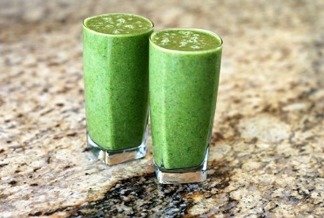
Simple Green Smoothie
Serves 2
Nutrition Information
per serving
Calories 299
Total Fat 4 g
Saturated Fat 2 g
Sodium (mg) 156
Fiber 7 g
Total Sugars 38 g
Protein 13 g
Photo courtesy pixabay.com
Ingredients:
- 1 c kale or spinach
- 1 banana frozen
- 1 c low-fat milk or your choice
- 1 c plain yogurt
- 1 apple (cored and sliced)
- 1 c frozen fruit
- 1 tbsp flaxseed (optional)
- 1 tbsp chia seeds (optional)

Directions:
1. In your blender, blend the kale or spinach with milk
2. Add remaining ingredients and blend
3. If you are making this for one, save the leftover smoothie for the next day
Source: https://www.usda.gov/media/blog/2015/02/23/whats-cooking-usda-mixing-bowl-collection-recipes-schools-and-child-care

Gut Health Smoothie
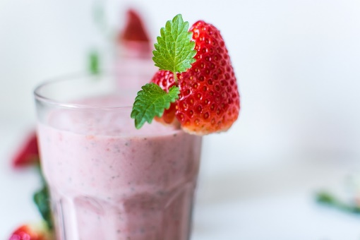
Serves 1
Photo courtesy pixabay.com
Ingredients:
Nutrition Information
Calories 313
Total Fat 8 g
Saturated Fat 1 g
Sodium (mg) 109
Fiber 10 g
Total Sugars 32 g
Protein 12 g
- 1 cup milk of choice
- 1 ¼ tsp ground ginger
- ½ c frozen berries
- 1 frozen banana
- ¼ avocado
- ½ tsp turmeric

Directions:
1. Combine ginger, frozen banana, and berries in a blender
2. Add avocado, milk, and turmeric to the blender
3. Blend until smooth

Blueberry Hill Smoothie
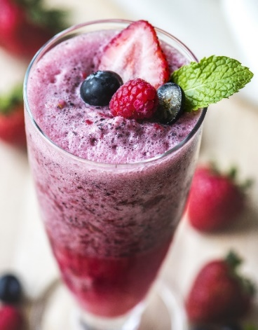
Ingredients:
- 1 ½ c apple juice. (Substitute could be white grape juice or milk)
- ½ medium banana
- 1 ½ c frozen blueberries
- ¾ c vanilla Greek yogurt
- Fresh berries and mint sprigs for garnish (optional)
Photo courtesy of pixabay.com

Directions:
1. Place the apple juice, banana, blueberries, and Greek yogurt in a blender
2. Blend until completely smooth
3. Pour into glasses and serve topped with blueberries and mint if desired
One Serving
Nutrition Information
Calories 541
Total Fat 0 g
Saturated Fat 0.5 g
Sodium (mg) 77
Fiber 12 g
Total Sugars 88 g
Protein 18 g
4. Put on your Fats Domino record and imagine you are back at the malt shop

Green Chia Smoothie or Pudding
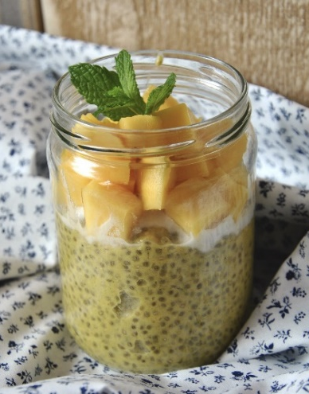
Photo by Lindsay VanKampen
Ingredients:
- 2 c fresh spinach
- 1 ½ c water (for a smoothie) or 1 c water (for pudding)
- 2 tbsp chia seeds
- Fruit of your choice (optional)

Directions:
1. Blend spinach, water, and chia seeds
2. Add fruit of your choice, such as a peeled orange, favorite berries, or bananas
3. Refrigerate for at least 30 minutes
4. Top with additional fruit for your preference
Nutrition Information
per 1 cup serving
Calories 65
Total Fat 4 g
Saturated Fat 0.4 g
Sodium (mg) 33
Fiber 5 g
Total Sugars 0.1
Protein 3 g
Source: https://www.nutritionix.com

Pineapple-Kale Smoothie
Photo by LIndsay VanKampen

Ingredients:
- 1 c brewed and cooled green tea
- 2 c spinach or kale (fresh)
- 1 c frozen or canned pineapple chunks (drained)
- ½ medium banana
- 2 tsp honey
- ½ tsp fresh ground ginger
- ¼ tsp ground turmeric
- 2 mint leaves (for garnish)
- 2 tbsp chia seeds
- Ice cubes (for thicker consistency)

Directions:
1. Combine all ingredients, except chia seeds (this is so they don’t stick to the blades/sides of the container) and blend in a blender
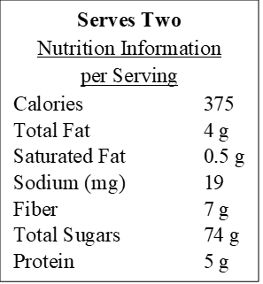
2. If you like your smoothie thicker, add ice cubes and blend until desired consistency
3. Add chia seeds and give a quick stir

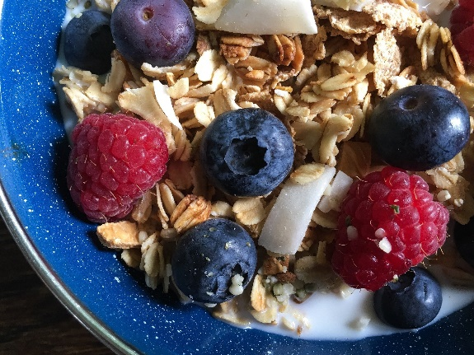
Fiber Starter Breakfast Bowl
Photo courtesy of Pixabay.com
One Serving
Nutrition Information
Calories 425
Total Fat 30 g
Saturated Fat 2 g
Sodium (mg) 347
Fiber 12 g
Total Sugars 6 g
Protein 17 g
Ingredients:
- ½ c berries or chopped apple
- 2 tbsp hemp seeds
- 2 tbsp chia seeds
- 2 tbsp sunflower seeds
- 2 c almond milk or any milk of your choice

Directions:
1. Combine all ingredients into a bowl
2. Let sit for two to three minutes for the seeds to absorb the milk

Source: https://yurielkaim.com/healthy-breakfast-bowl/

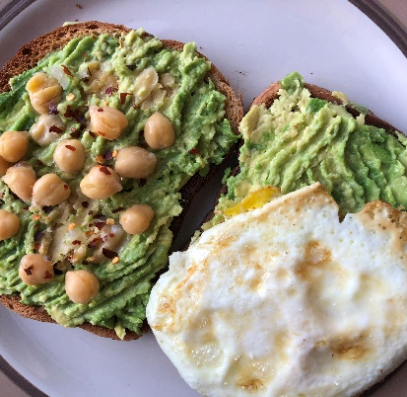
Avocado Toast
One Serving
Nutrition Information
Calories 377
Total Fat 19 g
Saturated Fat 2 g
Sodium (mg) 330
Fiber 17 g
Total Sugars 7 g
Protein 13 g
Photo by Ellie Magnuson
Ingredients:
- ½ medium avocado
- 1 c rinsed and drained garbanzo beans (a great way to boost your protein intake)
- ½ tsp garlic powder
- ¼ tsp crushed red pepper (optional)

Directions:
1. In a bowl, mash the avocado and beans together and add the seasonings to taste
2. Serve on whole-wheat toast or make it a finger food by serving on chopped up pita bread to present at a party
3. Top with scrambled eggs and garnish with veggies if you like
Want a spicier option?
Add chili powder, fresh cilantro, and a splash of hot sauce.

Want more Heart-Healthy Avocado Recipes?
Source: www.LoveOneToday.com/HeartHealth

Eggs, Kale & Sweet Potato Grits
(Serves 2)
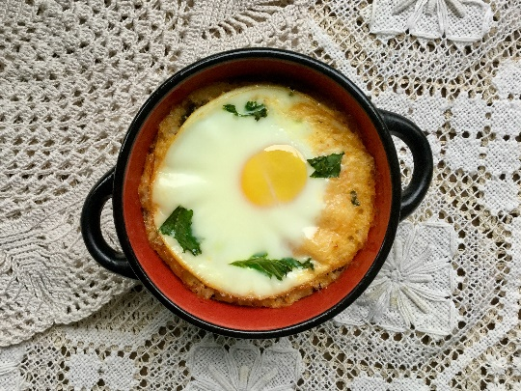
Photo by Lindsay VanKampen
Ingredients:
- 1 large, sweet potato (½ to ¼ cooked & mashed)
- 2 c fresh kale (chopped)
- 1 tsp vegetable oil (divided into two)
- 1 ½ c water
- 1 c milk
- ¾ c grits (quick-cooking)
- $1/3$ c shredded cheddar cheese
- ¼ tsp salt (optional)
- 4 eggs

Directions:
1. Preheat oven to 350˚F
2. Coat 4 soufflé dishes or a small casserole dish with vegetable oil
3. Make 3-4 slits in the sweet potato; cook in microwave until soft (~5-8 minutes)
4. Let sweet potato cool, they peel cut, and purée in a food processor (if you don’t have a food processor, just mash them in a large bowl)
5. Heat remaining vegetable oil in a saucepan, sauté kale just until wilted (5 minutes)
6. In a medium saucepan, boil water and milk, add grits and the sweet potato; cook until grits are soft
7. Divide grits mixture evenly in soufflé dishes (or casserole dish)
8. Make depressions with a large spoon and crack the egg in the depression
9. Bake the eggs uncovered for 30 minutes and wait 10 minutes to cool
Source:http://whatscooking.fnsusda.gov/recipes/myplate-cnpp/eggs-over-kale-and-sweet-potato-grits
One Serving is 2 soufflés
Nutrition Information
Calories 356
Total Fat 18 g
Saturated Fat 7 g
Sodium (mg) 440
Fiber 4 g
Total Sugars 6 g
Protein 19 g

Savory Bread Pudding with Kale and Butternut Squash
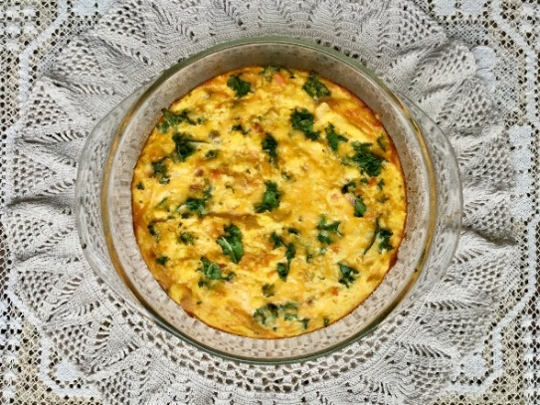
Photo courtesy of Lindsay VanKampen
Ingredients:
- 2 large eggs
- ½ onion
- 1 c low-fat milk
- ¼ c shredded low-sodium mozzarella or cheddar cheese
- 2 c bread (stale or dried)
- 1 ½ c chopped fresh kale
- 1 c frozen or fresh butternut squash
- ½ tsp vegetable oil
- ¼ tsp salt (optional) *omit if on a strict low sodium diet*

Note: If you don’t have stale bread, put fresh bread in a preheated oven at 250 ˚F and bake until dried (15 minutes).

Directions:
1. Preheat the oven to 375 ˚F. Lightly grate a 2-quart baking dish
2. Put a skillet over medium heat and add oil. Add the onion and cook until tender (10 minutes)
3. While the onion is cooking, put eggs and milk in a large bowl and mix until combined
4. Add the cheese, bread, kale, squash, and salt and mix well. Let the mixture stand at least 15 minutes until the bread absorbs most of the milk
5. When the onion has finished cooking, add it to the bread mixture and mix well
6. Pour the mixture into the prepared pan and transfer to the oven
7. Bake uncovered for 30 minutes until lightly browned and set. Let stand 15 minutes before serving
Two Servings
Nutrition Information
Calories 329
Total Fat 12 g
Saturated Fat 4 g
Sodium (mg) 654
Fiber 6 g
Total Sugars 13 g
Protein 19 g

*is 360 mg of sodium if salt is omitted*

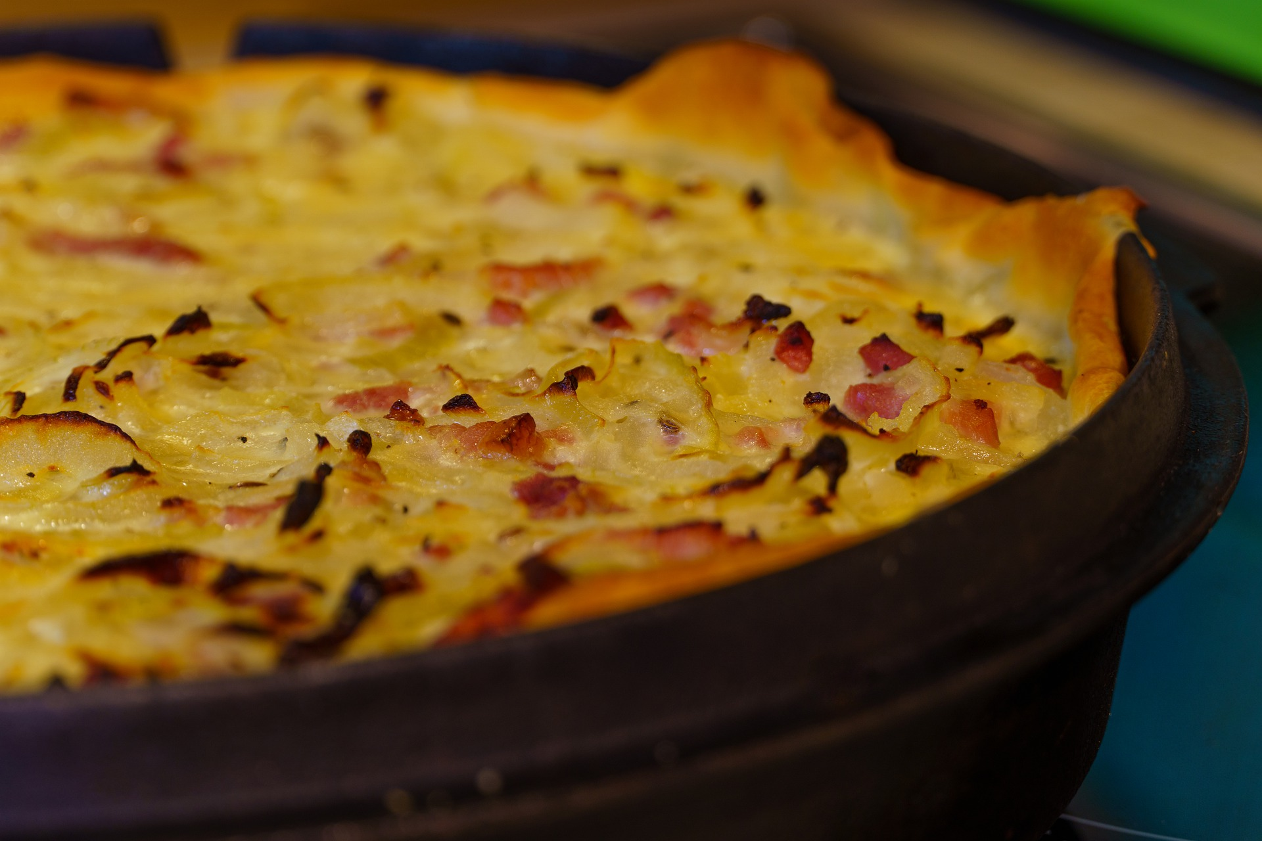
Quick Crustless Quiche
Photo courtesy of Pixabay.com
Serves 2
Ingredients:
Two Servings
Nutrition Information
Calories 329
Total Fat 20 g
Saturated Fat 7 g
Sodium (mg) 349
Fiber 3 g
Total Sugars 4 g
Protein 25 g
- 1 package of frozen spinach or 2-3 c fresh
- ½ onion
- ½ green pepper
- 6 eggs
- 1 ½ c chicken broth
- ¼ c cheddar cheese
- 1 tsp black pepper
- 1 tsp herbs of your choice ~parsley

Directions:
- Cook spinach, onion, and green pepper or any other choice of vegetables in a 9 in cast iron skillet
- In a bowl, whisk together the eggs and add enough broth to thin out the eggs to a pourable, smooth consistency
- Pour into the cast iron skillet with the cooked vegetables and add in the cheese, stir to combine
- Cook at 400℉ for 15 minutes or until the internal temperature reaches 165℉
- Refrigerate or freeze leftovers

Variation: Add meat or tofu if you would like, applewood smoked bacon or sausage is delicious but raises the sodium.

Roasted Squash Breakfast
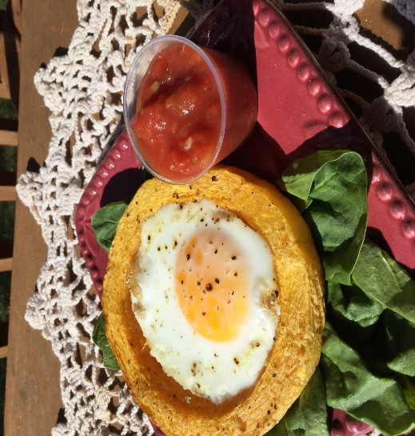
Photo courtesy of Pam VanKampen
Ingredients:
- 1 ½ c butternut squash cut down the side of the squash in $1/3$ in slices
- 2 tbsp extra-virgin olive oil
- ¼ tsp freshly ground black pepper
- ½ tsp salt
- Eggs (1 for each circle squash)
- Shredded cheese (optional)
- Salsa or sriracha sauce
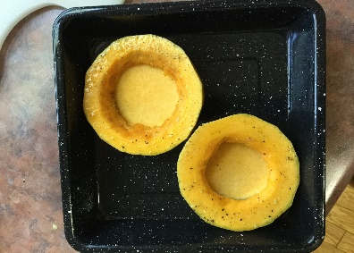
Two Servings
Nutrition Information
Calories 307
Total Fat 22 g
Saturated Fat 7 g
Sodium (mg) 510
Fiber 5 g
Total Sugars 3 g
Protein 10 g
Directions:
1. Preheat oven to 425 ˚F
2. Place olive oil on a plate and coat the squash on both sides and season with black pepper and salt on all sides
3. Bake for 15 to 20 minutes. Remove the pan and allow to cool for 1 to 2 minutes
4. In the same pan, crack an egg into each of the hollow squash centers
5. Put back into the oven 425 ˚F and bake for another 15 minutes
6. Remove and top with cheese and bake until melted
7. Serve hot with salsa or sriracha sauce on a spinach bed, toast, or a plate

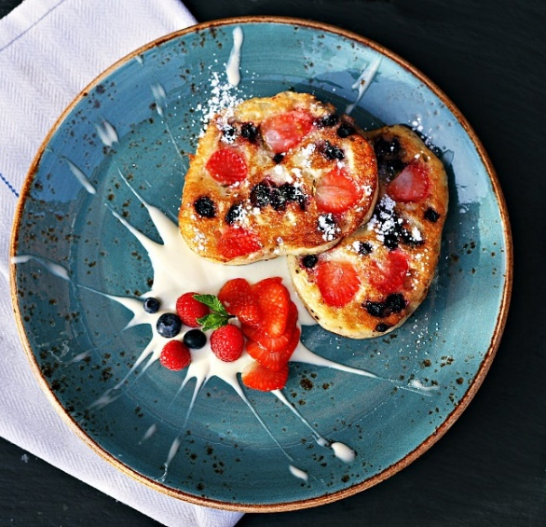
10 Minute Oatmeal Blueberry Pancakes
Photo courtesy pixabay.com
Ingredients:
- ½ c rolled oats
- ½ tsp baking powder
- 1 c of any Greek yogurt
- ½ ripe banana, mashed
- 1 egg
- ½ tsp vanilla
- Dash of cinnamon
- Additional Fruit of your choice (optional)

Directions:
- In a medium bowl, mix all ingredients except the optional fruit
- Prepare your skillet with non-stick spray or a little oil and heat over medium heat
- Pour the batter onto the skillet and add fruit into the pancake if desired
- Flip when bubbles appear, and the edges look crispy
- Enjoy with additional fruit on top

One Serving
Nutrition Information
Calories 428
Total Fat 8 g
Saturated Fat 2 g
Sodium (mg) 389
Fiber 6 g
Total Sugars 16 g
Protein 36 g

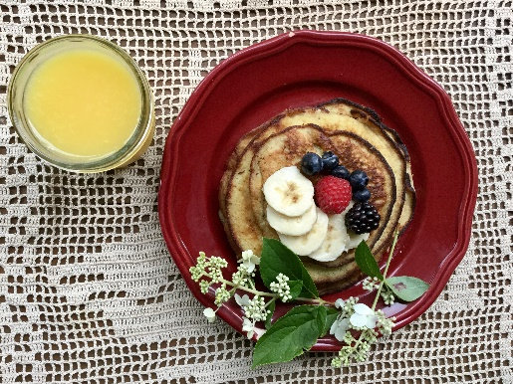
Peanut Butter Pancakes
One Serving
Nutrition Information
Calories 281
Total Fat 10 g
Saturated Fat 0 g
Sodium (mg) 0
Fiber 4 g
Cholesterol (mg) 338
Protein 19 g
Photo courtesy from Lindsay VanKampen
Ingredients:
- 1 medium banana
- 2 eggs, large
- ¼ tsp vanilla
- ½ tsp cinnamon
- 2 tbsp flour of your choice (I recommend oat flour)
Directions:
- Spray pan with nonstick cooking spray and turn on to low/medium heat
- Smash banana until smooth then add 2 eggs and the vanilla
- After those are mixed, add the flour and combine the cinnamon until the batter is smooth
- Add 2 tbsp of batter onto the heated pan and flip when the pancakes start to bubble on the one side
- Cook a short time on the other side until golden brown

Lunch
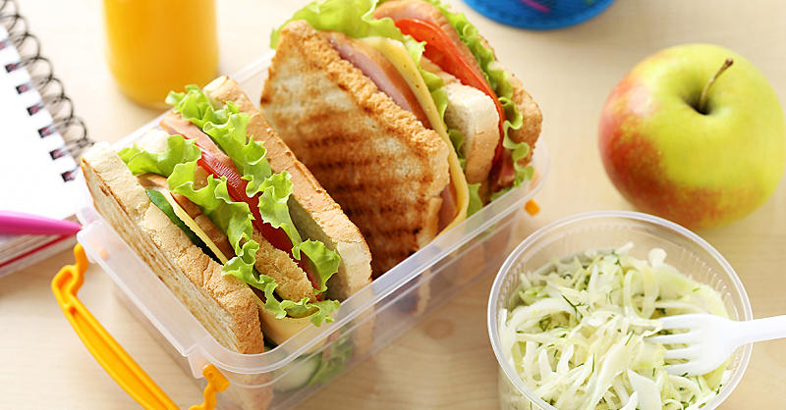
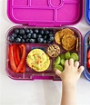
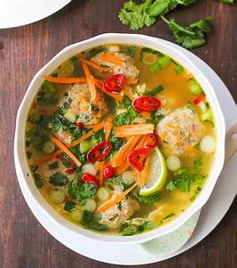

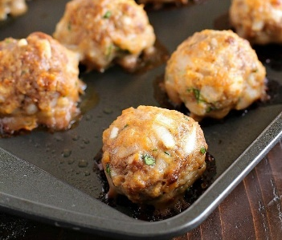
Baked Meatballs

Photo courtesy pixabay.com
Ingredients:
- 1 lb. lean ground beef
- ½ c onion, finely chopped
- ½ c breadcrumbs
- 1 clove garlic, minced
- 1 egg, beaten
- 3 tbsp ketchup
- 1 tbsp Worcestershire
- 1 tsp salt (optional)
- 1 tsp pepper
- ½ tbsp dried parsley

Directions:
- Preheat the oven to 450℉ and spray a large sheet with cooking spray
- Mix the onion, breadcrumbs, garlic, egg, ketchup, Worcestershire, pepper, salt, and parsley in a large mixing bowl
- Add in ground beef and mix gently until combined. Form into 1-inch balls and then place them on the sprayed sheet
- Bake in the oven for 15-20 min until the meatballs are brown and cooked through
- Enjoy with a salad, mix it in with spaghetti, or even on a sandwich

Variations: Add shredded carrots, diced green pepper, shredded cheese, etc. Get creative and remember to pack in the flavor and nutrients with these add-ins.
Serving is 3 meatballs
Nutrition Information
Calories 284
Total Fat 14 g
Saturated Fat 5 g
Sodium (mg) 322
Fiber 1 g
Total Sugars 5 g
Cholesterol (mg) 110
Protein 25 g

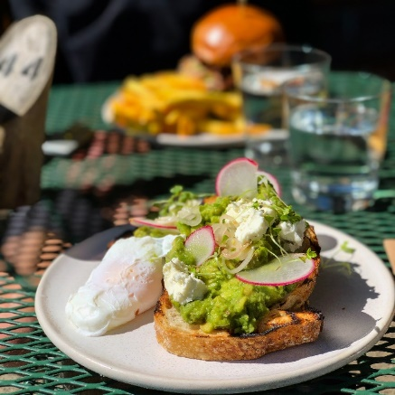
Avocado & White Bean Sandwich
Photo courtesy of Pixabay.com
Ingredients:
- 1 ripe avocado
- 8 oz white beans (recommend cannellini beans) rinsed and drained
- 1 tbsp lemon juice
- ½ tbsp extra virgin olive oil
- ½ garlic clove, minced
- $1/8$ tsp thyme
- $1/8$ tsp ground pepper
- 4 slices of whole wheat bread, toasted
- ½ c chopped jarred roasted red peppers, rinsed (optional)
- 4 thin slices of sharp cheddar cheese (optional)
- 2 c lettuce or greens of your choice

Directions:
- In a medium bowl, mash avocados, beans, lemon juice, oil, garlic, thyme, and pepper until mixed
- Place cheese on the bread then the peppers, ½ c avocado mix, and lettuce on the very top of the sandwich

One Serving is one toast
Nutrition Information
Calories 567
Total Fat 13 g
Saturated Fat 3 g
Sodium (mg) 456
Fiber 7 g
Total Sugars 8 g
Protein 22 g

Citrus Rice Pilaf

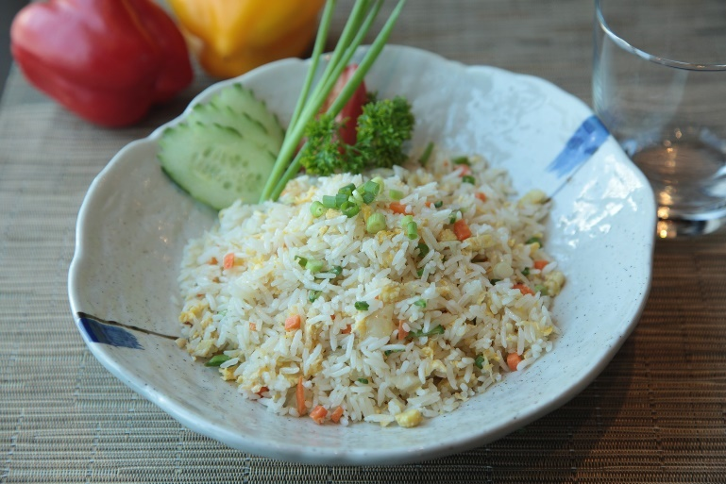
Ingredients:
- 1 Package (6 oz) rice pilaf mix
- 1 tbsp vegetable oil
- ½ c orange juice
- 1 c halved pitted dried plums
- ½ c sliced green onions
- ½ c sliced radishes or other vegetables
- 1 tbsp vinegar of your choice
- ½ -1 tsp finely grated orange peel
- Dash hot pepper sauce (optional)
- Orange slices (optional)
- Lettuce (if serving cold as a salad)

Directions:
- Prepare rice mix according to package directions, substituting 1 tbsp vegetable oil for the butter and ½ c orange juice for ½ c of the water
- Remove from heat when completed
- Stir in dried plums and cool to room temperature
- Mix in remaining ingredients except for lettuce
- You can serve this hot as a side dish or let it cool and serve over lettuce as a salad with a light citrus dressing
- Garnish with orange, lemon, or lime slices if you wish!

Source: https://www.californiadriedplums.org/recipes/citrus-rice-pilaf-salad
One Serving
Nutrition Information
Calories 575
Total Fat 8 g
Saturated Fat 1 g
Sodium (mg) 981
Fiber 9 g
Total Sugars 40 g
Protein 8 g

Black Bean and Rice
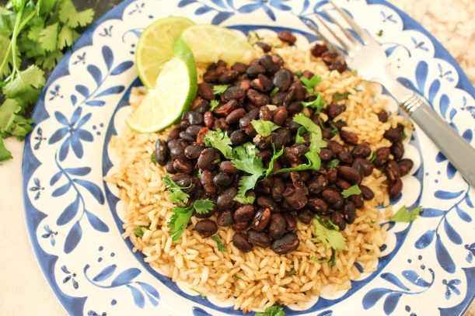

Photo by Rachel Robinson
Ingredients:
- ½ c brown rice
- ½ c water
- 1 can no-salt black beans (~12 oz)
- 1 tsp cumin
- 1 fresh lime or lime juice to taste
- 2 tsp cilantro (optional)

Directions:
- Add the dry rice to a medium-sized pot. Add the water to the pot of rice and bring to a boil
- Reduce the heat to low and allow it to simmer until the water is absorbed and the rice is soft and remove the rice from heat
- Drain and rinse the canned black beans
- Cook the beans in a small pot for 5-10 minutes on medium heat
- Add the cumin to the rice and stir
- Serve the black beans over the rice and squeeze the lime juice over the meal with the cilantro to top it off

Rice and beans build and maintain strong bones! This recipe is accommodating to those who have osteoporosis or who are at risk. Truly you are going to benefit from the protein and fiber provided from the rice and beans.
(Serves 2)
One Serving
Nutrition Information
Calories 402
Total Fat 2 g
Saturated Fat 0.5 g
Sodium (mg) 6
Fiber 16 g
Total Sugars 2 g
Cholesterol (mg) 0
Protein 18 g

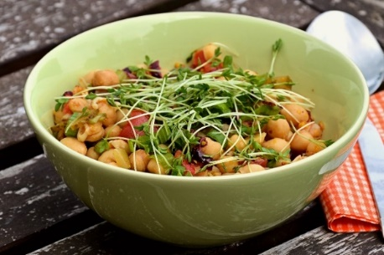
Dill-licious Chickpea Salad
Serves 2
Nutrition Information
Calories 376
Total Fat 7 g
Saturated Fat 0.8 g
Sodium (mg) 131
Fiber 16 g
Total Sugars 18 g
Cholesterol (mg) 2
Protein 19 g
Photo courtesy of Pixabay.com
Ingredients:
- Can of chickpeas, rinsed (~15 oz)
- Add chopped dill pickles or dill relish
- 1 tbsp mayo
- 1 tbsp finely chopped red onion
- 1 tsp mustard
- ¼ tsp turmeric
- 2 tsp of dried or fresh dill

Directions:
- Mash the chickpeas
- Combine all the ingredients and mix

Variations: Wraps or sandwiches or even using as a dip

Source: Jayme Bisbano, RD, LD

Beet Detox Salad
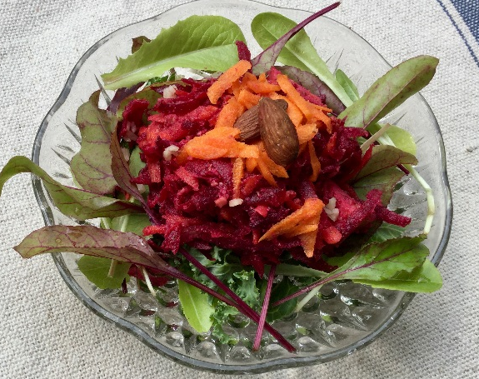
Photo by Lindsay VanKampen
Ingredients:
- 1 large beet, coarsely grated
- 1 large carrot, coarsely grated
- 1 large apple diced
- 2 tbsp flax seeds
- 2 tbsp almonds, chopped
- 2 tbsp fresh lemon juice
- 4 c mixed greens
- 2 garlic cloves, minced (optional)
- ¼ tsp sea salt (optional)

Directions:
- Toss all ingredients, except for the mixed greens, together in a large bowl
- Mix in remaining ingredients and mix this together up to 2 days in advance
- Garnish with apples or almonds when serving!

Source: http://www.prevention.com/food/healthy-recipes/meals-that-soothe-inflammation/slide/4

Serves 2
Nutrition Information
Calories 349
Total Fat 8 g
Saturated Fat 0.8 g
Sodium (mg) 176
Fiber 15 g
Total Sugars 36 g
Cholesterol (mg) 0
Protein 10 g

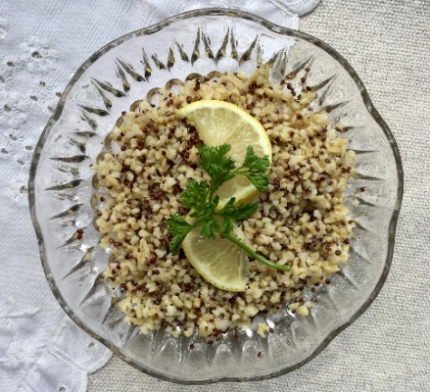
Herbed Quinoa
Photo by Lindsay VanKampen
Ingredients:
Quinoa:
- 2 ¾ c low-sodium chicken or veggie stock
- ½ c fresh lemon juice
- 1 ½ c quinoa (dry)
Dressing:
- ½ c extra-virgin olive oil
- ¼ c fresh lemon juice
- ¾ c chopped fresh basil leaves
- ¼ c chopped fresh parsley leaves
- 1 tbsp chopped fresh thyme leaves
- 2 tbsp lemon zest
- Kosher salt and freshly ground black pepper to taste
*1 cup of cooked quinoa has 5.2 g of fiber
Directions:
- Add the stock, lemon juice, and quinoa to a medium-sized saucepan
- Bring to a boil
- Reduce heat to a simmer and cover the pan Cook for about 12 to 15 minutes until the liquid is absorbed
- Begin the dressing while the quinoa simmers
- Mix olive oil, lemon juice, basil, parsley, thyme, and lemon zest together and add salt and pepper to taste
- Pour the dressing over the quinoa and toss the ingredients
- Can be served hot or chilled

Source: http://www.foodnetwork.com/recipes/giada-de-laurentiis/herbed-quinoa-recipe-2012212

Serves 6
Nutrition Information
Calories 500
Total Fat 25 g
Saturated Fat 4 g
Sodium (mg) 82
Fiber 3 g
Total Sugars 3 g
Cholesterol (mg) 87
Protein 38 g

Quinoa with Root Vegetables
Photo courtesy of Pixabay.com
Ingredients:
- 1 c carrot, chopped
- 2 c butternut squash, ½ inch cubes
- 1 c red onion, large dice
- 1 c yellow squash
- 2 tbsp dried thyme
- 1 tbsp oil
- 1 tbsp coriander and orange zest
- ½ c currants
- $1/{3 }$c vegetable broth
- 1 c quinoa
- 1 ½ c water
- $1/{3 }$c flat-leaf parsley

Directions:
- Combine the first 8 ingredients in a large bowl and stir vegetables until they are well coated
- Place broth in a large casserole bowl, the spread veggies along the bottom
- Meanwhile, bring water, quinoa to a boil in a medium saucepan and simmer for about 25 minutes
- Fluff quinoa with a fork and place in a large bowl
- When veggies are done, add to the bowl and stir in with quinoa
- Season more if needed and toss in parsley
Serves 2
Nutrition Information
Calories 364
Total Fat 9 g
Saturated Fat 1 g
Sodium (mg) 115
Fiber 16 g
Total Sugars 16 g
Cholesterol (mg) 0
Protein 9 g

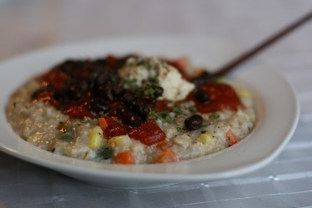
Loaded Lunchtime Oatmeal
Photo courtesy of Angela Liddon

Ingredients:
- ½ c Old Fashioned Oats ®
- 1 ¾ c water
- ½ c frozen veggies
- Dash of fresh ground black pepper
- Pinch of sea salt
- ¼ tsp freshly minced garlic
One Serving
Nutrition Information
Calories 567
Total Fat 13 g
Saturated Fat 3 g
Sodium (mg) 456
Fiber 7 g
Total Sugars 8 g
Protein 22 g
Toppings: (As desired per your preferences)
Some options are black beans, ½ tsp. parsley flakes, sundried tomato, herb seasoning, spaghetti sauce, and hummus

Directions:
- Put oats and water into a pot on medium heat, stirring frequently for 5 minutes
- Add frozen veggies, black pepper, sea salt, and garlic to the pot
- Cook 7-8 minutes on low-medium heat, constantly stirring
- Put into a bowl and add toppings before serving Source: http://ohsheglows.com/2009/12/10/loaded-lunchtime-oatmeal/

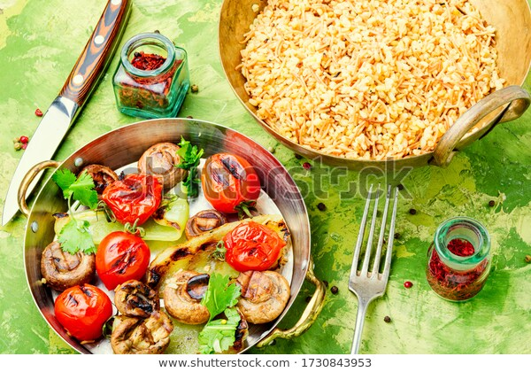
Three Pepper Oat Pilaf
Photo courtesy of Pixabay.com
Ingredients:
- ½ c red bell pepper
- ½ c yellow bell pepper
- ½ c mushrooms
- ½ c green onions (this could be less based on preference)
- 2 garlic cloves, minced
- 1 ¾ c Old Fashioned Oats ®, uncooked
- ¾ c chicken broth
- ½ tsp salt
- 1 tsp olive oil
- 2 egg whites or 1 egg lightly beaten
- 2 tsp dried basil
- ½ tsp black pepper

Directions:
- In a 10-inch nonstick skillet cook the peppers, mushrooms, green onions, and garlic in the oil over medium heat
- In a large bowl mix oats and eggs until oats are evenly coated then add to skillet and stir occasionally for 5-6 minutes
- Add broth, basil, salt, and pepper
- Continue cooking until the liquid is absorbed
- Serve immediately

Papaya Black Beans and Rice
Two Servings
Nutrition Information
Calories 340
Total Fat 10 g
Saturated Fat 2 g
Sodium (mg) 750
Fiber 8 g
Total Sugars 5 g
Cholesterol (mg) 82
Protein 15 g

Photo by Pam VanKampen

Ingredients:
- 1 tsp olive oil
- ½ c chopped red onion
- ¼ c fresh orange juice
- $1/8$ c fresh lemon juice
- 1 tbsp fresh chopped cilantro (optional)
- ¼ tsp cayenne or black pepper
- ½ c finely chopped red bell pepper
- ½ c finely chopped green bell pepper
- 1 medium papaya, peeled, seeded, and diced or ½ c frozen
- 1 garlic clove
- 1 15-oz can black beans, rinsed & drained
- 3 c cooked brown rice

Directions:
- Heat oil in a large skillet over medium heat
- Add all ingredients to skillet except beans and rice
- Cook for 5 minutes, stirring occasionally until bell peppers are crisp-tender
- Stir in beans
- Cook about 5 minutes or until heated through
- Serve over rice

Source: pbhfoundation.org
Serves 4
Nutrition Information
Calories 411
Total Fat 3 g
Saturated Fat 1 g
Sodium (mg) 425
Fiber 16 g
Total Sugars 11 g
Cholesterol (mg) 0
Protein 14 g

Simple Tomato Basil Soup
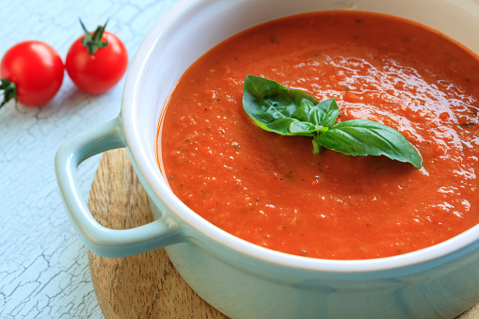
Photo courtesy of Pixabay.com
Ingredients:
Two Servings
Nutrition Information
Calories 427
Total Fat 8 g
Saturated Fat 5 g
Sodium (mg) 1489
Fiber 7 g
Total Sugars 50 g
Protein 18 g
- 2 cans condensed tomato soup
- 3 medium tomatoes
- 2 garlic cloves
- 6 fresh basil leaves
- 3 c milk of your choice
- Parmesan cheese (optional)
Note: Reduce the sodium with low sodium soup
Directions:
- Combine tomatoes, garlic, and fresh basil in a food processor until desired consistency
- In a large pot, combine tomato soup and milk
- Add the mixture from the food processor and heat on medium-low stirring

Gazpacho

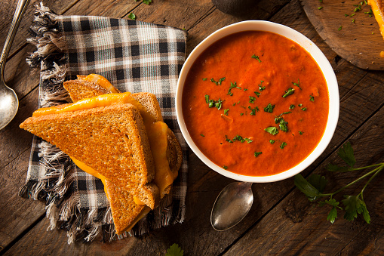
Photo courtesy Pixabay.com
Ingredients:
- 8 large tomatoes, peeled
- 1 large cucumber, peeled, seeded, and finely diced
- 1 large green bell pepper, finely chopped
- 1 medium-sized red onion, minced
- 3 tbsp red wine vinegar
- 1 tbsp olive oil
- 3 tbsp lemon juice
- 2 ½ tbsp chopped fresh parsley or 2 tsp dried basil
- Salt and pepper to taste
- Hot pepper sauce to taste

Directions:
- Core the tomatoes and gently squeeze out the seeds
- Coarsely chop half in a food processor
- Combine the puree and chopped tomatoes in a large mixing bowl
- Add the remaining ingredients
- Normally is served cold, but serve hot if desired
- Garnish with croutons or even fresh herbs
One Serving
Nutrition Information
Calories 513
Total Fat 17 g
Saturated Fat 2 g
Sodium (mg) 419
Fiber 24 g
Total Sugars 51 g
Cholesterol (mg) 0
Protein 17 g

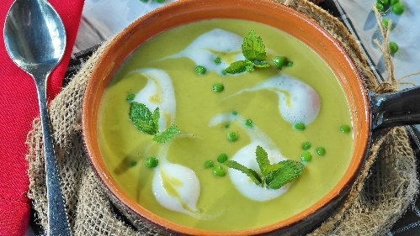
Split Pea Soup
Photo courtesy of pixabay.com
Two Servings
Nutrition Information
Calories 308
Total Fat 2 g
Saturated Fat 1 g
Sodium (mg) 1060
Fiber 25 g
Total Sugars 9 g
Cholesterol (mg) 0
Protein 18 g
Ingredients:
- 2 c dried split green peas
- ½ tsp celery seed
- 1 tbsp dried chopped onions
- 1 tbsp dried minced garlic
- 1 bay leaf
- 1 chicken bouillon cube

Directions:
- Layer all ingredients in a mason jar and seal to store
- When ready to prepare, place all ingredients into four cups of water in a saucepan
- Bring to a boil over high heat and reduce to low after
- Simmer the peas until tender ~30 minutes
- Remove and discard the bay leaf

This is a great shelf-stable emergency meal!

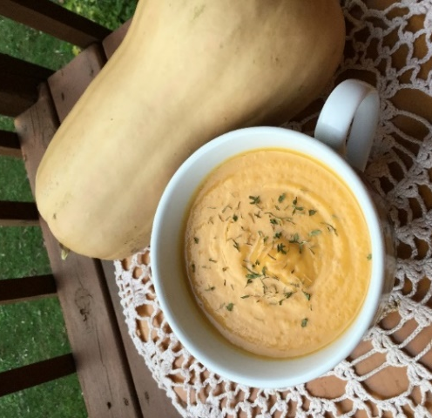
Butternut Squash Soup
Photo by Pam VanKampen
Ingredients:
- 1 small butternut squash (cut in half)
- 1 apple, peeled and cut into cubes
- 1 small yellow onion, diced
- 1 tbsp olive oil
- ¼ tsp salt
- ½ c low-sodium vegetable broth
- ½ c low-fat milk
- Seasonings of your choice

Directions:
- Preheat oven to 400°F
- Place the butternut squash and apple pieces on a baking sheet and roast in the oven
- Remove the apple pieces after 20 minutes, or when soft
- While the squash continues cooking, sauté diced onions, olive oil, and salt in a pan over medium-low heat. Stir occasionally; cook until onions are soft, about 5 minutes.
- Remove the squash after it has cooked, 40 minutes in total, or when soft
- Carefully cut the squash in half or quarters; set aside to cool for about 10 minutes
- Add cooked onions and vegetable broth to a blender, and puree until smooth
- Scoop out the flesh of the butternut squash and discard the skin
One Serving
Nutrition Information
Calories 510
Total Fat 15 g
Saturated Fat 2 g
Sodium (mg) 735
Fiber 22 g
Total Sugars 40 g
Cholesterol (mg) 2
Protein 10 g
- Add cooked squash and apple to blender and puree
- Slowly add milk while pureeing until smooth. Serves 4.

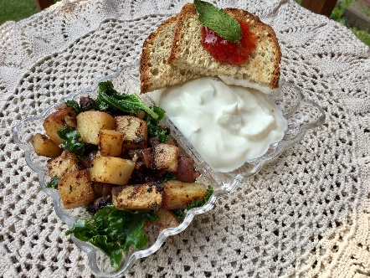
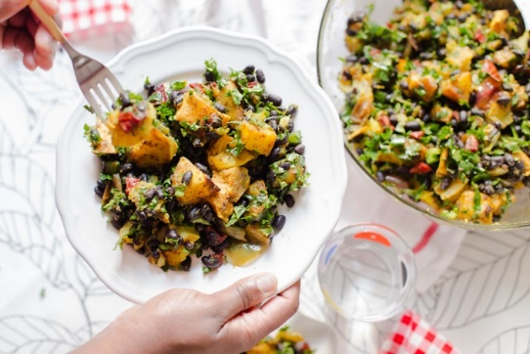
Potato, Black Bean & Kale Skillet
Photo courtesy elsbro.com and Lindsay VanKampen
Ingredients:
- 4 red potatoes, diced into ¼” pieces
- 2 ½ c kale, chopped
- 2 tbsp olive oil
- 1 clove garlic, minced
- ¼ c chopped onion
- 1 tsp chili powder or jerk seasoning
- $1/8$ c water
- ¼ tsp salt or salt-free seasoning
- $1/8$ tsp cayenne pepper
- 1 can 15 oz no added salt black beans, drained and rinsed
- ½ c nonfat plain Greek yogurt (optional)

Directions:
- In a skillet over medium heat, add garlic and onions to the oil and cook until the onions start to brown
- Add diced potatoes, chili powder, water salt, and pepper to skillet and cover lid and cook 8-10 minutes stirring occasionally
- Add chopped kale and black beans and cook about 3-5 more minutes stirring gently
- Serve with Greek yogurt for a creamy bite
Two Servings
Nutrition Information
Calories 525
Total Fat 16 g
Saturated Fat 2 g
Sodium (mg) 133
Fiber 13 g
Total Sugars 13 g
Cholesterol (mg) 3
Protein 20 g

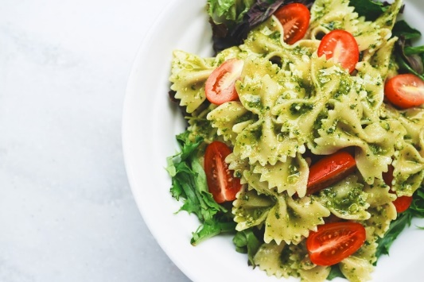
Garden Pasta Salad
Photo courtesy Pixabay.com-pexels
Ingredients:
- 1 box bow tie pasta (15 oz)
- ¾ c red wine vinegar
- ¾ c olive oil
- 1 tsp fresh basil
- 1 c fresh arugula
- 1 c fresh grape tomatoes
- 1 small red onion
- 1 green pepper

Directions:
- Bring water to a boil and cook pasta according to box directions
- Chop red onion and green bell pepper, mixing in a large bowl, then sauté with fresh basil
- Add fresh grape tomatoes and sliced black olives to the bowl after the onion and green bell pepper have been sautéed
- Once pasta is cooked to preference, drain, and add to the bowl
- Let mixture cool in the fridge
- In a separate bowl, mix vinegar and oil until combined
- Once pasta is cold, pour the dressing mix into the bowl and thoroughly mix until everything is evenly coated
- Place a bed of arugula on a plate and top with the pasta salad
- Garnish with more fresh basil if desired
Serves 7
Nutrition Information
Calories 452
Total Fat 24 g
Saturated Fat 3 g
Sodium (mg) 5
Fiber 3 g
Total Sugars 4 g
Cholesterol (mg) 0
Protein 8 g

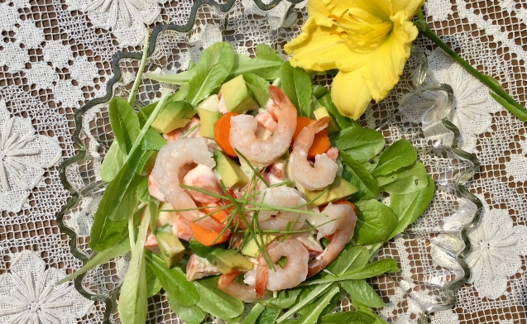
Avocado and Shrimp Salad

Photo courtesy from Lindsay VanKampen
Ingredients:
- 2 tbsp plain Greek yogurt
- 2 tsp canola oil
- 3 tsp lime juice
- ¼ tsp ground black pepper
- 1 small apple, cored and finely diced
- 1 ½ c finely chopped celery
- ¼ c chopped scallions
- ½ c chopped cilantro (optional)
- 1 lb large cooked, peeled, shrimp
- 1 avocado
- 1 c lettuce

Directions:
- Combine the yogurt, oil, lime juice, salt, and pepper in a large bowl
- Core the apple and finely dice it and finely chop the celery, cilantro, and scallions and add to the bowl
- Cook the shrimp (remove and discard the shrimp tails) and add it to the bowl
- Stir all the ingredients in the bowl
- Dice the avocado and add it to the bowl, stirring gently
- Serve and enjoy on a bed of lettuce!

Source: https://recipes.heart.org/recipes/2009/avocado-and-shrimp-salad
Serves 3
Nutrition Information
Calories 422
Total Fat 16 g
Saturated Fat 3 g
Sodium (mg) 1903
Fiber 7 g
Total Sugars 9 g
Cholesterol (mg) 406
Protein 47 g

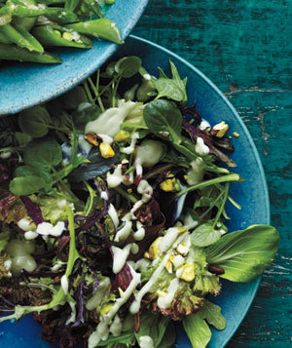
Spring Lettuce with Avocado Dressing and Pistachios
Photo courtesy from Anna Williams
Ingredients:
- ¼ avocado
- ½ c buttermilk
- 2 tsp red wine vinegar
- Pepper to taste
- 6 c mixed spring lettuce (red leaf, watercress, baby bok choy)
- $1/3$ c shelled, roasted pistachios
Directions:
- In a food processor, combine avocados, buttermilk, vinegar, and pepper until smooth
- Prepare the lettuces on a plate
- Drizzle dressing over lettuce and garnish with pistachios

Source: https://www.realsimple.com/food-recipes/browse-all-recipes/spring-lettuces-avocado-dressing

I would recommend making this recipe with your kids! It’s very easy and allows them to be more comfortable in the kitchen.
One serving
Nutrition Information
Calories 412
Total Fat 28 g
Saturated Fat 5 g
Sodium (mg) 377
Fiber 10 g
Total Sugars 10 g
Cholesterol (mg) 9.8
Protein 16 g

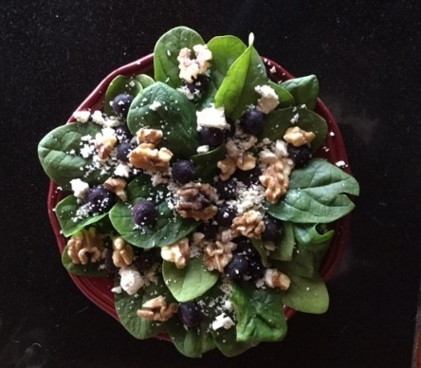
Easy MIND Healthy Salad
Serves 1-2
Nutrition Information
Calories 186
Total Fat 14 g
Saturated Fat 3 g
Sodium (mg) 300
Fiber 3 g
Total Sugars 4 g
Cholesterol (mg) 13
Protein 7 g
Photo courtesy from Pam VanKampen
Ingredients:
- 1 c dark leafy greens (baby spinach, baby kale, romaine, green salad mixes)
- $1/8$ c blueberries, or other berries, fresh
- 2 tbsp walnuts, or other nuts
- 1 tbsp red wine vinaigrette dressing
- 1 tbsp feta cheese (optional)
Directions:
- Fill a bowl or plate with a big pile of greens. Top with blueberries and walnuts (you can also add tuna, leftover chicken, reduced-fat feta or goat cheese, and other veggies as you like).
- Drizzle with salad dressing and enjoy!

Source: https://www.fivehearthome.com/brain-healthy-salad-recipe/

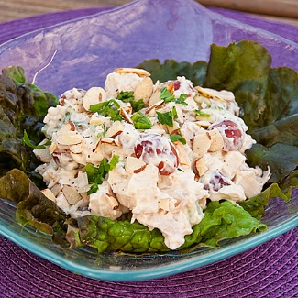
Yogurt Dill Chicken Salad
Serves 3-4
Nutrition Information
Calories 445
Total Fat 19 g
Saturated Fat 3 g
Sodium (mg) 1189
Fiber 2 g
Total Sugars 6 g
Cholesterol (mg) 133
Protein 53 g
Ingredients:
- 3 c cooked chicken, diced
- $2/3$ c Greek yogurt (plain or vanilla)
- ¼ c mayonnaise
- 2 large shallots, minced
- ½ c finely chopped fresh dill
- Salt and pepper to taste
Directions:
- Whisk together the yogurt and mayonnaise and toss with the chicken.
- Mix in the shallots and dill. Season with salt and pepper to taste. You can also add grapes, celery, nuts, or seeds to boost the nutrients.
- Refrigerate for at least an hour to let the flavors combine. The chicken salad will keep up to 3 days in the refrigerator.
- Serve on a bed of greens or make a sandwich, put in a tomato or avocado. Get creative!
Source: https://www.thekitchn.com/recipe-yogurt-and-dill-chicken-salad-lunch-recipes-from-the-kitchn-28363

Mayo-free Avocado Tuna Salad
Serves 2
Nutrition Information
Calories 331
Total Fat 17 g
Saturated Fat 3 g
Sodium (mg) 517
Fiber 9 g
Total Sugars 5 g
Cholesterol (mg) 19
Protein 21 g
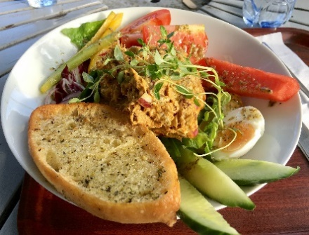
Photo courtesy from Pixabay.com
Ingredients:
- Bread of your choice for toasting
- 5 oz can of tuna
- 2 tbsp Dijon mustard
- 2 tbsp onion, chopped
- $1/{3 }$c celery, finely chopped
- ¼ of an apple, finely chopped
- 1 ripe, fresh avocado, peeled, pitted, and cubed.
- 1 tbsp fresh lemon juice
- Black pepper to taste
Directions:
- In a large mixing bowl, combine the tuna, Dijon mustard, onion, celery, and apples
- Add in lemon juice and black pepper
- Using a spatula, fold in the avocado cubes
- Spoon the tuna salad gently over toast or a bed of lettuce
Source: www.LoveOneToday.com

Garden Fresh Sandwich
One serving
Nutrition Information
Calories 286
Total Fat 10 g
Saturated Fat 4 g
Sodium (mg) 610
Fiber 6 g
Total Sugars 5 g
Cholesterol (mg) 19
Protein 15 g
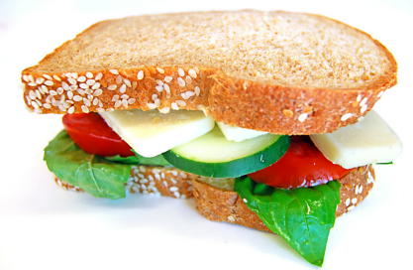
Photo courtesy from Pixabay.com
Ingredients:
- 2 slices whole-wheat bread
- 2 teaspoons Dijon mustard
- 1 slice of cheddar or swiss cheese
- 2 slices tomato
- 4 slices cucumber
- Leafy green lettuce

Directions:
- Spread one side of each piece of bread with mustard
- Lay ingredients on one slice of bread and top with the other slice

Note: Apps and websites are a great way to find fantastic recipes
Source: https://www.choosemyplate.gov/myplatekitchen

Peanut, Peach, and Pineapple Wrap
Photo courtesy from Pixabay.com
Ingredients:
- 1 can sliced peaches (15 oz), drained
- 1 can pineapple tidbits, in juice, drained
- ½ c red or green bell peppers (sliced or chopped)
- 1 tsp cinnamon
- 4 whole wheat tortilla
- ½ c chunky peanut butter
- 3 c lettuce

Directions:
- In a medium bowl, combine peaches, pineapple, bell pepper, and cinnamon
- Warm the tortillas a few seconds in the microwave or skillet
- Spread 2 Tablespoons of peanut butter on one side of each tortilla, leaving room along the edges
- Spoon equal amounts of the peach mixture over peanut butter, then top with lettuce.
- Fold the sides and bottom edges of each tortilla toward the middle over the filling, then roll so the tortilla covers the filing.

Source: USDA Mixing Bowl
Serves 4
Nutrition Information
Calories 419
Total Fat 19 g
Saturated Fat 3 g
Sodium (mg) 411
Fiber 10 g
Total Sugars 23 g
Cholesterol (mg) 0
Protein 14 g

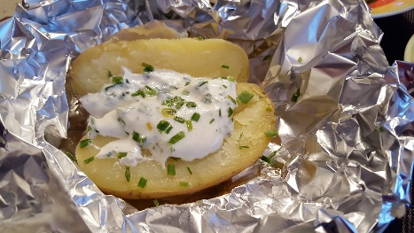
“Hobo” Wrap
Photo courtesy from Pixabay.com
Ingredients:
- 1/2 lb. lean ground beef
- 2 medium potatoes
- 1 small onion, peeled and sliced
- 2 medium carrots, peeled and sliced
- Dash of salt and pepper or salt-free seasoning of your choice
- 1 tsp garlic powder

Directions:
- Layout 2 sheets of tin foil
- Slice onion into thin slices
- Shape the ground beef into two hamburger patties
- Layer the patties on top of the onions
- Place the sliced potatoes on top of the burger and onion
- Slice the carrots and layer them next
- Add desired seasonings and oil if desired
- Fold and seal the pouches of tin foil
- Bake at 350 degrees for 20 to 30 minutes
- Top with sour cream if you like

Tip: Try making this recipe with any vegetables you may have laying around!
Source: Rada Cutlery Blog
Serves 2
Nutrition Information
Calories 466
Total Fat 16 g
Saturated Fat 4 g
Sodium (mg) 260
Fiber 8 g
Total Sugars 15 g
Cholesterol (mg) 99
Protein 34 g

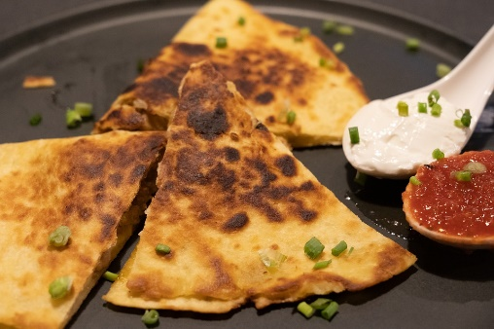
Black Bean Quesadillas
Photo courtesy from Pixabay.com- Chris Tweten
Ingredients:
- ½ teaspoon extra virgin olive oil
- ¼ c fresh tomato, diced
- ¼ c green bell pepper, diced
- ¼ c onion, diced
- ½ c low-sodium black beans drained and rinsed
- ½ c shredded reduced-fat Colby & Monterey Jack cheese
- 2 8-inch whole-grain tortillas
- Optional: serve each quesadilla with 1 tablespoon of salsa
Directions:
- Dice tomato, pepper, and onion, and place into a medium bowl
- Mix in black beans and cheese
- Divide the mixture evenly over half of each tortilla (about ½ cup each)
- Fold tortillas in half, brush with oil, and place them on a griddle or pan over medium-high heat
- Flip the tortillas when they are browned and crisp, about 5 minutes per side
- Cut the tortillas into wedges and serve with salsa, if desired

Source: www.choosemyplate.gov
Recipe makes
Nutrition Information
Calories 609
Total Fat 27 g
Saturated Fat 13 g
Sodium (mg) 1168
Fiber 10 g
Total Sugars 5 g
Cholesterol (mg) 60
Protein 28 g

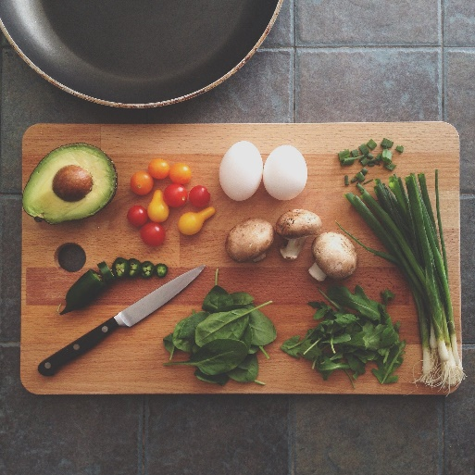
Dinner
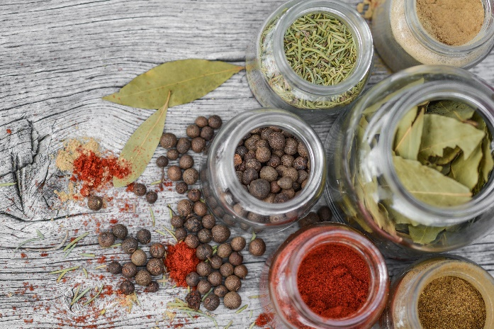
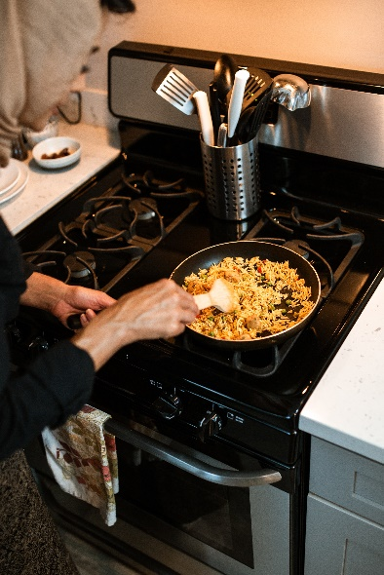

Stuffed Peppers
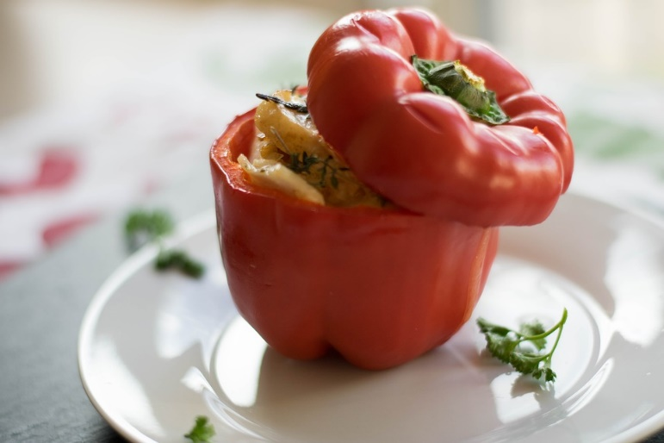
Photo courtesy of Pixabay.com
Ingredients:
- 4 large bell peppers
- 15 oz can tomato sauce
- ½ lb. ground chicken or turkey
- $1/3$ c chopped onion
- 1 c cooked brown rice
- $1/8$ tsp salt
- $1/8$ tsp black pepper
- $1/8$ tsp garlic powder

Directions:
- Cut the tops off the peppers and remove the seeds. Place the peppers in a large saucepan and cover with water. Bring to a simmer and cook for 3 minutes, just until the peppers are slightly soft. Drain and rinse with cool water. Set aside on paper towels to drain.
- In a skillet, heat the ground protein and onion until cooked. Drain.
- Add the salt, pepper, rice, garlic powder, and half of the tomato sauce.
- Stir well and spoon mixture into the peppers.
- Top with the other half of the tomato sauce.
- Bake in an ungreased dish at 350 for 25-30 minutes. Serve warm.

Recipe from: Rachel Ballard
Serves 2
Nutrition Information
Calories 513
Total Fat 9 g
Saturated Fat 2 g
Sodium (mg) 1270
Fiber 12 g
Total Sugars 22 g
Cholesterol (mg) 120
Protein 52 g

Cranberry Orange Chicken
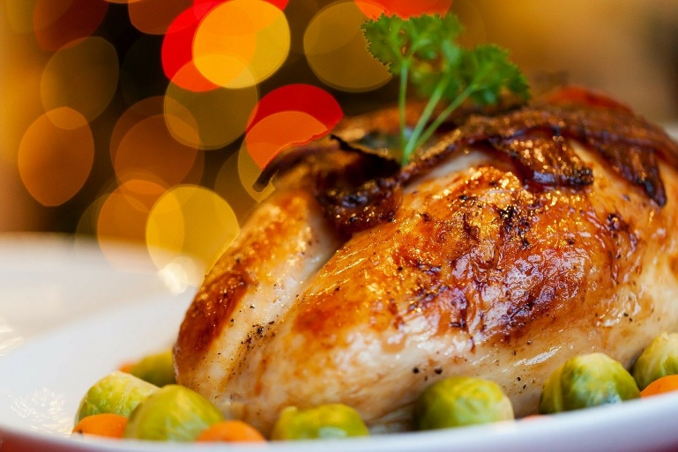
Photo courtesy of Pixabay.com
Ingredients:
- ½ tbsp extra-virgin olive oil
- 2 turkey cutlets or chicken breasts
- 3/4 c high-pulp orange juice
- 1 ½ tsp Dijon mustard
- ½ tsp cinnamon
- ¼ c dried cranberries
- Dash of salt and pepper

Directions:
- Heat olive oil over medium-high heat and lightly season the poultry.
- Put poultry in a skillet and cook until golden brown on both sides, be sure it is cooked all the way through. Remove and keep warm while you make the sauce.
- Sauce: Add orange juice, mustard, cinnamon, and dried cranberries to the pan, stirring often.
- Bring to a boil and cook until the sauce has thickened.
- Place poultry on serving plates and top with the orange-cranberry sauce.
- Serve with whole-grain bread or rice, non-fat milk, and a veggie or salad for a brain-boosting meal!

Source: https://superfoodsrx.com/recipes/cranberry-orange-turkey-recipe/
Serves 6
Nutrition Information
Calories 326
Total Fat 7 g
Saturated Fat 2 g
Sodium (mg) 260
Fiber 2 g
Total Sugars 23 g
Cholesterol (mg) 102
Protein 38 g

Stuffed Chicken Breast
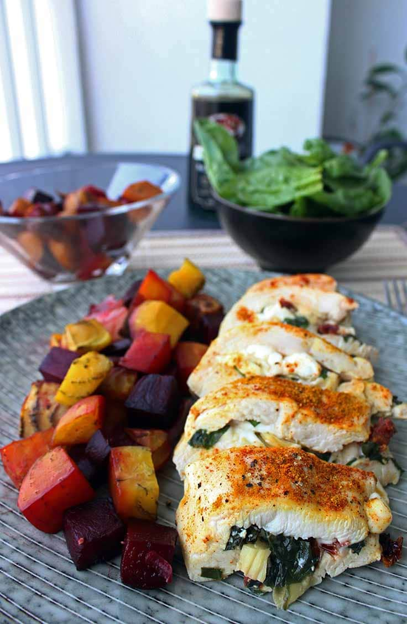
Photo courtesy of Pixabay.com
Ingredients:
- 1 chicken breast
- 1 oz low-fat mozzarella
- 1 artichoke heart (from a can)
- 1 tsp sundried tomato, chopped
- 5 large basil leaves
- 1 clove garlic
- ¼ tsp curry powder
- ¼ tsp paprika
- Pinch of pepper
- 4 toothpicks

Directions:
- Preheat the oven to 375 ºF
- Butterfly the chicken breast
- Chop up mozzarella, artichoke, basil, tomato, and garlic
- Mix and stuff into the chicken breast
- Use toothpicks to close the chicken breast around the stuffing
- Place the chicken breast on a baking sheet and add the seasonings
- Bake about 20 minutes (depending on the size of the chicken breast)

Source: https://diabetesstrong.com/stuffed-chicken-breast/

Recipe makes
Nutrition Information
Calories 320
Total Fat 11 g
Saturated Fat 5 g
Sodium (mg) 417
Fiber 3 g
Total Sugars 1 g
Cholesterol (mg) 122
Protein 45 g

Daily vitamin intake:
Vit A: 18%, Vit C: 11%, Calcium: 15%, Iron: 17%

Breaded Chicken Breast
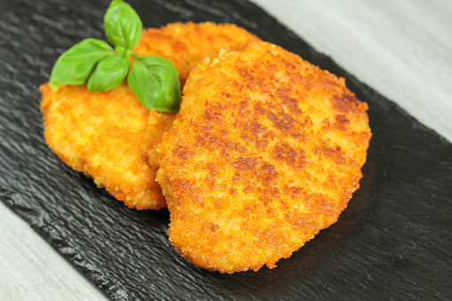
Photo courtesy from Pixabay.com
Ingredients:
- ¾ c oats (quick, old fashioned, or uncooked)
- ¼ c grated parmesan cheese
- ½ tsp ground cumin
- 4 boneless, skinless chicken breast halves
- 2 tbsp Dijon mustard

Directions:
- Heat oven to 450 ºF
- Place oats, cheese, and cumin in blender or food processor for about 1 minute and set aside
- Pound each of the chicken breasts between sheets of waxed paper to about ¼ in thickness
- Spread mustard thinly over both sides of chicken and evenly coat with oat mixture
- Place chicken on a pan
- Spray one side of chicken evenly with cooking spray to coat completely, about 10 seconds
- Bake the chicken for about 15-20 minutes or until browned

Serves 4
Nutrition Information
Calories 300
Total Fat 8 g
Saturated Fat 2 g
Sodium (mg) 386
Fiber 2 g
Total Sugars 0.3 g
Cholesterol (mg) 107
Protein 41 g

Meatloaf
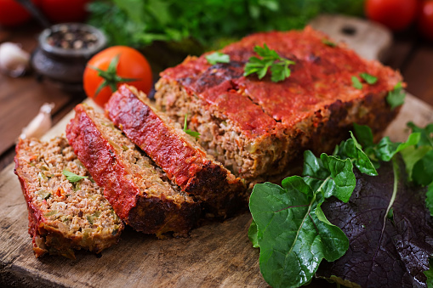
Photo courtesy from Pixabay.com
Ingredients:
- 1 beaten egg
- 2 tbsp Worcestershire sauce
- ¼ c chopped onion
- (2) ¼ c ketchup
- 1 ½ lb. ground beef
- $1/3$ c milk
- ¾ c quick oats
- ½ tsp rubbed sage
- ¼ tsp black pepper
- ½ tsp salt

Directions
- In a large bowl, combine all ingredients and mix well
- Press into a sprayed loaf pan
- Bake uncovered at 350 ºF for one hour and drain off some of the fat
- Spread another ¼ c ketchup over meatloaf and cook for another 10 minutes or until meat reaches 160 ºF for 5 minutes
- Let stand for 10 minutes before serving
Serves 6
Nutrition Information
Calories 343
Total Fat 17 g
Saturated Fat 6 g
Sodium (mg) 537
Fiber 1 g
Total Sugars 6 g
Cholesterol (mg) 123
Protein 31 g

Anti-Inflammatory Broccoli, Ginger, Leek & Turmeric Soup

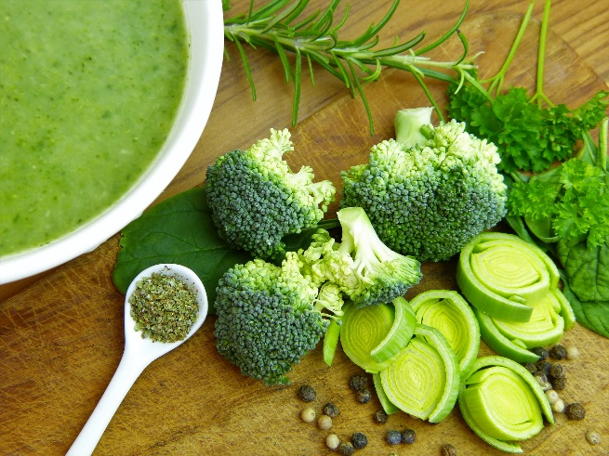
Photo courtesy of Pixabay.com
Ingredients:
- 3/4 tbsp olive oil
- 4 c chopped leeks
- 1 tbsp chopped ginger or ¼ tsp ground ginger
- 4 c broccoli florets
- 1/2 tsp turmeric
- Pinch of black pepper
- 3 c vegetable or chicken stock

Directions:
- Heat oil in a large pot over medium heat. Add the leeks and cook, stirring occasionally, about 7-10 minutes, until leeks are cooked through.
- Transfer the leeks to a slow cooker with the ginger, broccoli, turmeric, salt, oil, and stock.
- Cover and cook on low for about 3 hours- until broccoli is tender.
- Using a blender or handheld blender, blend until creamy and smooth.

Source: https://sweetpeasandsaffron.com/anti-inflammatory-broccoli-ginger-turmeric-soup-slow-cooker/
Serves 3-4
Nutrition Information
Calories 395
Total Fat 5 g
Saturated Fat 1 g
Sodium (mg) 884
Fiber 8 g
Total Sugars 15 g
Cholesterol (mg) 0
Protein 42 g

Walnut Crusted Salmon Fillets

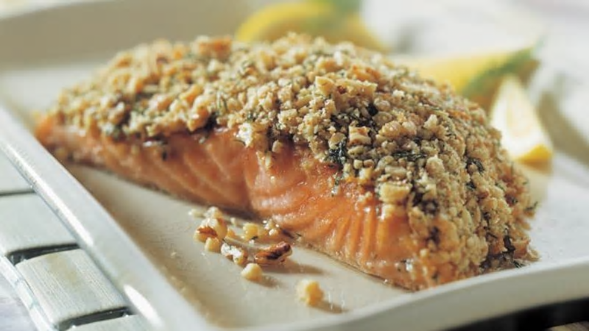
Serves 3
Nutrition Information
Calories 431
Total Fat 33 g
Saturated Fat 4 g
Sodium (mg) 205
Fiber 3 g
Total Sugars 1 g
Cholesterol (mg) 60
Protein 26 g
Photo courtesy of Pixabay.com
Ingredients:
- ¾ c walnuts
- 1 ½ tbsp dry breadcrumbs
- 1 ½ tbsp lemon rind, finely grated
- 1 ½ tbsp extra virgin olive oil
- 1 ½ tsp fresh dill, chopped
- 3-3 oz salmon fillets, skin on
- 1 tsp Dijon mustard
- 1 tbsp fresh lemon juice
- Salt and pepper to taste

Directions:
- Place walnuts in a food processor or chopper, coarsely chop. Add breadcrumbs, lemon rind, olive oil, and dill; pulse until crumbly. The mixture should stick together. Season with salt and pepper; set aside.
- Arrange salmon fillets skin side down on parchment paper-lined baking sheets. Brush tops with mustard.
- Spoon walnut crumb mixture over each fillet; gently press the crumb mixture into the surface of the fish. Cover with plastic wrap; refrigerate for up to 2 hours.
- Bake at 350°F 15 to 20 minutes, or until salmon flakes with a fork. Just before serving, sprinkle each with lemon juice.

Source: https://www.walnuts.org/cooking-with-walnuts/recipes/crunchy-walnut-crusted-salmon-fillets/

Walnuts have more antioxidants than any other nut! These antioxidants help protect our bodies against free radicals, which have been linked to cancer, atherosclerosis, and other diseases. Walnuts have also been proven to lower blood cholesterol and have anti-inflammatory properties.
Many are wary of nuts because they are relatively high in fat and calories, but the type of fat along with the abundant nutrients they contain make walnuts a healthy choice.
To avoid excessive calorie consumption, limit yourself to a single 1-ounce serving of walnuts a day.

Salmon Baked in Foil
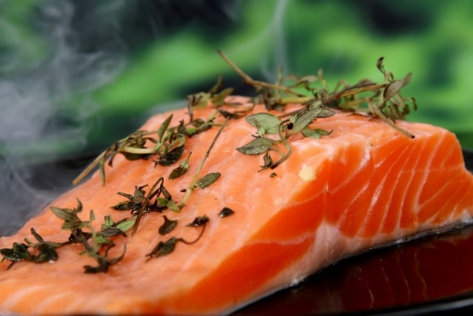
Photo courtesy of Pixabay.com
Ingredients:
Serves 2
Nutrition Information
Calories 337
Total Fat 18 g
Saturated Fat 3 g
Sodium (mg) 230
Fiber 1 g
Total Sugars 2 g
Cholesterol (mg) 101
Protein 36 g
- 1-2 (5 ounces each) salmon fillets
- 1 tbsp (divided) olive oil
- 1 tomato, chopped or 1/2 can chopped tomatoes, drained
- 1 chopped shallot
- 1 tbsp lemon juice
- ½ tsp dried oregano
- ½ tsp dried thyme
- Salt and pepper to taste

Directions:
- Preheat the oven to 400 degrees F.
- Sprinkle salmon with 1 teaspoon olive oil, salt, and pepper. Stir the tomatoes, shallots, 1 tablespoon of oil, lemon juice, oregano, and thyme in a medium bowl to blend.
- Place a salmon fillet, oiled side down, on a sheet of foil. Wrap the ends of the foil to form a spiral shape. Spoon the tomato mixture over the salmon. Fold the sides of the foil over the fish and tomato mixture, covering completely; seal the packets closed. Place the foil packet on a heavy large baking sheet.
- Bake until the salmon is just cooked through, about 15-25 minutes. Using a large metal spatula, transfer the foil packets to plates and serve.
Source: http://www.foodnetwork.com/recipes/giada-de-laurentiis/salmon-baked-in-foil-recipe-1914818

Tip To limit trans fat:
- Select lean cuts of beef and pork especially cuts with “loin” or “round” in the name.
- Cut back on processed meats high in saturated fat, like hot dogs, salami, and bacon.
- Drain the fat off of cooked, ground meat.
- Eat fish regularly. Try different ways of cooking such as baking, broiling, grilling, and poaching.
- Use liquid vegetables and soft margarine instead of stick butter.

Spinach Baked Salmon
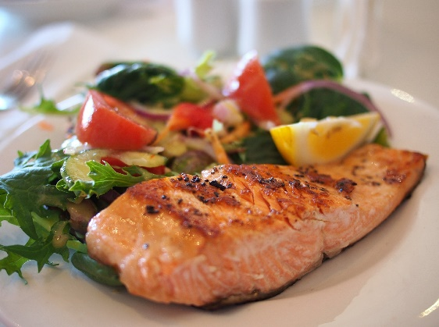
Photo courtesy of Pixabay.com
Ingredients:
Serves 3
Nutrition Information
Calories 379
Total Fat 18 g
Saturated Fat 3 g
Sodium (mg) 479
Fiber 2 g
Total Sugars 2 g
Cholesterol (mg) 107
Protein 42 g
- 1 tsp olive oil
- 2 oz spinach
- 1 tsp grated lemon zest
- ¼ c chopped, roasted red bell peppers, rinsed and drained if in can
- ¼ c fresh basil (coarsely chopped)
- 2 tbsp chopped walnuts
- Cooking spray
- 3 salmon filets (about 5 oz ea.), rinsed and patted dry
- 2 tbsp Dijon mustard
- 2 tbsp plain dry breadcrumbs
- ½ tsp dried oregano
- ½ tsp garlic powder
- $1/8$ tsp pepper

Directions:
- In a large skillet, heat the oil over medium heat, swirling to coat the bottom. Cook the spinach and lemon zest for 2 minutes, or until the spinach is wilted, stirring constantly. Transfer to a medium bowl. Stir in the roasted peppers, basil, and walnuts. Let cool for 5 minutes.
- Preheat the oven to 400°F. Line a baking sheet with aluminum foil. Lightly spray the foil with cooking spray.
- Place the salmon on the baking sheet. With a pastry brush or spoon, spread the mustard over the fish. Then, with a spoon carefully place a scant ½ cup spinach mixture into, or on top of, each fillet.
- In a small bowl, stir together the remaining ingredients. Sprinkle over the fish. Lightly spray the top with cooking spray.
- Bake for 12 to 13 minutes, or until the fish is the desired doneness and the filling is heated through.

Source:https://recipes.heart.org/Recipes/1267/Spinach-Stuffed-Baked-Salmon

Asian Pan Seared Salmon Salad for One
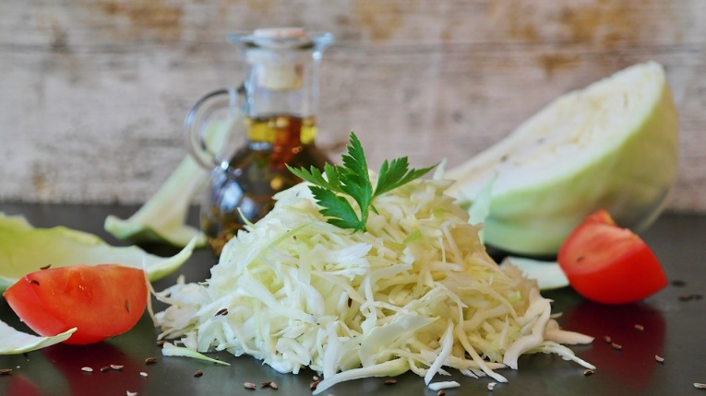
Photo courtesy of Pixabay.com
Ingredients:
- 1 6 oz wild salmon filet
- 1 c chopped cabbage
- ¼ c chopped green onion
- $1/8$ c peanuts
- 1 tsp Balsamic vinegar
- 2 tsp extra virgin olive oil, divided
- 1 tsp sesame oil
- 1 tsp soy sauce
- ¼ tsp Chinese 5 Spice Powder or to taste
- Salt and pepper to taste

Directions:
- Heat a large heavy skillet over medium heat, add peanuts, and cook for ~3 minutes, stirring constantly to prevent burning. Remove peanuts from skillet and allow to cool.
- Add 1 teaspoon oil to the same skillet, and place salmon filet, skin side down, in the pan. Sprinkle salt and pepper on top and cook for 4 minutes, then flip over and cook for another 3 minutes. Remove salmon from pan to cool.
- While this is cooking, chop the cabbage and onions up.
- Then make the dressing by combining the remaining olive oil with the sesame oil, balsamic vinegar, soy sauce, and the Chinese 5 Spice Powder. Stir well and set aside.
- Assemble the salad by placing the cabbage on a plate, top with the salmon filet, sprinkle the green onions and peanuts on top, then drizzle the dressing over the salad.

Source: www.eastewart.com
Recipe makes
Nutrition Information
Calories 568
Total Fat 39 g
Saturated Fat 5 g
Sodium (mg) 723
Fiber 4 g
Total Sugars 5 g
Cholesterol (mg) 120
Protein 52 g

Yes-You Can Black Bean Chili
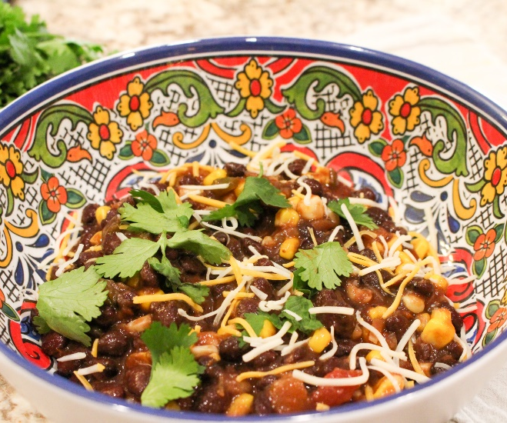
Photo by Rachechial Robinson
Ingredients:
- 12 oz can low-sodium black beans, drained liquid reserved
- 1 c low-sodium salsa
- 1 c frozen corn
- Freshly squeezed lime juice (optional)
- Fresh cilantro (optional)
- Hot sauce to taste

Directions:
- Mix beans, corn, and salsa in a 5-quart pot
- Add the reserved liquid to reach desired consistency
- Cook over medium heat for 20 minutes
- Add additional toppings just before serving

The black beans are high in fiber which helps you feel fuller with fewer calories. This recipe may help improve glucose levels, metabolism, cholesterol levels, & digestion.
Serves 2
Nutrition Information
Calories 326
Total Fat 2 g
Saturated Fat 0.2 g
Sodium (mg) 772
Fiber 20 g
Total Sugars 5 g
Cholesterol (mg) 0
Protein 16 g

Source: Physicians Committee for Responsible Medicine

Red Bean Veggie Soup
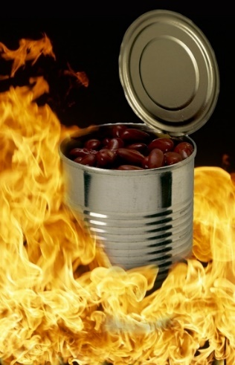
Recipe makes
Nutrition Information
Calories 427
Total Fat 3 g
Saturated Fat 2 g
Sodium (mg) 578
Fiber 22 g
Total Sugars 20 g
Cholesterol (mg) 0
Protein 24 g
Photo courtesy of Pixabay.com
Ingredients:
- 1 can drained no-added salt red beans
- 4 c low-sodium vegetable broth
- 2 tsp oregano
- 1 tsp Italian seasoning
- 2 c of chopped veggies of your choice (use leftover veggies that are still in your fridge)

Directions:
- Add all the ingredients
- Simmer in a pot until veggies are crisp (10-15 minutes)

Snacks
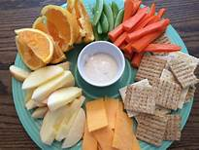
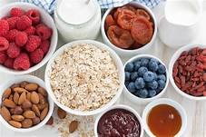

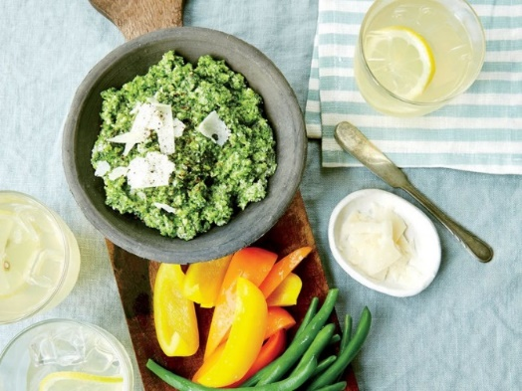
Zucchini Pesto
Photo courtesy Jennifer Causey
Ingredients:
- 1 ½ lb. of zucchini, shredded
- 8 tsp olive oil, divided
- 2 chopped garlic cloves
- 2 tbsp water
- 1 c fresh parsley
- $1/3$ c slivered toasted almonds
- ¼ c fresh mint
- ½ tsp grated lemon rind
- 2 tsp fresh lemon juice
- ¼ tsp black pepper
- 1 $1/3$ oz grated parmesan cheese

Directions:
- Shred zucchini with a box grater and squeeze dry in a paper towel
- Cook zucchini in 2 tbsp of olive oil and garlic in a large deep skillet over med-low heat for 15 min, occasionally stirring
- Add 2 tbsp of water at last 2 minutes of cooking, scrape the pan to loosen stuck pieces, and let cool
- Combine parsley, almonds, and mint in a food processor, pulsing until finely chopped
- Add zucchini mixture, add last 2 tbsp of oil, lemon rind, lemon juice, and pepper to combine, but not smooth
- Stir in cheese
- Serve dip with other fresh vegetables or on slices of toasted whole-grain bread!
One Serving of 2 tbsp
Nutrition Information
Calories 300
Total Fat 16 g
Saturated Fat 4 g
Sodium (mg) 356
Fiber 2 g
Total Sugars 3 g
Protein 10 g

Homemade Granola
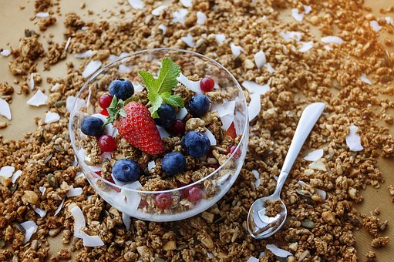
Photo courtesy from Pixabay.com
Ingredients:
- 4 c old fashioned rolled oats
- ¼ c sunflower seeds
- 2 tbsp canola oil
- 1 c dried fruit
- 1 c sliced almonds
- ½ c maple syrup
- ½ tsp salt
- ½ c shredded coconut

Directions:
- Heat oven to 350 ºF
- Toss oatmeal, almonds, coconut, and sunflower seeds with maple syrup, oil, and salt
- Place on rimmed baking sheet
- Bake and toss once until golden and crisp (about 25-30 minutes)
- Once the oat mixture has cooled slightly and still warm, add the dried fruit
- Let the mixture cool down before you enjoy
- Sprinkle on yogurt or eat as cereal with milk

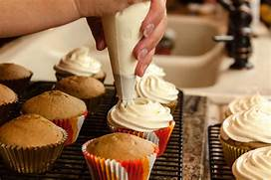
Dessert
One serving about a cup
Makes eight servings
Nutrition Information
Calories 435
Total Fat 19 g
Saturated Fat 4 g
Sodium (mg) 155
Fiber 8 g
Total Sugars 25 g
Cholesterol (mg) 0
Protein 10 g
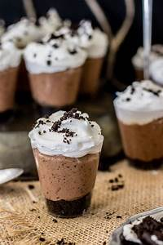

Applesauce Oatmeal Muffins
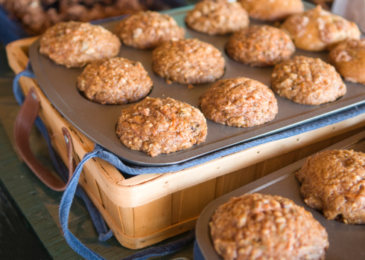
Photo courtesy by Pixabay
Ingredients:
Muffins
- 1 ½ c oats
- 1 tsp baking powder
- ¾ tsp ground cinnamon
- ½ c skim milk
- 3 tbsp vegetable oil
- 1 ¼ c flour
- ¼ tsp baking soda
- 1 c unsweetened applesauce
- ½ c packed brown sugar
- 1 egg white, lightly beaten

Topping:
- ¼ c oats
- 1 tbsp brown sugar
- 1 tbsp melted butter
- Dash of cinnamon

Directions:
- Heat oven to 400 ºF
- Line 12 medium muffin cups with paper or spray bottoms with cooking spray
- Combine dry ingredients in a large bowl
- In a smaller bowl, combine applesauce, milk, sugar, oil, and egg white, blend well
- Add into the dry ingredients and mix until incorporated
- Fill muffin tin ¾ the way full and sprinkle with topping
- Bake for 20-22 minutes and cool for 5 minutes before removing from the pan
Makes 10-12 muffins
Per one muffin serving
Nutrition Information
Calories 221
Total Fat 6 g
Saturated Fat 1 g
Sodium (mg) 103
Fiber 2 g
Total Sugars 15 g
Cholesterol (mg) 0.3
Protein 4 g

Sweet Potato Apple Cinnamon Muffins
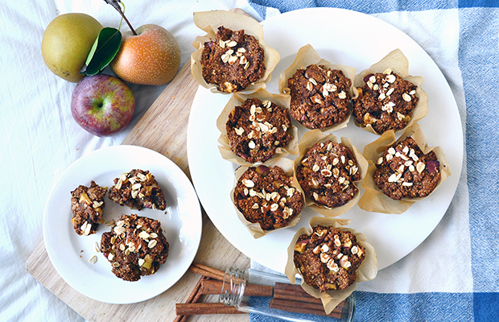
Photo courtesy of Pixabay.com
Ingredients:
Makes 8-12 muffins
Per one muffin serving
Nutrition Information
Calories 236
Total Fat 10 g
Saturated Fat 7 g
Sodium (mg) 114
Fiber 4 g
Total Sugars 20 g
Cholesterol (mg) 0
Protein 3 g
- 1 sweet potato
- 2 large apples, cored and chopped into small pieces
- 2 ¼ c whole rolled oats or 1 ¾ c flour
- 1 tbsp chia seeds
- 1 tsp baking powder
- 1 tsp baking soda
- ¼ tsp salt
- 1 tbsp cinnamon
- 6 tbsp coconut oil, melted
- ¾ c sugar

Directions:
- Bake the sweet potato at 375 degrees for 1 hour or until tender. Or microwave for 5- 8 minutes, until tender.
- Cut the apples into small pieces.
- Preheat the oven to 450 degrees.
- Put the oats into a food processer and blend until a flour-like consistency form. Or you could substitute flour.
- Place the chia seeds in a bowl with 3 Tbsp of water, set aside after stirring.
- Put the flesh of the baked sweet potato in the food processor with ¼ c water and process until smooth. Or you can mash or stir together with the water.
- Mix the oat flour, or flour, baking soda, baking powder, salt, and cinnamon.
- Mix the melted coconut oil, sugar, and chia seed gel very well before mixing in 1 cup of the sweet potato puree. (Freeze any extra for next time).
- Mix the wet and dry ingredients and fold in the apple chunks before dividing the mixture into muffin tins.
- Bake for 10 minutes at 450, then reduce heat to 400, then bake for another 5 to 10 minutes

Source: http://dailyburn.com/life/recipes/sweet-potato-healthy-muffin-recipe/

The perfect fall fruit, nothing is more reminiscent of fall than apple orchards and pumpkin patches.
Apples are packed with polyphenols, antioxidants, and vitamin C. No wonder the popular saying, “An apple a day keeps the doctor away,” promotes the idea of fewer doctors’ visits. I think everyone would agree they’d rather be celebrating fall festivities than sitting in the doctor’s office with a nasty cold!

Berry Frozen Yogurt

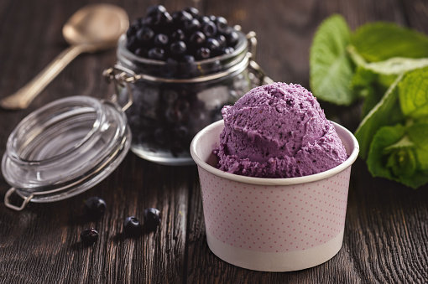
Photo courtesy of Pixabay.com
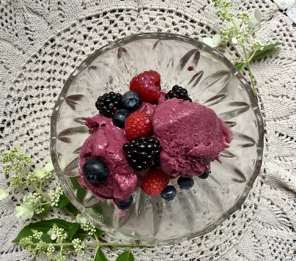
Photo Courtesy of Lindsay VanKampen
Ingredients:
- 2 c frozen berries
- ½ c plain Greek yogurt
- 2 tbsp honey
- 1 tsp lemon

Directions:
- Add all ingredients to a food processor or blender
- Blend for 2 minutes or until the mixture is creamy
- Serve soft or transfer to an airtight container and store up to two weeks

Source: http://gimmedelicious.com/2016/05/10/healthy-5-minute-berry-frozen-yogurt/
Two servings
Nutrition Information
Calories 201
Total Fat 1 g
Saturated Fat 0.3 g
Sodium (mg) 32
Fiber 8 g
Total Sugars 38 g
Cholesterol (mg) 3
Protein 8 g

Greek Yogurt or Ice Cream with Chia Seeds

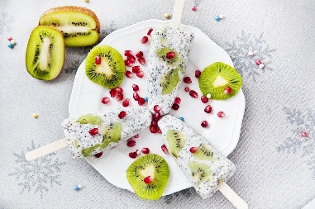
Photo courtesy of Pixabay.com
Directions:

- Stir in some chia seeds to your favorite yogurt, sorbet, sherbet, or ice cream
- Add some fresh fruit and freeze in a paper cut or popsicle mold. It is a refreshing summer treat!

Olive Oil Zucchini Bread
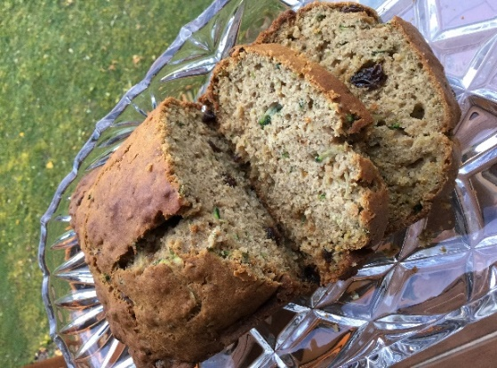
Photo by Pam VanKampen
Ingredients:
- 1 ½ c grated zucchini
Makes six slices
Nutrition Information
Calories 358
Total Fat 14 g
Saturated Fat 2 g
Sodium (mg) 378
Fiber 2 g
Total Sugars 26 g
Cholesterol (mg) 55
Protein 7 g
- $2/3$ c light brown sugar
- $1/3$ c olive oil
- $1/3$ c plain Greek Yogurt or mashed banana
- 2 large eggs
- 1 tsp vanilla extract
- 1 ½ c flour
- ½ tsp salt
- ½ tsp baking soda
- ½ tsp baking powder
- 1 ½ tsp ground cinnamon
- ¼ tsp ground nutmeg
- 1 tsp grated lemon zest
- ½ c walnuts (optional)
- ½ c raisins (optional)
Directions:
- Heat oven to 350 degrees. Spray an 8-inch loaf pan.
- In a large bowl, use a rubber spatula to mix together the grated zucchini, sugar, olive oil, yogurt or bananas, eggs, and vanilla extract.
- Whisk together the flour, salt, baking soda, baking powder, lemon zest, and spices in a separate bowl. Fold the dry ingredients into the wet ingredients. Fold in the walnuts and raisins if using.
- Pour the batter into the prepared loaf pan and bake for 40 to 55 minutes, rotating the pan halfway through baking. The bread will be done when a toothpick inserted into the middle comes out clean.
- Cool on a wire rack for 10 minutes. Remove the bread from the pan and cool on a rack completely before cutting and serving.

Source: https://mobile.nytimes.com/recipes/1017522/olive-oil-zucchini-bread.html

Summer Squash Bread
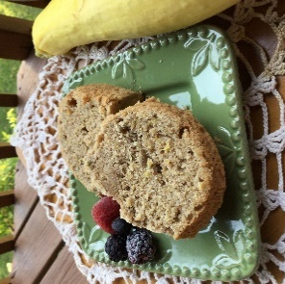
Ingredients:
- 3 eggs beaten
- 2 c white sugar
- 1 c vegetable oil
- 2 tsp vanilla extract
- 3 c all-purpose flour
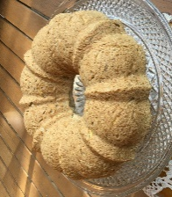
- 3 tsp baking powder
- 2 tsp ground cinnamon
- 2 tsp ground nutmeg
- 2 c shredded summer squash
- ¼ c Sunflower seed kernels (optional)
- $1/3$c raisins (optional)

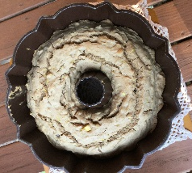
Directions:
- Preheat oven to 325°F. Grease a bunt pan.
- In a large bowl, use an electric mixer to beat the eggs until fluffy. Beat in the sugar, oil, and vanilla. Gradually mix in the flour, baking powder, cinnamon, and nutmeg. Fold in the squash, raisins, and sunflower kernels. Transfer to the prepared baking dish.
- Bake 45 minutes in the preheated oven, until a knife inserted in the center comes out clean.

Source: http://allrecipes.com/recipe/75200/summer-squash bread/?internalSource=staff%20pick&referringId=1093&referringContentType=recipe%20hub&clickId=cardslot%203
Twelve servings
Nutrition Information
Calories 430
Total Fat 19 g
Saturated Fat 3 g
Sodium (mg) 137
Fiber 1 g
Total Sugars 3 g
Cholesterol (mg) 41
Protein 4 g

Greek Yogurt Zucchini Bread

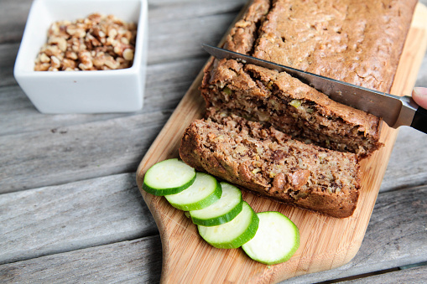
Photo courtesy of Pixabay.com
Ingredients:
- $1/3$c vegetable oil
- $1/3$c brown sugar
- 1 large egg
- ½ c plain Greek yogurt
- 1 ½ tsp pure vanilla extract
- 1 ½ c all-purpose flour
- ½ tsp baking powder
- ½ tsp baking soda
- ½ tsp salt
- 1 tsp ground cinnamon
- 1 c shredded zucchini
- OPTIONAL: orange zest, walnuts, raisins, chocolate chips

Directions:
- Preheat oven to 350 ºF and grease a 9x5 loaf pan
- In a medium bowl, whisk wet ingredients. In a large bowl whisk together the dry ingredients. Pour wet ingredients into the large bowl and mix with a wooden spoon/rubber spatula. Fold in zucchini and optional ingredients.
- Spread batter into pan. Bake for 40-50 minutes. The bread is done when a toothpick comes out clean.
- Remove bread from oven and set on a wire rack to cool.

Source: HuffPost Food and Drink
Serves 6
Nutrition Information
Calories 298
Total Fat 13 g
Saturated Fat 2 g
Sodium (mg) 364
Fiber 1 g
Total Sugars 13 g
Cholesterol (mg) 28
Protein 6 g

No-Bake Chocolate Cherry Oat Bars
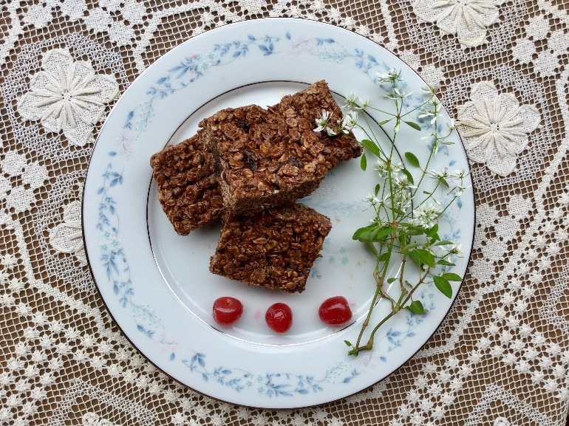
Photo courtesy of Lindsay VanKampen
Ingredients:
- 2 c rolled oats
- 1 ½ c rice cereal
- ½ tsp salt (optional)
- ½ c peanut butter
- 4 oz chopped 60% cacao bittersweet chocolate or ¾ c chocolate chips
- ½ c coconut oil
- ¼ c honey
- 1 c (5 oz) dried cherries

Directions:
- Line an 8 x 8-inch baking pan with parchment paper, leaving a bit of paper to hang over the sides.
- Combine oats, rice cereal, and salt in a large bowl.
- Melt together peanut butter, chocolate chips, coconut oil, and honey in a saucepan over medium heat, or melt in a microwave for ~ 1minute, stirring frequently.
- Pour wet mixture over oat mixture. Stir to combine. Stir in cherries.
- Pour mixture into prepared pan. Press to evenly cover the bottom of the pan.
- Chill for at least 3 hours. Cut and store in the refrigerator.
Source: http://www.eatright.org/resource/food/planning-and-prep/recipes/no-bake-chocolate-cherry-oat-bars-recipe#.WJOHk9nZbn4.email
Nutrition Information
Calories 328
Total Fat 18 g
Saturated Fat 10 g
Sodium (mg) 162
Fiber 2 g
Total Sugars 13 g
Cholesterol (mg) 2
Protein 5 g

Gluten-Free Hazelnut Brownies

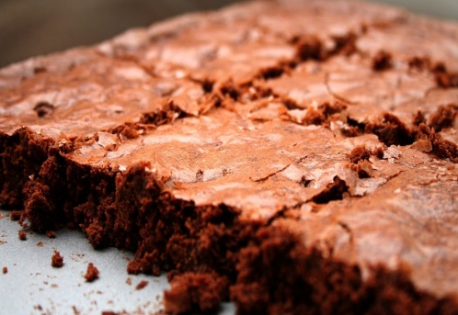
Photo courtesy of Pixabay.com
Ingredients:
- ½ c coconut oil
- 4 oz of gluten-free chocolate chunks
- ½ c sugar
- 2 tsp vanilla extract
- 2 large eggs
- ¾ c hazelnut flour
- ¾ c almond flour
- ¾ c gluten-free chocolate

Directions:
- Preheat oven to 350 °F. Grease an 8-inch metal baking pan.
- In a large microwave-safe bowl, heat oil and 4 oz. of chocolate chunks for 30 seconds at a time until melted.
- Add vanilla extract and eggs and mix until well incorporated.
- Stir in the hazelnut and almond flour just until combined.
- Add the remaining ¾ cup of chocolate chunks and stir until combined.
- Spoon the brownie batter into the pan and spread until even.
- Bake for 32-34 minutes, or until the center is set.

Source: https://www.glutenfreepalate.com/grain-free-hazelnut-brownies/

Nutrition Information
Calories 236
Total Fat 17 g
Saturated Fat 12 g
Sodium (mg) 20
Fiber 0.7 g
Total Sugars 17 g
Cholesterol (mg) 35
Protein 3 g

Brownies with Dried Plums

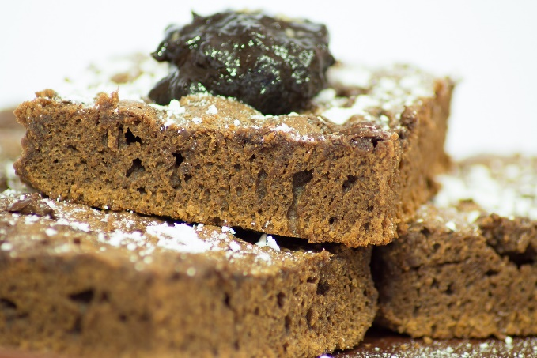
Photo courtesy of Pixabay.com
Ingredients:
- 8 oz semisweet chocolate
- ¼ c vegetable oil
- ½ c sugar
- ¼ c Dried Plum purée
- 2 large eggs
- 1 tsp vanilla extract
- $1/3$cup flour of your choice
- Pinch salt
- ½ c coarsely chopped walnuts (optional)

Directions:
- Heat oven to 325ºF. Spray an 8x8 inch baking pan with cooking spray and line with parchment paper, leaving the paper overhanging on 2 sides; spray the paper with cooking spray.
- In a double boiler, melt chocolate with oil over simmering water. You can also melt in a microwave-safe dish for 1-2 minutes stirring halfway through.
- Whisk in sugar and dried plum purée until mixed; whisk in eggs and vanilla.
- Fold in flour and salt just until blended; fold in walnuts if desired.
- Scrape into prepared pan, spread evenly. Bake about 30 minutes or until done. Cool in pan for at least 10 minutes.

Source: https://www.californiadriedplums.org/recipes/moist-and-fudgy-brownies-with-california-dried-plums
Nutrition Information
Calories 236
Total Fat 13 g
Saturated Fat 5 g
Sodium (mg) 43
Fiber 1 g
Total Sugars 24 g
Cholesterol (mg) 33
Protein 3 g

Gluten-Free Black Bean-Zucchini Brownies

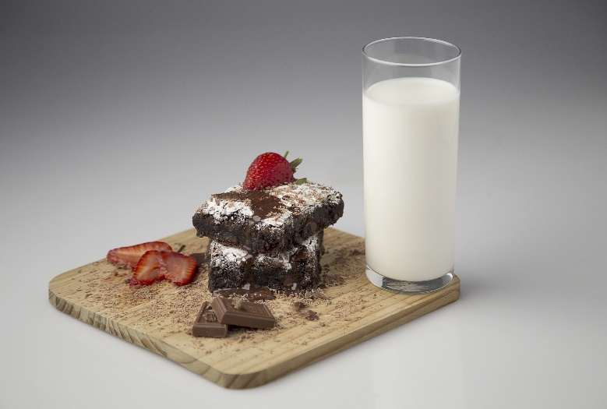
Photo courtesy of pixabay.com
Ingredients:
- 1 15 oz can black beans, rinsed and drained
- 3 eggs
- 2 tbsp coconut oil or canola oil
- ½ c unsweetened cocoa powder
- ½ tsp baking powder
- 1 tsp vanilla extract
- ½ c brown sugar
- ½ c semi-sweet chocolate chips (optional)
- 1 c zucchini, grated and patted dry
- Cooking spray

Directions:
- Preheat oven to 350 ℉
- Spray an 8x8 brownie pan with cooking spray and set aside
- Add all of the ingredients except the chocolate chips and zucchini into a blender or food processor and blend until smooth
- Fold in chocolate chips and zucchini
- Pour into the pan and bake for 30-35 minutes, insert a toothpick, if it comes out clean, brownies are done
- Leave in pan to cool before cutting

Tip: Drink milk with sweet desserts. The protein in milk helps stabilize your blood sugar and can help you feel more satisfied. Your mom was right, a glass of milk with sweets is a great idea!
Source: http://www.peanutbutterandpeppers.com/2013/08/24/chocolate-zucchini-beanie-brownies/
Nutrition Information
Calories 226
Total Fat 8 g
Saturated Fat 5 g
Sodium (mg) 234
Fiber 7 g
Total Sugars 18 g
Cholesterol (mg) 54
Protein 7 g

Gluten-Free White Chocolate Chip Peppermint Cookies
Photo courtesy of Pixabay.com
Ingredients:
- 1 ½ c gluten-free all-purpose flour
- 1 tsp baking soda
- ¼ tsp sea salt
- ½ tsp guar gum or xanthan gum
- 2/3 c white chocolate chips
- ½ c crushed peppermint candy canes
- ¾ c gently melted butter
- 1 egg
- ¼ c sugar
- ½ tsp peppermint extract

Directions:
- Preheat the oven to 350 °F. Spray or grease a cookie sheet.
- Mix flour, baking soda, sea salt, xanthan gum, white chocolate chips, and crushed peppermint in a large bowl.
- In a separate bowl, whip together butter, egg, sugar, and peppermint extract.
- Add the liquid ingredients to the dry ingredients and mix them together. Shape into cookies and bake for 10-12 minutes.

Source: https://www.glutenfreeliving.com/recipes/desserts-sweets/white-chocolate-chip-peppermint-cookies/
Nutrition Information
Calories 280
Total Fat 14 g
Saturated Fat 9 g
Sodium (mg) 274
Fiber 1 g
Total Sugars 19 g
Cholesterol (mg) 44
Protein 3 g

Molasses Cookies
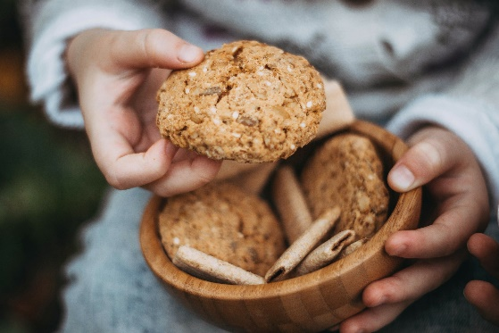
Photo courtesy of Pixabay.com
Ingredients:
- $2/{3 }$c corn or sunflower oil
- 1 c sugar
- ¼ c molasses
- 1 chia “egg” (see note below)
- 2 c flour
- 2 tsp baking soda
- 1 tsp cinnamon
- ½ tsp ground cloves
- ½ tsp ground ginger
- ½ tsp salt

Directions:
- Combine all ingredients in a mixing bowl and blend thoroughly.
- Shape into a large ball and wrap in plastic, (or wax paper), and refrigerate for at least one hour.
- Remove from refrigerator and form into 1-inch size balls
- Roll in granulated sugar
- Place on a greased cookie sheet (or parchment paper) 2″ apart
- Bake at 375° F for 8-10 minutes

Source: fullofbeans.us

Note: To use chia seeds as an egg substitute in baking, try mixing 1 tablespoon of chia seeds with 3 tablespoons of water, then let them sit for a few minutes. A gel will form that can be used instead of eggs in baking. It works best if you let sit in the fridge for 30 minutes.
Makes 12-14 Cookies
Nutrition Information
Calories 235
Total Fat 12 g
Saturated Fat 1 g
Sodium (mg) 311
Fiber 1 g
Total Sugars 20 g
Cholesterol (mg) 0
Protein 2 g

Pumpkin Chocolate Chip Muffins

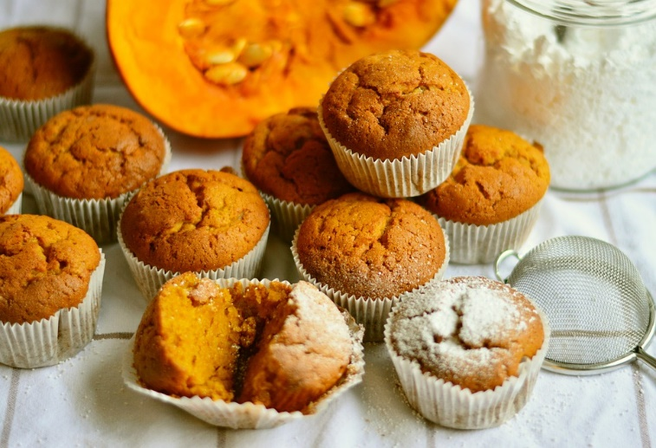
Photo courtesy of Pixabay.com
Ingredients:
- 2 c rolled oats
- 1 c pumpkin puree
- 6 oz plain Greek yogurt
- ½ c maple syrup
- 2 eggs
- 1 tsp baking soda
- 1 tsp cinnamon
- Pinch of salt
- 1 c chocolate chips

Directions:
- Place oats into the blender and pulse until oats are smooth
- Add the rest of the ingredients to the blender and mix till smooth
- Stir in chocolate chips if desired
- Transfer to grease or lined muffin tins and bake for 15 minutes at 375 degrees

Source: http://www.pinchofyum.com
Nutrition Information
Calories 234
Total Fat 7 g
Saturated Fat 4 g
Sodium (mg) 191
Fiber 3 g
Total Sugars 20 g
Cholesterol (mg) 38
Protein 7 g

Bean Red Velvet Cupcakes
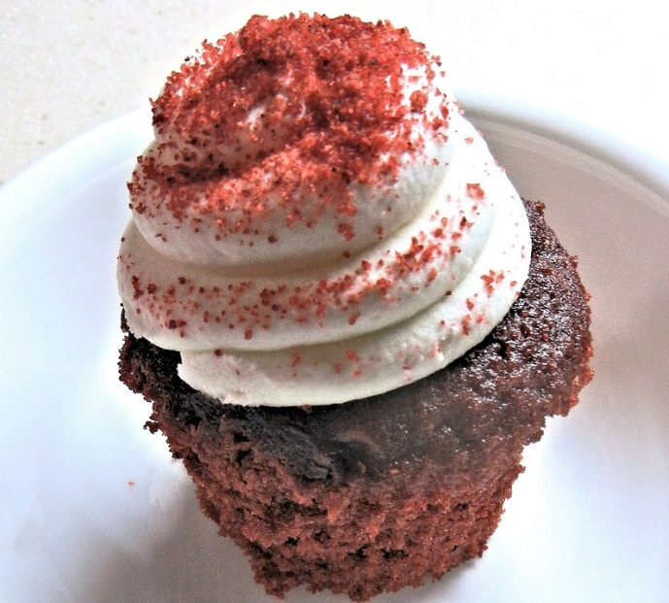
Photo courtesy of Pixabay.com
Ingredients:
- 1 can (8-15 oz) cannellini beans, drained & rinsed
- 1 package red velvet cake mix
- 1 large egg
- ½ c applesauce
- Option: frosting of your choice

Directions:
- In a small food processor, add beans & pulse until smooth
- Blend cake mix, pureed beans, egg, and applesauce in a large bowl at low speed until moistened
- Use a cupcake pan with paper liners & fill each one $2/3$full of batter
- Bake at 350 degrees for 12-15 minutes
- Cupcakes are done when a toothpick inserted in the center comes out clean
- Cool and frost

Source: http://www.bushbean.com

Serves 4
Nutrition Information
Calories 334
Total Fat 12 g
Saturated Fat 0.8 g
Sodium (mg) 407
Fiber 5 g
Total Sugars 19 g
Cholesterol (mg) 84
Protein 9 g

Raisin Pie
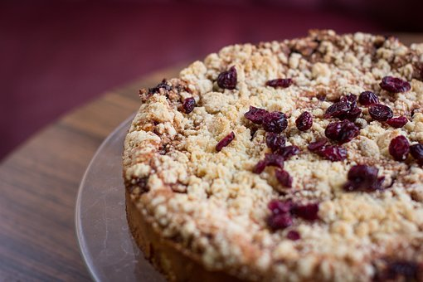
Photo courtesy of Pixabay.com
Ingredients:
- 1 c sugar
- 2 ½ tbsp all-purpose flour
- ½ -1 c water
- 2 c raisins
- ½ tsp salt
- ½ tsp cinnamon
- 1 tbsp butter
- Pastry for double-crust pie

Directions:
- In a saucepan, stir together sugar, flour, and then add water and mix well
- Stir in raisins, salt and cinnamon; cook and stir over medium heat until all incorporated (indications are bubbles forming at the top)
- Cook an additional minute
- Remove from heat and stir in butter
- Pour into a pastry-lined pie plate
- Top with a lattice crust or crumble on top
- Bake at 375℉ for about 45 minutes or until golden brown

Source: https://www.tasteofhome.com/recipes/raisin-pie/

Serves 8
Nutrition Information
Calories 381
Total Fat 2 g
Saturated Fat 1 g
Sodium (mg) 189
Fiber 3 g
Total Sugars 48 g
Cholesterol (mg) 2
Protein 5 g

Raw Wild Blueberry Pie

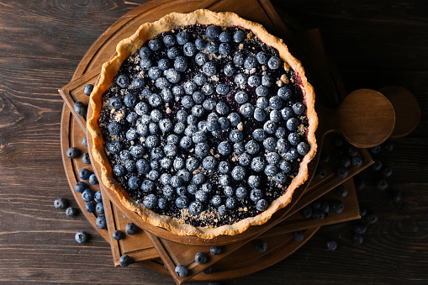
Photo courtesy of Pixabay.com
Ingredients:
- $1/{3 }$c cashews
- $1/{3 }$c unsweetened shredded coconut
- 4 c dates, pitted
- 20 oz frozen wild blueberries, thawed
- 1 mango, diced

Directions:
- For the crust: place the cashews, coconut, and 3 cups of dates in a food processor and blend until thoroughly combined and smooth. Press the crust into a 9 in a pie dish. Cover and refrigerate until the filling is ready.
- For the filling: place half of the wild blueberries and the remaining cup of dates, and the mango into a food processor and blend until smooth
- Stir in the other half of the blueberries
- Pour the filling into the pie crust and allow to set in the refrigerator for at least 40 minutes. Serve cold.

Source: http://www.medicalmedium.com/blog/wild-blueberries

Serves 6
Nutrition Information
Calories 417
Total Fat 7 g
Saturated Fat 3 g
Sodium (mg) 7
Fiber 12 g
Total Sugars 76 g
Cholesterol (mg) 0
Protein 4 g

Sides
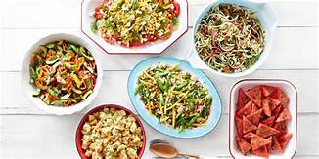
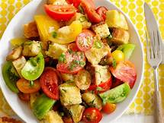

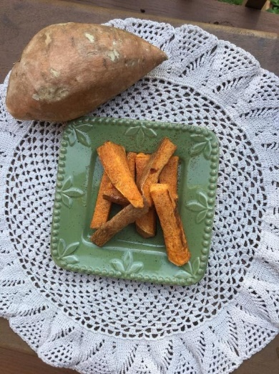
Baked Sweet Potato Wedges

Photo courtesy of Pam VanKampen
Ingredients:
- 1 tbsp olive oil
- ½ tsp paprika
- 8 sweet potatoes, sliced lengthwise into quarters
Serves 8
Nutrition Information
Calories 150
Total Fat 2 g
Saturated Fat 0.5 g
Sodium (mg) 54
Fiber 5 g
Total Sugars 9 g
Cholesterol (mg) 0
Protein 3 g

Directions:

- Preheat oven to 400 °F
- Lightly grease a baking sheet.
- Mix olive oil and paprika in a large bowl.
- Add in potato wedges and stir by hand.
- Place on a prepared baking sheet.
- Bake 20 minutes or until done, depends on how thick you cut the potatoes.
Source: https://www.allrecipes.com/recipe/13517/baked-sweet-potato-sticks/?internalSource=staff%20pick&referringId=782&referringContentTy%20pe=recipe

Spicy Roasted Broccoli
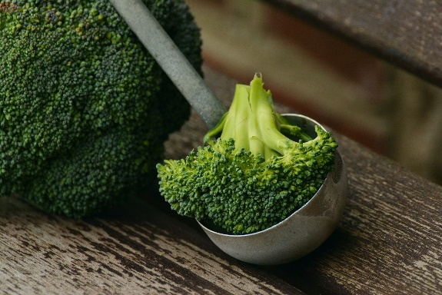
Photo courtesy of Pixabay.com
Ingredients:
- Broccoli, large stems trimmed and cut into 2-inch pieces (about 4 cups)
- 2 tbsp olive oil divided
- ¼ tsp salt-free seasoning blend
- $1/8$ tsp freshly ground black pepper
- 2 cloves garlic peeled and minced
- $1/8$ tsp crushed red pepper flakes

Directions:
- Preheat the oven to 450℉
- In a bowl, toss together the broccoli and the olive oil
- Sprinkle with salt-free seasoning and pepper
- Transfer to a rimmed baking sheet and bake for 15 minutes
- While that roasts, mix together 1 tbsp olive oil, garlic, and red pepper flakes if desired
- After the broccoli has cooked, drizzle mixture over the broccoli and stir to coat
- Return to the oven and bake until broccoli starts to turn brown (5-10 more minutes)

Source: wedmd.com

Per one cup serving
Nutrition Information
Calories 86
Total Fat 7 g
Saturated Fat 1 g
Sodium (mg) 24
Fiber 2 g
Total Sugars 1 g
Cholesterol (mg) 0
Protein 2 g

Healthy Cauliflower Rice

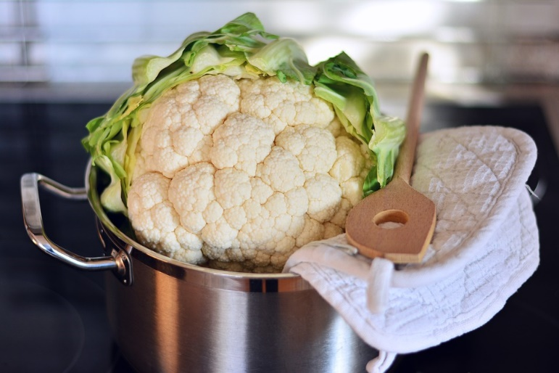
Photo courtesy of Pixabay.com
Ingredients:
- 1 large head cauliflower, separated into 1-inch florets
- 3 tbsp olive oil
- 1 medium onion, finely diced
- 2 tbsp fresh parsley leaves finely chopped or 1 tbsp dried parsley.
- Juice from ½ lemon

Directions:
- Trim the cauliflower florets, cutting away as much stem as possible. In 3 batches, break up the florets into a food processor and pulse until the mixture resembles rice.
- Heat the oil in a large skillet over medium-high heat. Add the onions, and stir to coat. Continue cooking, stirring frequently, until the onions are golden brown at the edges and have softened, about 5 minutes.
- Add the cauliflower, and stir to combine. Add salt or salt-free seasoning blend and continue to cook, stirring frequently, until the cauliflower has softened, 3 to 5 minutes. Remove from the heat.
- Spoon the cauliflower into a large serving bowl, garnish with the parsley, sprinkle with the lemon juice and season to taste with salt. Serve warm

Source: http://www.foodnetwork.com/recipes/food-network-kitchen/healthy-cauliflower-rice-3363582

Four servings
Nutrition Information
Calories 154
Total Fat 10 g
Saturated Fat 1 g
Sodium (mg) 64
Fiber 4 g
Total Sugars 5 g
Cholesterol (mg) 0
Protein 4 g

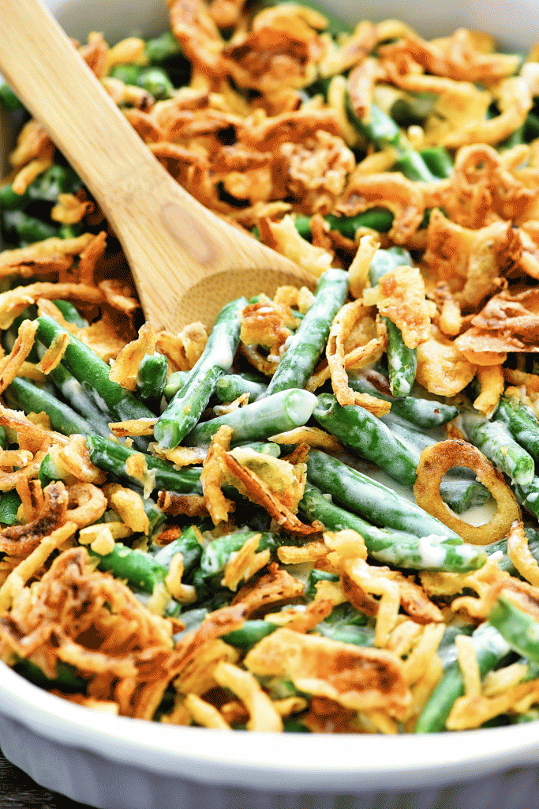
Green Bean Casserole
Serves 4
Nutrition Information
Calories 221
Total Fat 10 g
Saturated Fat 10 g
Sodium (mg) 177
Fiber 4 g
Total Sugars 5 g
Cholesterol (mg) 15
Protein 7 g

Photo courtesy of life-in-the-lofthouse.com
Ingredients:
- Small onion, diced
- Pinch of Kosher salt (optional)
- 1 lb. fresh green beans, stemmed and halved
- 1 tbsp extra-virgin olive oil
- 8 oz cremini mushrooms, sliced
- 2 tbsp unsalted butter
- 3 tbsp all-purpose flour
- 1 ½ c vegetable or chicken broth
- 3 tsp fresh thyme leaves
- Freshly ground black pepper
- Vegetable cooking spray
- 1 c fresh breadcrumbs

Directions:
- Bring a medium-large saucepan of water to a boil over high heat. Add green beans and cook uncovered until crisp-tender and bright green, about 3 minutes. Drain beans in a colander and rinse with cold water. Transfer to a large bowl.
- In the same saucepan, heat the oil over medium heat. Add the onions and mushrooms, season, cook, stirring occasionally, for about 7 minutes. Add mushrooms to beans.
- Melt butter in a small saucepan over medium heat. Add the flour and cook, stirring with a wooden spoon, until golden, about 2 minutes. Slowly whisk in the broth, increase the heat to high, and bring to a boil. Add 1 teaspoon of thyme, and seasoning. Reduce heat to maintain a simmer and cook until thickened, stirring occasionally for about 5 minutes. Pour sauce over the vegetables and stir to combine evenly.
- Spray a 2-qt baking dish with vegetable spray. Transfer the vegetable mixture to the pan. Add the remaining 2 teaspoons of thyme to breadcrumbs and scatter over vegetables. Bake uncovered for 20 minutes.

Source:https://www.foodnetwork.com/recipes/food-network-kitchen/green-bean-casserole-slimmed-recipe-2009016

Summer Fruit Salad
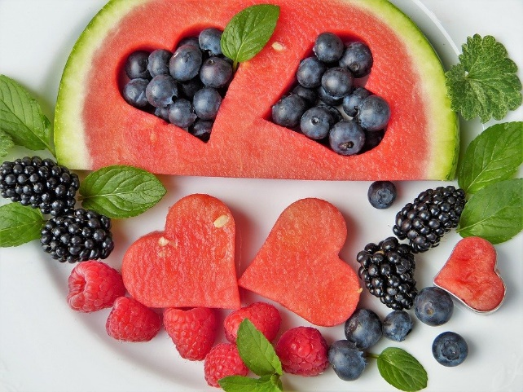
Photo courtesy of Pixabay.com
Ingredients:
- 6 oz blackberries
- 6 oz blueberries
- Bag of red grapes (~2 lbs)
- 16 oz strawberries
- 2 c of watermelon
Directions:
- Wash all produce
- Slice strawberries and cube the watermelon
- Toss all the fruit together being careful not to squish to berries
- Cover and refrigerate until ready to serve

Great for a house party or a get together with family!
These reminds me of great summer barbeques my family would always have.
Lasts up to three or four days, so be sure to enjoy with the company you’ll have.

Serves 4
Nutrition Information
Calories 116
Total Fat 1 g
Saturated Fat 0 g
Sodium (mg) 6
Fiber 6 g
Total Sugars 20 g
Cholesterol (mg) 0
Protein 2 g

Broccoli Apple Salad
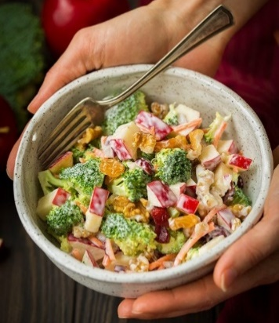
Photo courtesy of Jaclyn Cooking Classy
Ingredients:
Salad
- 2 c small diced broccoli florets
- 1 small apple, cored and diced
- ½ c walnuts
- ½ c carrots, roughly chopped
- ¼ c golden raisins or dried cranberries
- $1/8$ c chopped red onion

Dressing
- ½ c plain Greek yogurt
- ¾ tbsp apple cider vinegar
- 1 ½ tbsp honey
Directions:
Dressing
- Whisk together all the dressing ingredients in a medium mixing bowl
- Set aside to chill until ready to use
Salad
- Toss all salad ingredients together in a salad bowl
- Coat with the dressing then toss again to distribute evenly
- Chill until ready to eat and store leftovers in the fridge

Source: https://www.cookingclassy.com/broccoli-apple-salad/

Nutrition Information
Calories 858
Total Fat 39 g
Saturated Fat 4 g
Sodium (mg) 141
Fiber 16 g
Total Sugars 83 g
Cholesterol (mg) 6
Protein 28 g

Green Apple Salad
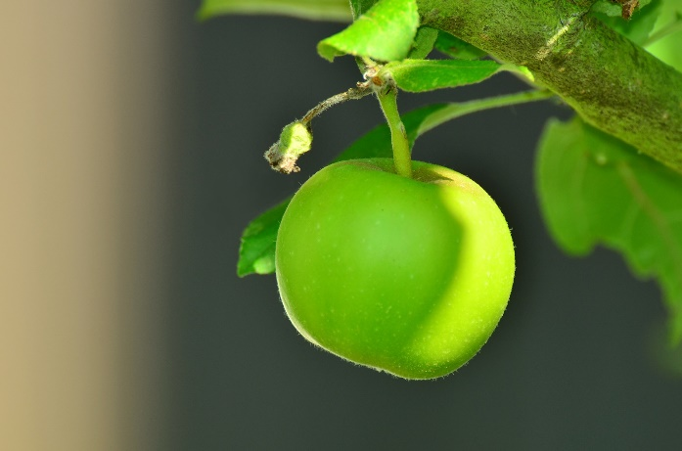
Photo courtesy of Pixabay.com
Ingredients:
- 4 c mixed salad greens
- 1 large Granny Smith apple (cut into small cubes)
- ½ c chopped walnuts
- ½ c fresh or dried blueberries
- ¼ c vegetable oil
- 2 tbsp balsamic vinegar
- 2 tbsp extra-virgin olive oil

Directions:
- Combine the salad greens, apple, walnuts, and blueberries in a large bowl
- Mix the vegetable oil, extra-virgin olive oil, and balsamic vinegar in a small bowl
- Pour the dressing (liquids) over the salad; toss to combine and chill until serving

Source: Mary Younkin

Serves 5
Nutrition Information
Calories 312
Total Fat 24 g
Saturated Fat 3 g
Sodium (mg) 14
Fiber 5 g
Total Sugars 14 g
Cholesterol (mg) 0
Protein 3 g

Anti-Inflammation

The body is trained to recognize foreign chemicals, bacteria, or anything that does not belong in the body. This process often leads to inflammation, which can affect one’s health.

An anti-inflammatory diet can greatly reduce inflammation and chronic disease.

Foods such as blueberries, apples, nuts, and leafy greens are high in antioxidants that reduce inflammation.

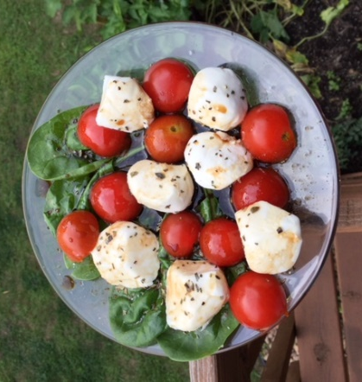
Easy Caprese Salad
Serves 2
Nutrition Information
Calories 338
Total Fat 25 g
Saturated Fat 8 g
Sodium (mg) 392
Fiber 3 g
Total Sugars 8 g
Cholesterol (mg) 36
Protein 15 g
Photo courtesy of Pam VanKampen
Ingredients:
- 3-4 fresh tomato or 2 c cherry tomatoes, cut in uniform size that you prefer
- 2-4 oz fresh mozzarella cheese
- 4 fresh basil leaves
- 2 tbsp extra virgin olive oil
- 1 tbsp balsamic vinegar
Directions:
- In a medium bowl, toss together the tomatoes mozzarella, and basil leaves
- Add olive oil to the bowl, and lightly toss together
- Drizzle the balsamic vinegar over the top of the salad

Source: https://www.trialandeater.com/chopped-caprese-salad/

Blueberry, Almond and Greens, Anti-Inflammatory Side Salad
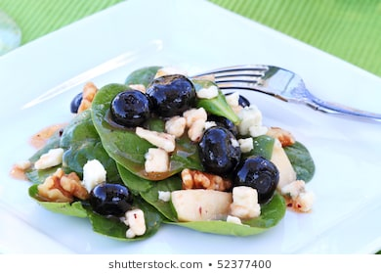
Photo courtesy of Pixabay.com
Ingredients:
- 1 c spinach
- ½ c kale
- ½ tomato, diced
- $1/8$ c almonds (slivered or chopped)
  - Substitute option: walnuts
- ¼ c fresh blueberries
- ½ tbsp extra virgin olive oil

Directions:
- Place the spinach and kale in a bowl
- Dice the tomato and add it to the greens
- Add the blueberries and almonds
- Drizzle on the olive oil
- Toss the salad together
- Serve and enjoy your fresh salad!
- (If preparing ahead of time, combine the ingredients and store them in the refrigerator in an air-tight container. Add the olive oil right before serving.)

Source: Nicole Tellock a UW Stout Student

Serves 1-2
Nutrition Information
Calories 190
Total Fat 15 g
Saturated Fat 2 g
Sodium (mg) 30
Fiber 4 g
Total Sugars 7 g
Cholesterol (mg) 0
Protein 5 g

Cinnamon Toast Pumpkin Seeds

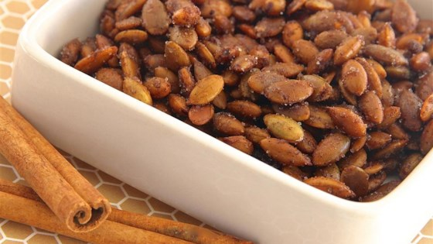
Photo courtesy of Pixabay.com
Ingredients:
- 1 ½ c pumpkin seeds
- 2 tbsp sugar
- ¼ tsp salt
- 1 tsp ground cinnamon
- 2 tbsp melted butter

Directions:
- Preheat oven to 300°F
- Mix butter, cinnamon, and salt (if desired) together in a bowl
- Remove pumpkin seeds from the pumpkin, wash and dry
- Place pumpkin seeds in a large bowl and pour the butter mixture over seeds; stir to evenly coat
- Spread seeds in a single layer onto a baking sheet and line with parchment
- Bake in the preheated oven, stirring occasionally until seeds are lightly browned, about 40 minutes or until done
- Remove baking sheet from oven; sprinkle stevia/sugar over seeds (if desired) and stir until evenly coated

Source: http://allrecipes.com/recipe/239621/cinnamon-toast-pumpkin-seeds/

Trail Mix
Serves 6
Nutrition Information
Calories 213
Total Fat 17 g
Saturated Fat 3 g
Sodium (mg) 131
Fiber 2 g
Total Sugars 14 g
Cholesterol (mg) 0
Protein 8 g
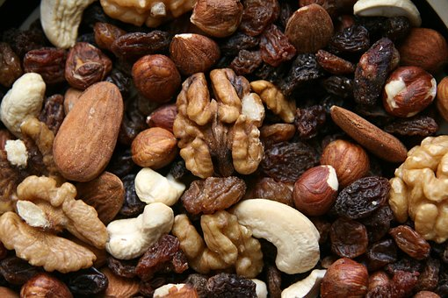

Photos courtesy of Pixabay.com
Ingredients:
Serves 10
Nutrition Information
Calories 272
Total Fat 18 g
Saturated Fat 2 g
Sodium (mg) 6
Fiber 4 g
Total Sugars 17 g
Cholesterol (mg) 0
Protein 8 g
- 1 c variety dried fruit
- ½ c raisins or dried cranberries
- 1 ½ c unsalted sunflower seeds
- 1 c unsalted dry-roasted peanuts or nuts of your choice
- Feel free to add dried bananas, apricots, prunes, pears, or apples

Directions:
- Mix the dried fruit, sunflower seeds, and dry-roasted peanuts in a large bowl
- Store in an airtight container
FYI: Trail mix is thought to be originated from Californian surfers for an energy-dense snack! National Trail mix day is August 31st.

Cinnamon Cashew Butter
Serving 2 tbsp
Nutrition Information
Calories 281
Total Fat 22 g
Saturated Fat 6 g
Sodium (mg) 103
Fiber 1 g
Total Sugars 5 g
Cholesterol (mg) 0
Protein 8 g
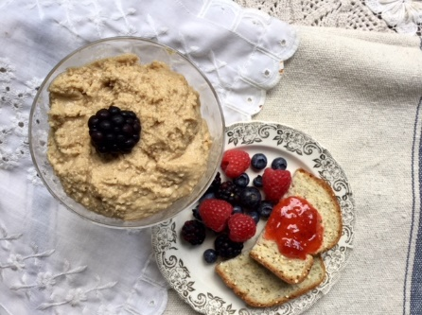
Photo courtesy of Lindsay VanKampen

Ingredients:
- 4 c of cashews
- 2 tbsp honey or Maple Syrup
- ½ tsp salt (optional)
- 1 tsp cinnamon
- 3 tbsp coconut oil (melted)
Directions:
- Add nuts to the food processor and blend for 3-4 minutes until finely ground
- Add honey or maple syrup, cinnamon, and salt and continue blending for 30 seconds
- Add melted coconut oil while the motor is running until fully blended
- Keep refrigerated
Source: http://vikalinka.com/2014/07/23/honey-cinnamon-cashew-butter/

Honey-Roasted Cinnamon Chickpeas
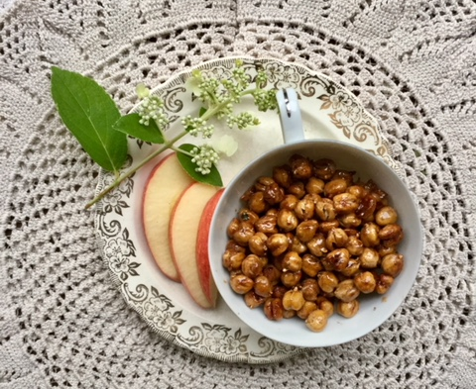
Photo courtesy of Lindsay VanKampen
Ingredients:
- 15 oz can organic garbanzo beans
- 1 tbsp olive oil
- 2 tbsp honey
- ½ tsp cinnamon
- ¼ tsp nutmeg
- ¼ tsp ground cloves (optional)
- $1/8$ tsp sea salt (optional)

Directions:
- Preheat oven to 375℉
- Line a baking sheet with parchment paper
- Drain and rinse the chickpeas and place them on a towel to dry
- Spread chickpeas on a baking sheet in a single layer
- Bake for 45 minutes or until crispy
- While the chickpeas are still hot, toss them in a bowl with oil, honey, cinnamon, nutmeg, cloves, and salt
- For a caramelized effect place them back in the oven for another 10 minutes (optional)
- Store in an airtight container

Source: http://www.popsugar.com/fitness/Roasted-Honey-Cinnamon-Chickpeas-27908653

High Fiber Bean Dip
Serves 4
Nutrition Information
Calories 237
Total Fat 6 g
Saturated Fat 1 g
Sodium (mg) 8
Fiber 8 g
Total Sugars 13 g
Cholesterol (mg) 0
Protein 9 g
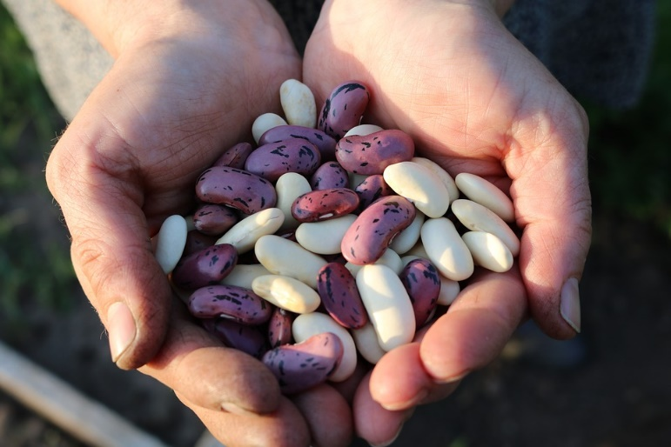
Photo courtesy of Pixabay.com
Ingredients:
- 1 clove garlic or 2 tsp minced
- 2 cans of prepared beans of your choice- drained. You can combine different types of beans if you like, for example, black beans and kidney beans or 2 cans of the same bean.
- 4 tbsp lemon juice
- 1 jalapeno pepper (if desired)
- 2 tbsp Tahini Sauce or Paste (if desired)
- 2 tbsp extra virgin olive oil
- ½ tbsp curry powder
- ½ tbsp cayenne pepper
- ½ tbsp coriander
- ½ tbsp Turmeric

Directions:
- Put all ingredients into a food processor and pulse until smooth
- Enjoy with some fresh veggies or whole-grain crackers
- Be sure to refrigerate the leftovers

Source: http://www.sofabfood.com/high-fiber-low-calorie-bean-dip/
Serves 6
Nutrition Information
Calories 219
Total Fat 6 g
Saturated Fat 1 g
Sodium (mg) 465
Fiber 13 g
Total Sugars 1 g
Cholesterol (mg) 0
Protein 10 g

Lime Cabbage Slaw
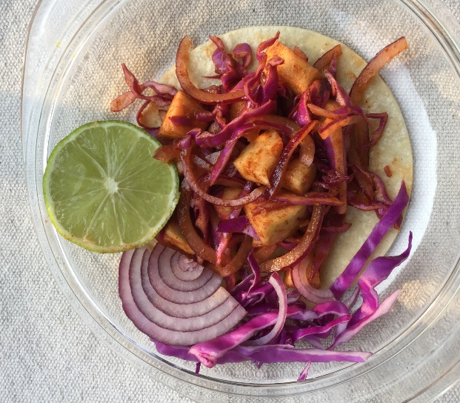
Photo courtesy of Pam VanKampen
Ingredients:
- ½ small red cabbage, cored & thinly sliced
- ¼ c cilantro, chopped (optional)
- ¾ c thinly sliced red onion
- ¼ c chopped apple
- 2 tbsp canola oil
- 1 ½ tbsp fresh lime juice
- 1 tbsp apple cider vinegar
- 1 clove garlic, minced
- 1 ½ tsp chili powder
- ½ tsp ground cumin (optional)
- ½ tsp ground paprika
- $1/8$ tsp cayenne pepper (optional)
- Dash of salt and pepper
- 6 corn or flour tortillas

Directions:
- In a mixing bowl whisk together oil, lime juice, apple cider vinegar, garlic, chili powder, cumin, paprika, cayenne, and season with salt and pepper to taste (about ½ tsp salt ¼ tsp pepper). This is your marinade.
- Add cabbage, red onion, apple, and cilantro to a medium mixing bowl. Pour lime juice and olive oil over top and season lightly with salt and pepper. Toss to evenly coat.
- Serve on a tortilla or eat as a side dish.

Source: CookingClassy.com

Per 2 tbsp serving
Nutrition Information
Calories 96
Total Fat 9 g
Saturated Fat 1 g
Sodium (mg) 120
Fiber 6 g
Total Sugars 2 g
Cholesterol (mg) 0
Protein 0.2 g

Simple Chia Pudding
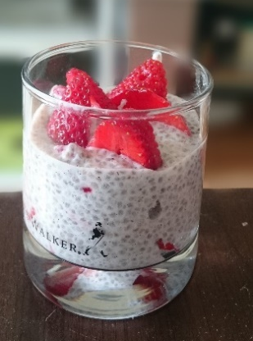
Serves 4
Nutrition Information
Calories 137
Total Fat 5 g
Saturated Fat 1 g
Sodium (mg) 46
Fiber 4 g
Total Sugars 10 g
Cholesterol (mg) 7
Protein 5 g
Photo courtesy of Pixabay.com
Ingredients
- $1/3$ c chia seeds
- 1 ½ c milk (of your choice)
- 2 tbsp maple syrup, honey, or agave
- ½ tsp vanilla
- Fruit of your choice

Directions:
- Combine all the ingredients in a pint jar. Cover the jar with a tight lid and shake well. Chill for about an hour, then shake again. Return to fridge and let chill for at least 4 hours or overnight.
- Chia seeds will expand and turn into pudding the consistency of applesauce. Serve cold with sliced fruit or toasted nuts on top.
Variations to try or make up your own!
- Maple syrup, pears & almonds (almond milk)
- Honey, orange segments & pistachios (milk)
- Toasted coconut, agave syrup, and banana (coconut milk)

Source: http://www.simplebites.net/how-to-make-simple-chia-pudding/

Did you Know:
Chia is primarily grown for its seeds, which are high in alpha-linolenic acid (ALA) an omega-3 fatty acid. The cardiovascular health benefits of a diet rich in ALA are well documented and chia is a delicious way to add ALA to your diet.
The recommended Dietary Reference Intake (DRI) for ALA is 1.6 g per day for adult males and 1.1 g per day for adult females. One tablespoon of chia seeds provides 1.32 g ALA, meeting the recommended DRI for women and satisfying nearly 83% of daily ALA needs for men.
The seeds also provide fiber, protein, minerals, and antioxidants, and are gluten-free.

Green Chia Smoothie or Pudding
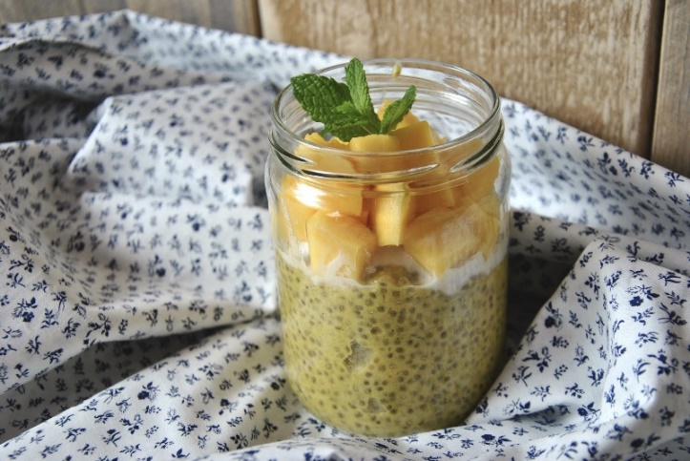
Photo courtesy of Pixabay.com
Ingredients:
- 2 c of spinach
- 1 ½ c of water (for a smoothie) or 1 cup water (for pudding)
- 2 tbsp of chia seeds
- Fruit for your choice (optional)

Directions:
- Blend the spinach, water, and chia seeds. For pudding use only 1 c water
- Add in the fruit of your choice, such as a peeled orange, your favorite berries, or banana, and blend again
- Refrigerate for at least 30 minutes or several hours
- Top with additional fruit if you like before serving

Chia seeds are high in calcium, magnesium, phosphorus, and protein-nutrients that are essential for bone health.
One serving
Nutrition Information
Calories 111
Total Fat 6 g
Saturated Fat 1 g
Sodium (mg) 64
Fiber 8 g
Total Sugars 0.5 g
Cholesterol (mg) 0
Protein 5 g

Beet and Pear Puree
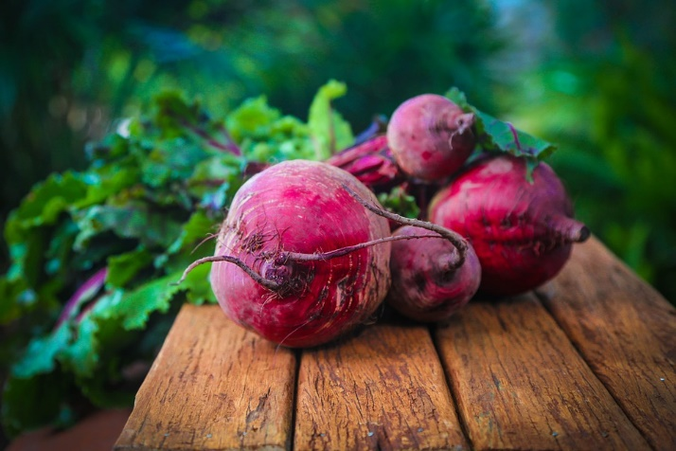
Photo courtesy of Pixabay.com
Ingredients:
- 3 medium beets
- 1 tbsp unsalted butter
- ½ c minced Vidalia onions
- 1 ½ Bosc pears-peeled, cored, and minced
- 2 tsp white sugar
- 3 tbsp cranberry vinegar
- ¼ tsp salt

Directions:
- Preheat oven to 400℉. Wash beets, and place in a roasting pan. Bake for 45 minutes to 1 hour, or until tender. Set aside to cool.
- Melt butter in a large skillet over medium heat. Stir in onion, pears, sugar, and vinegar; cook, stirring frequently, for 20 minutes.
- When the beets are cool enough to handle, peel and coarsely chop.
- Puree onion mixture in a food processor with a metal blade. Add salt and ½ of the beets; pulse 4 to 5 times. Add remaining beets, and pulse 2 to 3 times.
- Eat as a side dish, topping for meat, fish, or a salad.

Source: www.allrecipes.com
Serves 5-6
Nutrition Information
Calories 308
Total Fat 23 g
Saturated Fat 14 g
Sodium (mg) 256
Fiber 6 g
Total Sugars 15 g
Cholesterol (mg) 60
Protein 4 g

Dressing
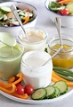
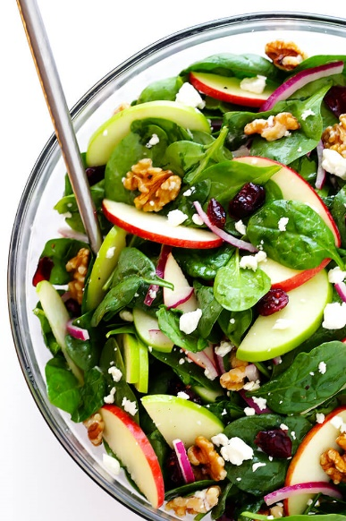

Greek Dressing
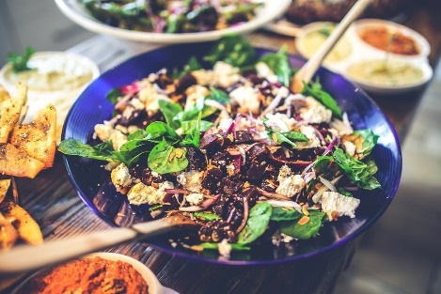
Serves 2 tbsp
Nutrition Information
Calories 122
Total Fat 13 g
Saturated Fat 2 g
Sodium (mg) 147
Fiber 0 g
Total Sugars 0 g
Cholesterol (mg) 0
Protein 0 g
Photo courtesy of www.kaboompics.com
Ingredients:
- 1 clove of garlic- minced
- 1 tsp dried oregano
- ½ tsp salt (optional)
- ¼ tsp ground black pepper
- ¼ c freshly squeezed lemon juice
- ½ c olive oil

Directions:
- Add minced garlic, oregano, salt, and pepper to the jar & mix/shake
- Squeeze lemon juice & strain seeds
- Add lemon juice and olive oil to the jar
- Close the jar and shake
- Pour on the mixture of salad greens
- Add roasted and raw veggies
- Add your choice of a crunch item
- Add additional seasoning and protein if desired

Source: http://www.simplyscratch.com/2010/11/my-big-fat-greek-dressing.html
For some reason, it always seems that when someone else makes me a salad it tastes better. I usually struggle to think of ingredients I could add to make my salad more flavorful and enjoyable. Here are a few steps that add variety and texture to boring salads.
- Start with a mixture of greens both tender and hearty- I like spinach and romaine.
- Add some roasted and raw veggies- this helps to add a variety of flavor and texture.
- Add dressing- you can make your own simple dressing at home!
- Add crunch- maybe roasted chickpeas, croutons, or nuts.
- Add seasoning- experiment and have fun.
- Add protein (optional)- especially if the salad is your main entrée. Try leftover chicken, nuts, beans, tuna, or a hardboiled egg.

These steps help me to construct a flavorful salad, has a variety of texture, and is not boring! I hope these tips help you love salads a little more.

Vinaigrette Salad Dressing
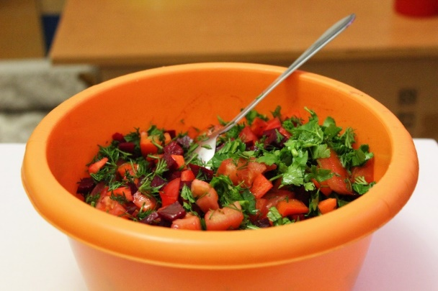
Photo courtesy of Pixabay.com
Ingredients:
- 3 tbsp shallots
- ½ c fresh basil leaves
- ¼ c extra-virgin olive oil
- 3 tbsp red wine vinegar
- 2 tsp honey
- 2 tsp Dijon mustard
- ½ tsp pepper
- ¼ tsp salt

Directions:
- Combine all ingredients in a food processor or blender and puree until smooth.
- Drizzle this dressing over sliced veggies, salads, beans, mix with cold grain salad, etc.
- This can be refrigerated up to 5 days, be sure to label with the date prepared.

Source: eatingwell.com
Serves 6
Nutrition Information
Calories 108
Total Fat 9 g
Saturated Fat 1 g
Sodium (mg) 140
Fiber 0.3 g
Total Sugars 6 g
Cholesterol (mg) 0
Protein 0.6 g

Greek Dressing
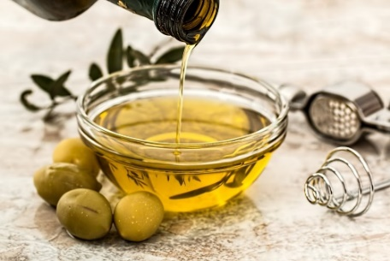
Serves 6
Nutrition Information
Calories 84
Total Fat 9 g
Saturated Fat 1 g
Sodium (mg) 147
Fiber 0 g
Total Sugars 0 g
Cholesterol (mg) 0
Protein 0 g
Photo courtesy of Pixabay.com
Ingredients:
- 1 fresh lemon
- ¼ c extra virgin olive oil
- 1 garlic clove
- 2 tsp dried oregano
- ½ tsp salt (optional)
- 1 tsp black pepper
Directions:
- Squeeze the juice of one lemon into a small mixing bowl
- Mince garlic and place into a bowl
- Wisk olive oil, garlic, and oregano
- Add salt and pepper to taste
- Toss on your salad & enjoy!

Source: https://www.primalpalate.com/paleo-recipe/greek-salad-dressing/

Nuts can be a great snack. Be aware of the serving size as the calories can add up quickly.
1 serving of nuts
1 ounce of Nuts

Almonds 20-24
Brazil 6-8
Cashews 16-18
Hazelnuts 18-20
Macadamia 10-12
Pecans 18-20
Pine Nuts 150-157
Pistachios 45-47
Walnut 8-11

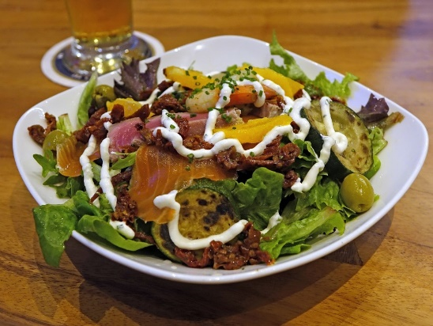
Creamy Herb Yogurt Dressing
Photo courtesy from Pixabay.com
Ingredients:
- ½ c milk
- 2 tbsp lime juice
- 1 c plain fat-free Greek yogurt
- ¼ tsp salt
- ¼ tsp pepper
- 1 tsp granulated onion
- 1 tsp garlic powder
- 1 tsp dried basil
- 1 tsp dried dill
- 1 tsp dried parsley

Directions:
- Combine milk and lime juice in a bowl. Allow mixture to rest for ~ 10 minutes
- Blend in the yogurt to the lime and milk mixture and rest for 5 minutes
- Add rest of the ingredients and continue mixing until fully blended
- Chill at least 12 hours before serving to allow the mixture to thicken
- Discard after 3 days

Note: This recipe is great for parties and especially when you can host quite a few people.

Nutrition Information
Calories 232
Total Fat 4 g
Saturated Fat 2 g
Sodium (mg) 740
Fiber 1 g
Total Sugars 15 g
Cholesterol (mg) 22
Protein 30 g
My Thoughts on Dietetics by Mikayla Lenz, UW-Stout Dietetic Student

Dietetics is an ethical pursuit to encourage and enhance the overall wellbeing of those around who may not be aware of the benefits of a balanced diet. A dietitian is a preceptor to those who are willing to listen and act on their health. I know that dietetics plays a key component between those in the medical field. I want to be that influencer and motivator for others. I care for others more than myself and I want to step up for those who need to care for themselves. I know I can implement nutrition into their lives with the knowledge at my hands. Thank you for influencing me and broadening my skillset by creating this cookbook!

About the Author
I am currently a junior at UW Stout and am going to further my education with a graduate degree. My favorite class that I have taken so far is microbiology. I wanted to be a part of the atmosphere even more, so I decided to be a lab assistant.
I have a loving family who supports me and allows me to try new recipes even if they are not the best. They always let me be creative in the kitchen. I love experimenting and finding my new favorite dishes, especially when I’m able to share my love in the kitchen with them.
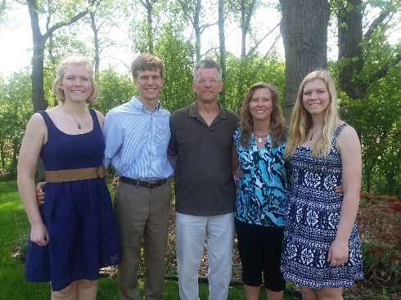
Down below are a few pictures of my family. My grandpa and I are boating together. The other is with two of my three siblings Treyton and Mackenzie and parents Treavor and Becky.
Picture Resources:
https://tse1.mm.bing.net/th?id=OIP.9qwhUVo-FToR1-kGkf4oVAAAAA&pid=Api&P=0&w=247&h=165

https://tse1.mm.bing.net/th?id=OIP.KTUg9RgImW0cb_FKcyeaBQHaLG&pid=Api&P=0&w=300&h=300

https://tse3.mm.bing.net/th?id=OIP.MY9DH9C9NL6FhMgwputnjgHaES&pid=Api&P=0&w=268&h=156

https://tse1.mm.bing.net/th?id=OIP.Q0PECwUilfhvBHvCatTNrgHaEK&pid=Api&P=0&w=348&h=197

https://tse1.mm.bing.net/th?id=OIP.3UG7_6tqv4PSvYNYo8eNWQHaEo&pid=Api&P=0&w=314&h=197

https://www.powertopay.com/wp-content/uploads/2013/10/iStock_000017574548_Full.jpg
https://tse4.mm.bing.net/th?id=OIP.fP8GNqCPGkwaxnbSuFxZZQHaIa&pid=Api&P=0&w=300&h=300

https://tse3.mm.bing.net/th?id=OIP.3uWQvs_wMqJkPExDY7RLPgHaHO&pid=Api&P=0&w=186&h=182

https://tse3.mm.bing.net/th?id=OIP.xAmYrY5NFt0ICfn6W4OuKQHaD3&pid=Api&P=0&w=327&h=172

http://parentingsquad.com/files/parentingsquad.com/styles/605x340/public/blog-images/family-cooking-pizza-Dollarphotoclub_65754176.jpg?itok=u0KlS3kd

https://tse2.mm.bing.net/th?id=OIP.dGB4RO9mYQtDNaIqG7WNFQHaFW&pid=Api&P=0&w=221&h=161

https://tse1.mm.bing.net/th?id=OIP.eBA0QwU5zua6MkVucIDQwwHaE8&pid=Api&P=0&w=250&h=167
https://tse3.mm.bing.net/th?id=OIP.kwbcdk3vYBhydIpgEP6pPwHaE7&pid=Api&P=0&w=227&h=152

https://tse4.mm.bing.net/th?id=OIP.bW8JqKVqPFS4jOamGoE_OwHaLH&pid=Api&P=0&w=300&h=300

https://tse1.mm.bing.net/th?id=OIP.8LA3LRnTmeT9tWAkAf8Z-QHaE7&pid=Api&P=0&w=272&h=182

https://tse2.mm.bing.net/th?id=OIP.eYV2PqsLCsZ9GmQGQj2FcAHaDt&pid=Api&P=0&w=326&h=164

https://tse2.mm.bing.net/th?id=OIP.5eKlW4pPKI2O9Sw0JMCELgHaFj&pid=Api&P=0&w=215&h=162

https://tse1.mm.bing.net/th?id=OIP.TafkFkVd7YrX7slTTyqW7gHaKu&pid=Api&rs=1&c=1&qlt=95&w=82&h=119

https://www.gimmesomeoven.com/wp-content/uploads/2016/09/Easy-Apple-Spinach-Salad-Recipe-Vegetarian-Fall-Vinaigrette-1.jpg

