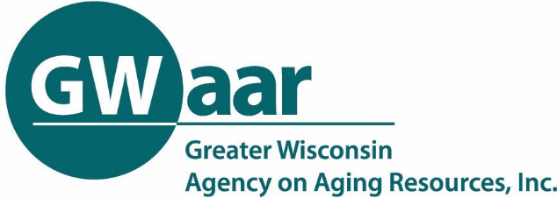
Aging Plan Development Support Meeting
February 25, 2021 --- 1:00-2:00 p.m.

Required Focus Area Review

Recording of the call: Click Here
GWAAR’s Aging Plan website: https://gwaar.org/plansamendmentsassessments

NOTES

Aging Plan Development Support meetings will occur on the 4th Thursday of the month at 1:00 for the next 6-7 months to help Aging Unit staff complete their 2022-2024 Aging Plans. Instead of offering one long meeting we will be providing guidance on one section/aspect at a time. The overall purpose:
- Increase understanding of the various sections of the plan
- Provide specific expectations and requirements
- Offer an opportunity to share ideas and ask questions
All materials related to developing your 2022-2024 Aging Plans can be found here: https://gwaar.org/plansamendmentsassessments

- Overview of Required Focus Areas for 2022-2024 Aging Plan Goals (Cindy)
- Reviewed the 4 program goal areas and 4 value goal areas
  - Program Goals
    - Title IIIB Supportive Services
    - Title IIIC Nutrition Program
    - Title IIID Health Promotion
    - Title IIIE Caregiver Support
  - Value Goals
    - Enhance ongoing community engagement
    - Person-centered services, maximizing consumer control and choice
    - Address a barrier to racial equity
    - knowledge and skills related to advocacy
- Goals
  - You are not expected to have a single goal for each area for each year.
  - Want you to consider long term goals that might take two or three years to accomplish.
  - You will have to show accomplishments or milestones toward your long-term goals
  - Your goals are structured more like a strategic plan in terms of outcomes
- Supportive Services Title IIIB
  - Many counties use their Title IIIB for general funding and salaries and not sure how to structure a goal around that.
  - Looking into what the federal agency is anticipating and will continue the conversation.
  - Some examples the OAA consultants thought up are focused on transportation, which isn’t included in the other focus areas.
  - Look for additional ways to use this goal area to build partnerships with service providers, advocacy to make services more accessible to older adults and individuals with disabilities.
  - The advocacy “value goal” could possibly count as your Title IIIB
- Milestones
- Milestones are things that would change, happen, or be completed at some point that would show that you're making progress. Annual AAA check-ins would be a good time to check on progress.
- Value Goals
- Value goals can count as a program goal if they are thoughtful in thinking about how to bring value goals onto program goals. They will have to be complex and meaningful.
- Sample Plans
  - Will get sample goals in all of the areas
- Visual
  - Working on template on what the document is going to look like.

- Vision of Wisconsin Aging Programs (Neal)
- Looking at goals from a short- and long-term perspective.
  - When writing you goals look beyond the three-year plan, think about where you want to be 10 or 20 years from now.
- There are huge challenges in front of us that are not going away
  - Poverty.
  - Programs serving equitably
- Great opportunity to think beyond 3 years
- Need to keep in mind the values of the Older American’s Act and serve those most in need
- We are changing the order of plan completion - County completes first, then AAAs, and then the state.
- When developing your goals think about the long path goal. A long path goal could appear in multiple plans.
- Recommended looking into “Long Path” planning

Q/A (ALL)
- There has been some flexibility in funding as a result as the pandemic and wondering when it will end. Answer: We don’t foresee the flexibility of funding continuing for planning cycle 2022-2024.
- What about “Wicked Questions”
  - Where can we get data to help solve these complex wicked questions? There will be data links provided to help.
  - Committees can help address some of these wicked questions. Little changes can make a big difference.
  - Lots of partners, like county health department, can help in the planning.
  - Link to Eric’s webpage for data : https://www.dhs.wisconsin.gov/aging/demographics.htm
  - How is public input going?
    - Tammy has been going to vaccination clinics for surveys – received over 200 participants.
    - Some struggling because pandemic and lack of internet
    - Working with advisory committees
    - Carissa received over 650 surveys through a mailing with pre-paid postage return envelop
    - OAA consultants can present on aging plan at advisory committee
    - Engage with commission and ask them to be community ambassadors. They can call and get public input.
    - Susan worked with county board supervisors to hand out to constituents and received about 200 back
    - Share ideas on community engagement to Jane or Nick to put in GWAAR newsletter

