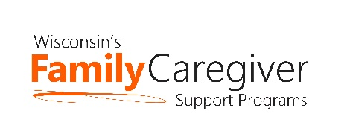

Wisconsin Caregiver Support Community Statewide Call
February 23, 2021 --- 10:00-11:00 a.m.
NOTES

Zoom Meeting Recording

- Advocacy Update – Janet Zander, GWAAR
See Feb 23 Advocacy Report – State Budget Summary.

- How to Engage Caregivers on Trualta – Pamela Tannouri
- Great ideas for engaging with caregivers who have signed up for Trualta. Suggesting content to caregivers enrolled in Trualta increases their engagement. It doesn’t take long to suggest content. Put it on your calendar at least monthly. See PowerPoint or view the Trualta webinar about engaging caregivers here. A link to the recording and slide deck can also be found in the Staff Space.
- There will be an additional Wisconsin Trualta staff training on March 11 from 11:00-12:00 pm (CST). This would be great for new coordinators and a good refresher for the rest of us. Here is the login information.
- Trualta sends out notifications to those who request to get notifications and will only get things that they selected as a topic of interest. New content uploaded every week or two.
- This week Music for Meditation for Caregivers will be uploaded to the portal.

- State and GWAAR Updates
- A draft version of the updated Chapter 11 (NFCSP) policy (and AFCSP) was sent out on February 11 and is posted on the GWAAR website. All of the policy waivers and changes and memos over the last years are now included in the policy.
- Grandparents and Relative Caregiver Update – A new workgroup will be formed under the umbrella of the Wisconsin Family & Caregiver Support Alliance (WFACSA). We are rounding up a dedicated number of people to attend monthly meetings to work on projects to increase visibility and support of relative caregivers. If you are interested in learning more about this group please complete this form. We will continue to have the Listserv where information about programs, presentations, advocacy efforts, resources and other supports for relative caregivers will be shared. If you want to join the listserv please sign up here.
- Please check the wisconsincaregiver.org website and verify the contact information for your agency is correct!
- Lynn will be forming a workgroup to discuss the issues surrounding “after caregiving” with the goal of creating an “After Caregiving Guide.” The idea would be to collect the various things that would be helpful to a caregiver after they are no longer providing care. Let Lynn Gall know if you are interested in helping with this statewide project.

- Assistive Technology and Ensuring Connections – Laura Plummer, DHS
- See power point for details on the presentation. There is a list of questions that can be used to help determine what type of technology might be best for people based on their situation.

- Next Meeting is March 23 at 10:00. The presentation will be a panel of caregiver support group facilitators (who are also DCSs) sharing ideas and best practices, and answering any of YOUR questions about how to plan and facilitate a caregiver support group.

