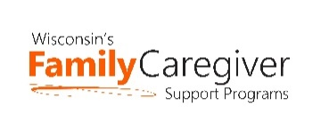
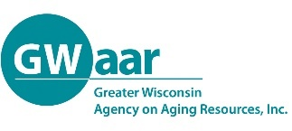
Grandparent and Relative Caregiver Workgroup - Updated
February 15, 2021 @ 1:00 pm
NOTES

RECORDING: https://zoom.us/rec/play/ppH262wH9oTVo7oIyYQCyw1GkADyBMvmc9QmHc1LGfhSzFOFaWQMk5YZsjAfsycjHLUrLVUQwXOpt8ab.8Tere2F9TFnY56fo?autoplay=true

- Presentation - Dealing with Anger and Resentment Towards the Birth Parent, Peg Cadd
Being a relative caregiver comes with many challenges. There can be anger and resentment towards the birth parents and added to that the stress of other family members pressuring you. Everyone has a different idea of how to parent and how the process should work. Join us for a short conversation on the stresses and how to help make it better for all involved. (Peg Cadd has been actively involved as a foster parent and trainer in Child Welfare in Wisconsin for over 38 years.)

Peg Cadd pegcadd@gmail.com

- Restructuring of RAPP Workgroup – Jane Mahoney and Rachel Watkins-Petersen, C0-Facilitators
This “RAPP Workgroup” has accomplished a lot over the last 2 years.
- Increased our knowledge of each other’s programs across the state
- Created a website of resources for Grandfamilies and Kinship families
- Created handouts for relative caregivers
  - NFCSP-RAPP Handout
  - Grandparenting & Kinship Care Resources
- Celebrated Wisconsin’s first Kinship Care Week

Moving forward there will be two ways to participate:
- Workgroup - We now have the opportunity to expand our work by creating a workgroup under the Wisconsin Family & Caregiver Support Alliance (WFACSA). The workgroup will join other workgroups (Employer Engagement, Family Navigator, and Expanding Respite) to help meet the mission of the WFACSA:
“Our mission is to raise awareness of family and caregiver support needs and increase the availability of and access to services and supports (both paid and unpaid) which will keep people across the lifespan engaged in their community as long as they desire.”
The workgroup would meet about every month, decide on a project or two to work on in 2021. One of the members would attend the monthly Steering Committee meetings to report on the activities of the workgroup and be the voice of relative caregivers in all topics discussed by the Steering Committee. If anyone is interested in learning more about participating in the workgroup, please fill out this form here and Rachel or I will be in touch. It is a great opportunity to participate in statewide work.

- Listserv: For those who are not interested in serving in the workgroup, we will continue to have the Listserv where information about programs, presentations, advocacy efforts, resources and other supports for kinship families, grandfamilies, foster, and adoptive families are shared. If you want to join the listserv please sign up here. Feel free to share this link with others who might be interested.

- Program Updates
- Christy from WI Adoption and Permanency Support shared about the virtual support groups and other events that are occurring. See flyer for details: https://wisapsp.org/wp-content/uploads/2018/03/KINnect-Family-Events.pdf
- Suggestion to find someone from the K-12 School District to participate in the workgroup. If anyone has any leads, please let Jane or Rachel know!

Notes by Jane Mahoney
GWAAR

