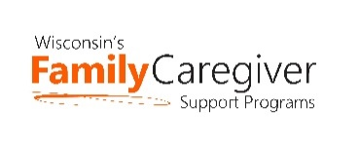
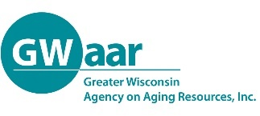
Grandparent and Relative Caregiver Workgroup - Updated
February 15, 2021 @ 1:00 pm
AGENDA
Join Zoom Meeting
Or call in: 1-312-626-6799
Meeting ID: 972 3772 0502
Passcode: 216243

- Welcome and Check-In – Jane Mahoney

- Presentation - Dealing with Anger and Resentment Towards the Birth Parent, Peg Cadd
Being a relative caregiver comes with many challenges. There can be anger and resentment towards the birth parents and added to that the stress of other family members pressuring you. Everyone has a different idea of how to parent and how the process should work. Join us for a short conversation on the stresses and how to help make it better for all involved. (Peg Cadd has been actively involved as a foster parent and trainer in Child Welfare in Wisconsin for over 38 years.)

- Restructuring of RAPP Workgroup – Jane Mahoney and Rachel Watkins-Peterson

- Program Updates – everyone

- Next Meeting

Purpose of RAPP Workgroup
Increase the number of Grandparents/Relative Caregivers being served in the state through:
- Replication of successful programs in new parts of the state
- Increasing attendance/use of existing programs with new ideas for engaging participants
- Increasing use of existing programs by better communication between organizations serving relative caregivers
- Collaboration for grants or new programs

