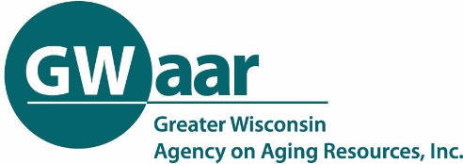
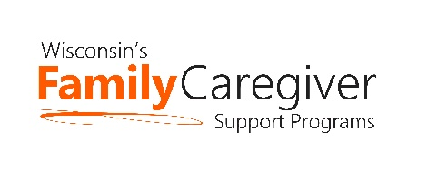

Wisconsin Caregiver Support Community Statewide Call
January 26, 2021 --- 10:00-11:00 a.m.
NOTES

Meeting Recording: https://zoom.us/rec/share/ouuQ3iqNzK3OP3svEgSsrCsfnHGvssLRPcaWBUIx602fwkLg0sd7MpujL7Lz_xFh.OYcyFg-3xS8t4r6m

- State and GWAAR Updates
- Trualta update
  - When a person signs themselves someone from the AU needs to make contact with them. They get notified that someone from their local agency will be contacting them so they should know it is going to happen. View it like someone calling or visiting your agency - when they sign up they are reaching out for help. It is not a cold call to respond to them as they initiated the service. They might not respond so be prepared to send more than one email. You can also engage with them on the platform by recommending content. Don’t give up but don’t pester. If they never respond that is out of your control and you won’t be able to put them in SAMS. They will be included in my report of the number of people enrolled.
  - I will be sending a Trualta user report so you have the data needed to enter your caregivers into SAMS. If they have not viewed any modules, they do not need to be entered.
  - Check the GWAAR website for Trualta instructions https://gwaar.org/family-caregiver-support-for-professionals Scroll down and click Trualta
- NFCSP exemptions have been extended to the end of 2021. This includes:
  - Removal of 112-hour cap on respite
  - Removal of 20% cap on supplemental services
  - Allowance for caregivers to be paid for providing care that was previously provided by an agency
- 2020 AFCSP Fiscal Reports - people will be receiving a link to submit their report in February.
- Budgeting caregiver funds – funds need to be spent and services delivered by the end of the funding period – frequent follow-up with caregivers is a must in order to help reduce the amount of underspending and ensure that caregivers are receiving the supports they need.
  - There have been questions about whether or not aging units need to send 1099s to caregivers who hired non-professionals for respite. I am working with the state on a final answer on this. In addition to telling caregivers to check with their tax advisor, this is a good website to consult: https://www.irs.gov/businesses/small-businesses-self-employed/family-caregivers-and-self-employment-tax

- Using OARS to Interview Caregivers - Brian Binder and John Plageman, ADRC of Brown County
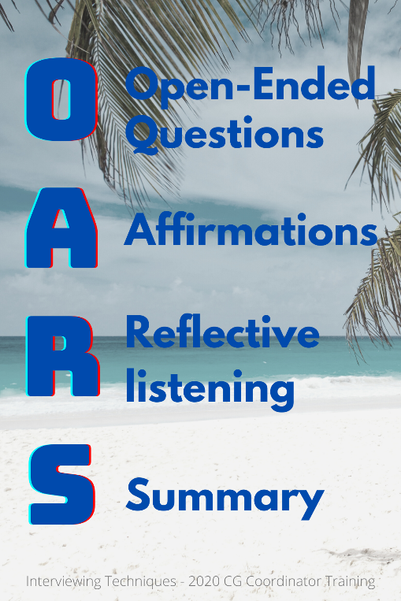
- Watch the recording (starts at 22:54) to see how to use Open ended questions, Affirmations, Reflections and Summaries while interviewing a caregiver to complete the needs assessment. Some tips:
  - Be comfortable with silence – allow the caregiver enough time to reflect and answer your questions – if you are talking more than they are, you’re not doing a great job.
  - Turn the interview into a conversation – shouldn’t feel like an interview
  - Ask permission to ask questions – builds rapport
  - This conversation can be a helpful to the caregiver in itself – a chance for the caregiver to tell their story to someone who listens and cares
  - Be patient when learning how to use OARS – try one technique at a time – “I will focus on using Affirmations in this interview”
  - See MI Cheat Sheet handout from John and Brian
  - See Open Ended Questions handout

Next call: February 23 at 10:00 am.
Topic: Assistive Technology update
Speaker: Laura Plummer

