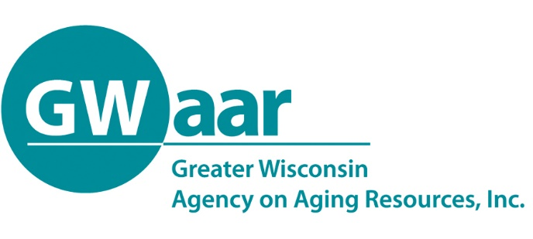

November 24, 2020

Dear Providers:
Re: General Reminders and 2021 Budgets
Hope this memo finds you all healthy and well.

The GWAAR Fiscal Staff wish to thank you for your hard work in getting your fiscal claims and SAMS data in by the deadlines. Your efforts have resulted in GWAAR having one of the most complete Federal Fiscal Year reports ever. Even with having complete fiscal data and SAMS data, the only outstanding issue is how they look when put together. We still have some work to do, but overall it has been an outstanding year.

Now that we have started the new Federal Fiscal Year, please keep up the great efforts in keeping your SAMS and Fiscal data current.

If you are looking for your MIPPA and NSIP contracts, we’ve heard from the State that they are in the approval process and we should be getting them out sometime in December via DocuSign. A new October-December claim form will be posted by December 4th, whether or not we have received these contracts.

As we begin to wrap up 2020, GWAAR will be sending out each providers variance report, which will have both your SAMS and Fiscal data. These must be returned to GWAAR by December 21st and then GWAAR will rolled them up and submit it to the State by our deadline.

By this time you should all be pulling together your 2021 budgets as they must be submitted to the GWAAR Fiscal email at fiscal@gwaar.org by 5pm on Wednesday, December 16th. The most recent version is on the website. We’ve had some questions about the carry over of funds from 2020, so as a reminder, the carry overs are:

- 100% of all remaining Title III (B, C1, C2, D and E), FFCRA and CARES funds will be carried over into 2021. These must be spent by 9/30/2021.
- State Senior Community Services (SSCS), Elder Abuse (EA) and Elder Benefit Specialist (EBS) funds will NOT carry over and must be spent by 12/31/2020.
- Alzheimer’s Family Caregiver Support Program (AFCSP) will only carry over 3% as usual.

Thank you for all that you do to serve the people of Wisconsin. Please feel free to call or email us with any questions or concerns you may have. Take Care.

Patrick

Patrick Metz, MA, MPH
Fiscal Manager
Cell # (608) 228-8089
patrick.met@gwaar.org

