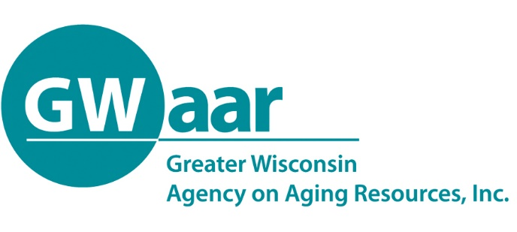

November 9th, 2020

Dear Providers:
Re: 2021 Budgets
Hope this memo finds you all healthy and well.

It is that time of year to submit your 2021 budgets to GWAAR. As you are developing your budgets, you will see that your budget allocations are based on the 2020 OAA original budget allocations. New to the form this year, we have added a column to allow for 2021 carryover projections. The 2021 budget form is attached and will be available on the GWAAR website at www.gwaar.org/fiscal-p. The completed forms must be submitted to the GWAAR Fiscal email at fiscal@gwaar.org by 5pm on Wednesday, December 16th.

Some reminders to consider when completing your budget form:
- Assume that normal spending and carryover requirements will be in place for 2021.
- All expenses reported on the GWAAR claim form must be used to support the provision of a Title III service.
- Do not include expenses for services provided through s85.21, Family Care, IRIS or Title VI dollars – or those services that are paid as a private pay, ineligible Title III service.
- AMSO expenses – encourage minimal use to conserve funds for actual service provision. If your County/Tribe charges you for those expenses, record them under the source of payment (i.e. contract) and if you don’t have to pay for them, you may record them under In-Kind.
- Transfer requests on this form are not the official transfer request as those will come out separately in March/April 2021.

Thank you for all that you do to serve the people of Wisconsin. Please feel free to call or email us with any questions or concerns you may have. Take Care.

Patrick

Patrick Metz, MA, MPH
Fiscal Manager
Cell # (608) 228-8089
patrick.metz@gwaar.org

