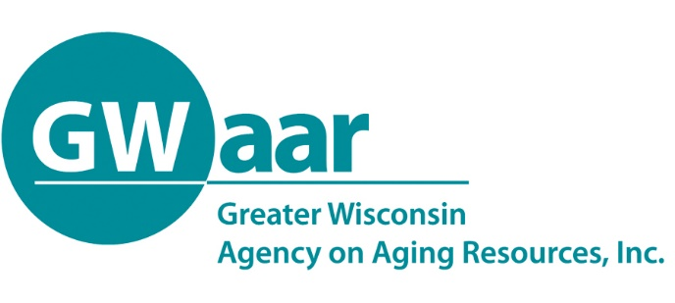

September 10th, 2020

Re: Transfer request update

Dear Providers:
I hope you are all staying healthy and well. This letter is to provide an update on the status of the transfer requests we have received and processed through the Bureau of Aging and Disability Resources (BADR). The transfer requests have been reviewed and approved by (BADR) and the Administration of Community Living (ACL). While all transfer requests submitted have been approved, we want you to be aware of differences you will see between your GWAAR claim form allocations and what will be in the contract amendments from GWAAR.

For those that submitted June requests, those will be included in your contract amendments, except for Title III-D, Title III-E and CARES-E requests. With the major disaster declaration, ACL provides that the state can utilize flexibility in spending those D and E funds without formal transfer. Therefore, while the transfers are approved, you will not be seeing the movement of those funds on your contract amendments.

For the July transfer requests, transfers were approved but not formally processed within Title III-C programs. ONLY Title III-B and CARES-B will be included in your contract amendments for July.

Please continue to claim your allocations and enter your SAMS data to conform with what you submitted in your June and July transfer requests. GWAAR will do the rest to meet the federal reporting requirements of our State and Federal partners.

Should you have any questions regarding this memo, please reach out to either myself or Carrie Kroetz. We would be glad to assist.

Thank you.

Patrick

Patrick Metz, MA, MPH
Fiscal Manager
Greater Wisconsin Agency on Aging Resources, Inc.
1414 MacArthur Rd, Suite A
Madison, WI 53714
Cell # (608) 228-8089
patrick.metz@gwaar.org
www.gwaar.org

