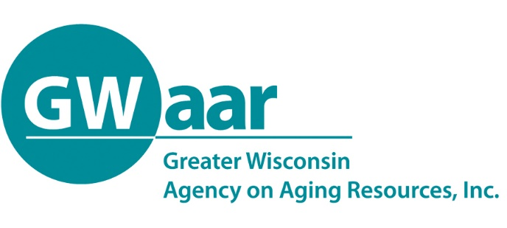

August 31, 2020

Re: Transfer request update from BADR

Dear Providers:
This letter provides an update on the status of the transfer requests received by and processed through the Bureau of Aging and Disability Resources (BADR). The transfer requests have been reviewed and approved by BADR, and the proposed modifications in use of program funds have been approved by ACL as allowable under the major disaster declaration approved by the Federal Emergency Management Administration.

One technicality in this process requires explanation. In contrast to normal procedures for transferring funds across program areas, ACL is allowing states flexibility in spending program funds where they are most needed without making formal transfers. This means that local Aging Units can use funds as requested on the “transfer forms” submitted in June and July, but except for the Title IIIC1 and IIIC2 transfers requested in June, and Title IIIB transfers requested in July, the funds will not be moved across programs as contract amendments. Instead, GWAAR has used the transfer requests to create a system for tracking the intent of counties and tribes to spend these funds in specified program areas. Your expenses will be monitored and paid by GWAAR as indicated in your transfer requests and approved by BADR and ACL.

The ACL did formally transfer funds from Title IIIC1 to Title IIIC2 as requested by local aging units in June, and Title IIIB funds as requested in July, and those transfers will be reflected in contract amendments. However, these exceptions to the general approach outlined here will not require special action on the part of local aging units when it comes to reporting. You will claim your expenditures for all programs and enter your SAMS data for all programs to conform with what you submitted in your transfer requests, whether or not the funds were formally moved through contract amendments. GWAAR will do the rest to meet the reporting requirements of our State and Federal partners, who need to document how the funds were spent to provide services.

Should you have any questions regarding this memo, please reach out to GWAAR fiscal staff for further assistance.

