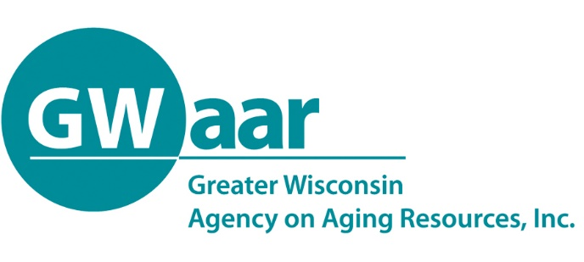

August 10, 2020

RE: MIPPA Year End Closeout

Dear Providers:
Hope this memo finds you all healthy and well.

DEADLINE - Friday August 14, 2020.

The MIPPA Contract closes on 9/30/2020. The State needs to know who is not going to be able to spend their MIPPA claims by this Friday. If I don’t hear from providers, the State may reallocate your MIPPA funding. So please send an email to fiscal@gwaar.org with a note that you either will or will not spend your remaining MIPPA contract amount and what that amount is that won’t be spent. I apologize for the short notice, but just received the email from the State this afternoon.

As always, should you have any questions or concerns, please call or email GWAAR fiscal staff. We are here to help.

Thank you.

Patrick

Patrick Metz, MA, MPH
Fiscal Manager
Greater Wisconsin Agency on Aging Resources, Inc.
1414 MacArthur Rd, Suite A
Madison, WI 53714
Cell # (608) 228-8089
patrick.metz@gwaar.org
www.gwaar.org

