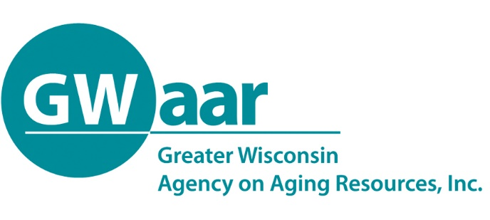

July 20, 2020

Dear Providers:
Hope this memo finds you all healthy and well. Just wanted to give a quick reminder that the second and final of two allocation transfer opportunities is due this Friday 07/24/2020.

When making transfer requests, keep in mind that there are three different pots of funding (Original Title III, FFCRA and CARES Act) and the transfers can only occur within the same pot of funding. Also keep in mind that once you request this final transfer, the transfers cannot be reversed.

Please send your transfer request to the GWAAR Fiscal email at fiscal@gwaar.org. The attached official excel transfer form from GWAAR must be used to make the transfer requests, which can also be found on the GWAAR website’s fiscal page. Any transfer requests that were submitted in your original budget last year will not be considered – all requests must now be made via the official transfer form. As always GWAAR fiscal staff are at the ready to assist you with this process, as well as completing your claim forms.

These transfer requests will result in additional contract amendments that will come via DocuSign, so make sure that GWAAR has the most up-to-date contact information to allow for timely completion of these amendments. If you request transfers in each of the three (3) pots of funding, you will get three (3) separate contract amendments. Please send your contract and amendment questions, as well as any updated contact information, to Sky Van Rossum at Sky.VanRossum@gwaar.org.

Thank you.

Patrick

Patrick Metz, MA, MPH
Fiscal Manager
Greater Wisconsin Agency on Aging Resources, Inc.
1414 MacArthur Rd, Suite A
Madison, WI 53714
Cell # (608) 228-8089
patrick.metz@gwaar.org
www.gwaar.org

