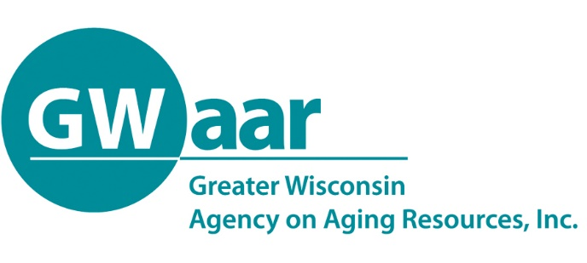

July 6, 2020

Dear Providers:
Hope this memo finds you all healthy and well. A newly updated GWAAR claim form is coming out this week with updated contract numbers for those who requested transfers and for those that applied for and received any special project funds.

What you will also see in this updated form, is the service usage percentage requirements in the Title III-B services of:

- 6% of Access to Services
- 5% of Legal/Ben. Assist.
- 7% of In-Home Services

also applies to the same service lines in the CARES B tab.

The 20% limit on Supplemental Services in Title III-E will also apply to services provided in CARES E – Supplemental Services.

The SPAP error that many of you were seeing will also be fixed along with a few other formula fixes.

As always, if you find a formula or something that just doesn’t work or look right, please give the fiscal staff a call or email, so that we can fix it for everyone.

Thank you.

Patrick

Patrick Metz, MA, MPH
Fiscal Manager
Greater Wisconsin Agency on Aging Resources, Inc.
1414 MacArthur Rd, Suite A
Madison, WI 53714
Cell # (608) 228-8089
patrick.metz@gwaar.org
www.gwaar.org

