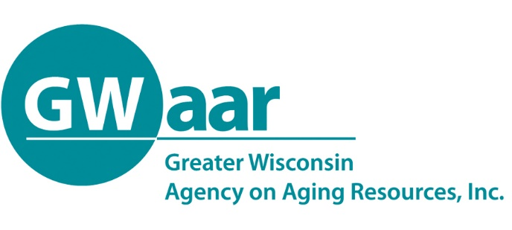

May 29, 2020

Dear Providers:
Hope this memo finds you all healthy and well. As GWAAR is beginning to review your April claim forms, we have been seeing some issues and want to make sure everyone is on the same page with how the claiming should work with the new Families First Coronavirus Response Act (FFCRA) and Coronavirus Aid, Relief, and Economic Security (CARES) Act funding. While the FFCRA and CARES Act funds were distributed as amendments to the Original OAA contract, they are each unique pots of funding that must be tracked separately both fiscally (GWAAR Claim Form) and programmatically (SAMS).

NOTE: If you have already submitted your April claim form, please review it and make sure that it complies with the guidance given below. If it requires revisions, please make those revisions and resubmit to the GWAAR fiscal@gwaar.org email.

In addition to the guidance below, GWAAR will be presenting a Fiscal webinar:

Subject: Fiscal Webinar – Addressing FFCRA and CARES Expense Submissions
Date: Tuesday, June 2, 2020
Time: 11:30am-12:30pm
Call-in Information: 1-800-977-8002
Call-In Code: 4645344#
Link: : Fiscal Webinar 06-02-20 (enter your name as a guest)

For those unable to participate, the webinar will be posted within 24 hours within the Fiscal Training webinar library (Fiscal Webinars Library).

As of April 1, 2020, all Home Delivered Meal – C2 costs must be claimed against your program income collected for the month and the FFCRA-C2 funding. You should also continue to use your Nutrition Services Incentive Program (NSIP) funding to cover the raw food costs of the meals provided, as well as supplementing your costs with the State Senior Community Services (SSCS) allocation. If you should have some unspent Title III-C1 and /or Title III-C2 Program Income, in your March 2020 GWAAR Claim Form, please expense the unspent balance(s) to the FFCRA tab - Program Income Expense columns. Program Income should always be spent first and should not be reported more than once within the claim. One last important point to remember is that both FFCRA and CARES Act funding DO NOT require a match, so Cash Match expenses should not be claimed at all, but you still may report any In-Kind Match within the Title IIIC-2 tab for continued reporting purposes.

Once you have fully expended your FFCRA allocation, follow the same process in the above paragraph using the CARES C2 Act funding, keeping in mind that you still must spend your program income first.

Also beginning with the April claim form, if you have III-B and III-E expenses to be claimed, you must claim those expenses against the CARES Act B and E allocations, until they are fully expended; once again using any program income first.

Now…what everyone has been waiting for…there will be two chances to transfer funds. Keeping in mind that there are three different pots of funding (Original Title III, FFCRA and CARES Act) and the transfers can only occur within the same pot of funding. GWAAR will be distributing a transfer form that will allow you to request transfers within each pot of funding, keeping in mind that once you request the transfer, you cannot reverse it after the final submission date.

The first transfer request will be made available next week and will be due back to GWAAR no later than Friday, June 26th. You must use the official transfer form from GWAAR to make your transfer requests. Please keep in mind that you may want to re-open a congregate site later in the year, so you may wish to conserve some of that funding for later. To make it an easier decision, you will have a second chance to transfer funds with a deadline of Friday, July 24th. That transfer request form will be sent out in the first week of July to give you plenty of time to consider your final transfer request. As always GWAAR fiscal staff are at the ready to assist you with this process as well as completing your claim forms.

These transfer requests will result in additional contract amendments that will come via DocuSign, so make sure that GWAAR has the most up-to-date contact information to allow for timely completion of these amendments. If you request transfers in each of the three (3) pots of funding, you will get three (3) separate contract amendments. Please send your questions and updated contact information to Sky Van Rossum at Sky.VanRossum@gwaar.org

One last gentle reminder is to make sure that you get your claim forms in by the 10th of each month, as with the additional workload at GWAAR we can no longer assure that last minute claims get processed and paid timely.

Thank you for all that you do to serve the people of Wisconsin. Please feel free to call or email us with any questions or concerns you may have. Take Care!

Patrick

Patrick Metz, MA, MPH
Fiscal Manager
Greater Wisconsin Agency on Aging Resources, Inc.
1414 MacArthur Rd, Suite A
Madison, WI 53714
Cell # (608) 228-8089
patrick.met@gwaar.org
www.gwaar.org

