Meeting Invitees: Nutrition Directors

Agenda:
Time: | Topic: | Discussion | Follow-up Items:
1:30 pm | Welcome | Thank you for joining the call today! Winter arrived too early this year.  The Theme is Winter Preparedness. We will be focusing on the following 3 areas:  - Back-Up plans for Staff and Volunteers who have to quarantine and/or if your vendor is ill and unable to prepare meals?  - Grab n Go- what are your plans for the winter months?  - Social Connectedness- What are you doing to keep people engaged and feeling connected?  - Other? | Access the recording of the 10/23 call at this link
 | Back-Up plans for Staff and Volunteers who have to quarantine and/or if your vendor is ill and unable to prepare meals? | - LCO staff exposed; quarantine for 2 wks.; and E.C. county central kitchen staff exposed… b/up w/ Fall Creek School district... but they are also quarantined (need multiple b/up plans in place).  - Alberta from LCO said to make sure you touch base w/ all home delivered folks to make sure you have correct contact info… some may have new #s.  - Have a conversation w/ your counties and tribes next to you to see if they are willing to help with meals in the event of an emergency (Mutual Aide Agreement). Some other partners to consider reaching out to for meals, frozen storage for additional meals, dry storage for boxes of food, cooks since they are likely Serv Safe trained. Bottom line,  - Restaurants  - Caterers  - Hospitals  - Jail  - Nursing Homes/Assisted Living  - Schools/Colleges/Universities  - Grocery stores/deli  - Food Bank and food pantries  - Casinos  - Work with your Food Vendors and know what they have available for shelf-stable meals. It’s a good idea to send out a 3-day supply of meals (frozen or shelf-stable) in case there is a delay in getting the emergency backup started.  - Barb Applebee…someone else stepped up to do shelf-stable meals for LCO (?)  - LCO has a strong relationship with the vendor who supplied Shelf Stable meals  - Chippewa share meals w/ E. C. – don’t put all eggs in one basket... have multiple relationships to help w/ meals in the future.  WHAT PLANS HAVE YOU MADE?:  - Scott (Ho-Chunk)… early experience in March; staff member positive; drew cooks in from other meal sites (closed a few days around Easter… had zero interruption… have cooks and staff in 5 sites to step in  - Darby (Barron) – staff is b/up plan…could bring in other staff trained to do the cooking;(PAM -do you have staff who are Serv Safe trained)  - Barb (Sawyer)– Hayward – closed Winter and Exland in spring… restaurant in Exland stepped up. Drivers took meals to Winter... Exland folks picked up their meals… for 2 wks. Seem to be short or ppl quit every week. Very emotional and stressed (mentioned crying).  - Missy (Washburn) – has a plan... 2 site mgrs. In Birchwood who filled in cooking… Spooner kitchen; previous site mgr willing to fill in. Bulk food out of one location would result in adjusting delivery times.  - Clark co. – relief staff; 2 kitchens; frozen meal and pantry items  Nick Musson, GWAAR Transportation Specialist asked – does anyone have b/up for HD meal drivers?  Do you have plans to advise participates of delays?  - Missy – using transport drivers to help if volunteers out  - Jean/Bad River – no meal driver… Jean has been in the position since 8/31.. hoping to hire a driver but no luck so far. Cook and Jean split meal routes. Assist cook does curbside. HD… sent a letter out to supply cooler outside door so no contact. The staff is tested every Monday. Talking about b/up and frozen meals.. need time and staff. Challenging 7 wks. Also, shelter at home in Bad River right now. Prepackage food/freeze when they do have time… at least for homebound people. Less urgent for curbside because they can be out and about. (Pam – yes can make ahead and freeze. need to follow parameters – Pam will f/up ) – Reinhart is the distributor.  - Pam – keep in mind. Work with local restaurants and casinos (some casinos are closed; restaurants too); tricky w/ frozen and shelf-stable... not as healthy.  - Darby – Suspended dining at 9 sites and they are back up now. Drivers. Barron county does shared positions... paid drivers work 2 wks. on 2 off. Reach out if you would like more info on that… retired folks like those positions. AddLIFE Transit also does 2/2. Reinhart has shelf-stable and emergency meal packs (micro)..they arrived within 1 week. However, be sure to order early, supplies may become an issue.  - Jen J. shared the 2 weeks on 2 weeks off rotation has helped a ton!  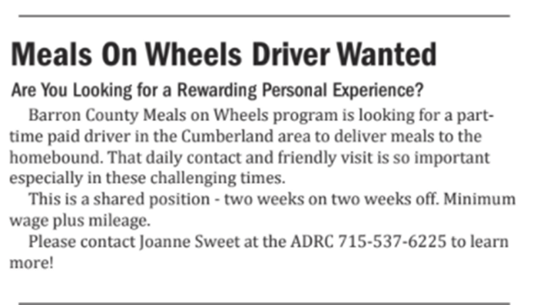  - Jean Lynch suggested reaching out to local rotary club, they have funding for Blizzard Meals and they may fund COVID meals, it doesn’t hurt to ask.  SHELF-STABLE MEALS / EMERGENCY  - Barb (Sawyer) – picked up 150 meals (stew, soup, sausages, beans, cookies, crackers, milk, water) – enough for 3 days. Been doing for 5 yrs. (Community food shelf – do for free!) Reach out to Pantries. A local church has a food pantry…brings some food to them too. They have a freezer full.  - Darby – tried to order from Traditions. they are a few months behind... still have an order in w/ them though (these meals would meet 1/3 of DRIs for older adults).  - Missy – Darby... are the ones from Reinhart the basic or complete? Darby.. basic micro. Missy – did box deliveries and provided those types of meals.. people like them but complaints about sodium. Darby – yeah, not the most nutritious, but something).  - Sarah stated that there might be another uptick in March. So order shelf-stable meals sooner than later  - Renea – St. Croix Cty ordered meals from CPI. They come in small boxes.. needs to look over (1 wk turnaround to receive)  - Alberta...LCO – make sure you get permission from participants that its ok to share their info w/ other drivers… | 11/6 Nutrition Peer Sharing Call Information (Lori’s Region)  Join Microsoft Teams Meeting  +1 608-338-1382 United States, Madison (Toll)  (877) 565-2671 United States (Toll-free)  Conference ID: 177 962 308#  11/13 Nutrition Peer Sharing Call Information (Jean’s Region)  Join Microsoft Teams Meeting  +1 608-338-1382 United States, Madison (Toll)  Conference ID: 475 093 689#
 | Grab n Go- what are your plans for the winter months? | ARE YOU STILL PLANNING TO DO IN WINTER? ANY MODIFICATIONS  - Darby – Barron Cty... still doing; RL is standing outside to delivers; winter staff will come in and out to deliver (participants stay in the car); other sites come inside  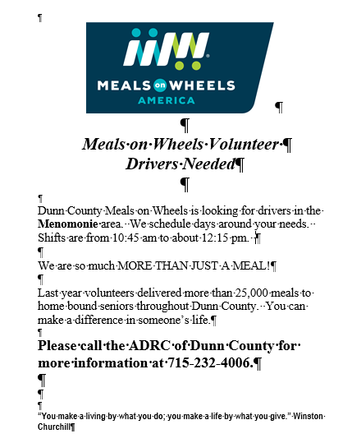  - Janine (Price)– They had a site manager that had to quarantine so another site had their bulk food delivered, they packaged up and delivered the meals for Grab n Go to the site and for HDM folks. Everybody stepped up to get it done; not a lot of options… have some subs and backups but not 3rd tier. PAM – heartwarming how people step up; let them know they are so appreciated. Janine… thankful for anyone who helps... training in temps. Likes Darby’s 2/2 idea! When some seniors aren’t showing up they may not be well... need to make sure site mgrs are checking on everyone. Do welfare checks. Look out for each other.  - Bernie (Dunn) He was the Altoona School District director last year. He said the option for schools to help depends on the district. If it is a smaller amt… could be feasible. He is now the Dunn Cty Nutr. Director. They don’t have a kitchen gets meals from Dunn cty… working with Mayo Red Cedar Medical Center to be the backup vendor. Focusing on drivers and site mgrs... They placed a FB ad in Menomonie that got lots of interest for drivers. Bernie shared the ad. Bobbette posted it to FB. Adding another route in Menomonie. Due to increased demand. | Dunn Cty HDM Ad
 | Social Connectedness- What are you doing to keep people engaged and feeling connected? | - Barb – send info out 2-3 x a week; send we miss you notes (You are “bootiful”); one participant asked for extra “notes” to send to his granddaughters… he loves them. Will call ppl if they don’t hear from them and see how they are doing.. they appreciate  - Jean – chat – some people do trivia… something to look forward to. Dane county used to donate newspapers to HDM.  - (Pam – notes on Forest County – sending out) – works w/ Library; has coloring page; a scavenger hunt; St. Croix... Back in My Day… got pages of replies from people reminiscing… took minds off of today.  - Darby? Anyone doing home visits, assessments. Pam – iron county was.. and was well received.  - Lori – Bingo in a county (healthcare/self-care bingo).. cute idea!! Green Bay partnered w/ Drs Hospital.. called people; Winnebago.. volunteers called just to chat (mental health call).  - Pam – back to drivers in Douglas county – staff goes w/ drivers to learn route in case something happens.  - Winter Preparedness Toolkit from FEMA with a wealth of useable materials including social media posts, handouts, etc. https://www.ready.gov/winter-weather-safety-social-media-toolkit  - EatUp Recipe Booklet for shelf-stable foods https://www.houstonfoodbank.org/wp-content/uploads/2020/04/Eat-Up-Recipes.pdf  - Anyone doing AARP Friendly voices? AARP calls people. Goes along w/ Well Connected  - AARP Family Caregiver Support FB page (laura)  DARBY – has anyone done anything special for drivers? Would like to celebrate them on the upcoming call.  - Renea (St. Croix Cty) transport supervisor sent note and bag of lifesavers; Hudson volunteer drivers.. getting chocolate G.C.; because they were unable to have a recognition banquet for volunteers.  - PAM – Jackson county did volunteer appreciation parade (video link); worked w/ a partner/Interfaith to make gift bags; Partnership with Interfaith and Jackson County ADRC. They distributed “Caregiver Bags”. They have over 200 volunteers in the community of which 100 participated in the drive-through. The remaining were delivered, or they stopped by the office to pick up. Contact Lyn Gates for more information and details Lynette.Gates@co.jackson.wi.us  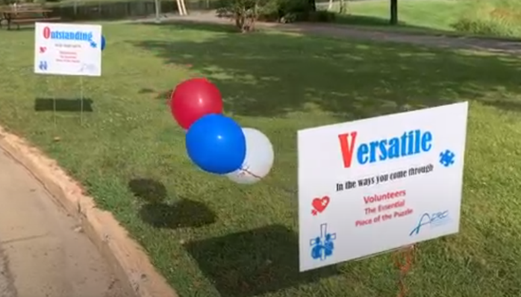  - View a 1.5-minute video of the amazing parade at  https://drive.google.com/file/d/1bFKI5H8M6sWUXHJ7rtbvGzCjDSKDidAe/view  - Lisa in Douglas… recognized outside w/ reward and plaque. featured in newsletter and goodies  Socialization Ideas  General Resources:  - COVID-19 Wisconsin Connect www.covid19wisconsinconnect.org or Search for COVID-19 Wisconsin Connect on the App Store or Google Play.  - Free desktop and mobile app. Check it out. So many useful features including “Let’s Chat”  - Dealing with Hearing Loss. A taped recording of WPR interview with Juliette Sterkens. https://www.wpr.org/shows/dealing-hearing-loss  - Wellness Guide to Overcoming Isolation During COVID-19: Being Connected, Staying Connected, and Choosing Connection. This free resource guide is full of great information.  - Action for Happiness helps people take action for a happier and kinder world. Several resources https://www.actionforhappiness.org/resources  - AARP Friendly Voice, Connecting People to People. Trained AARP Friendly Voice Volunteers provide calls.  - Generations on Line (GoL) Response to Covid-19. NEW abundant FREE offerings. Each bullet below can be found at www.generationsonline.org/family  - Made our free tablet tutorials available as both app & website. A website is easier to share remotely with a new learner. (For Apple/Android/Amazon devices)  - Added free smartphone tutorial that teaches how to access the Internet using a smartphone (Apple & Android Smartphones)  - Added Zoom to our free video-calling teaching (along with our previous teachings of Skype and FaceTime.) Found within the tutorials. We also added a shortcut to video calling on the top right-hand corner of tapping the instructions page.  - Created free family guides to help a family member through purchasing, setting up, and teaching an older adult to use the tablet while staying remote if necessary.  - Lastly, we now provide, via our monthly emailed newsletter, supportive materials AND additional flyers you can use in your newsletters to seniors. Topics to date have covered Medicare enrollment, Census, Internet safety, online banking, avoiding scams, and more.  - For more information contact Katie Burke kburke.gol@comcast.net  St. Croix County ADRC  - “Back in My Day- School Version”. They asked 5 questions and they got a lot of replies that they posted in the newsletter. I loved it and I think it helped people reminisce in a cool way. Check it out https://www.sccwi.gov/DocumentCenter/View/6199/September-2020-ADRC-News-PDF  - Activities for Grandparenting from a Distance (page 6 of the newsletter) Several practical ideas https://www.sccwi.gov/DocumentCenter/View/6199/September-2020-ADRC-News-PDF  - Virtual Coffee Chat and Virtual Bingo check it out in the October newsletter, page 2.  - Recipe Box Sharing. They ask participants to submit a favorite recipe and then they post them in their newsletter. Check out the add-in their October newsletter on page 18 and the monthly featured recipe on page 8.  - Holiday Memory Essay Contest. Too fun. See October newsletter page 18.  Iron County ADRC  - Lunch Buddies – they are offering a staff person to go eat with an HDM person. The staff brings their own lunch and a chair and has lunch outside with them at a safe distance. (See flyer)  (Double click to open)  - Theme Days for grab and go – Once a month the meal sites host a theme party in which we ask the members to dress up and for those who do their name gets put in a drawing for a free meal ticket. The cooks dress up, music is provided at the Hurley Senior Center outside when pick-up time, and seniors are provided with freebies, candy, information flyers, inspirational items. Etc. They did a 4th of July and Hawaiian and are doing Cowboy/Wild West in Sept.  - Offering Scenic Rides (See flyer) (Double click to open)  - She tried to do a pen pal program between 3rd-grade class and seniors but couldn’t get enough seniors interested. I thought it was a GREAT idea, but this is where the “Seniors in Charge” thing comes in. Even if it is a good idea, if the seniors don’t want to do it, it is really up to them. 😊  Forest County Office on Aging  - Share Your Stories. Your Voice is Powerful! They have updated their newsletter received a facelift and more pages. We can thank Kayla for that. She has been trying to help me find ways to engage all of you and help with social isolation. For some time, I have wanted to change the newsletter to make it more appealing. We want our readers to be more engaged. We are asking for stories. Kayla is putting in monthly story prompts to get some of your writers and storytellers to submit your stories. You can write about anything. We are hoping the story prompter will get you thinking. We want to publish your stories in the newsletter, you can be anonymous. I realize many of you may not have access to the Internet and computer or don’t feel comfortable using it. If you don’t have a computer, write it on paper and mail it to us. Let us know if there is anything, we can do to help you. Check out their newsletters with this new monthly section that started in Sept 2020. (See the Sept. Issue. page 2 and 16)  - Trivia Questions in the newsletter. A great idea. Check out page 3 of the Sept. Issue.  - New Books at Library Section. Nice partnership with the Crandon library to list available new books. If you deliver library books with HDMs, this would be great to mention as well. See page 5 of the Sept. Issue.  - Coloring Page. Included on the last page of the newsletter, check out the Sept. Issue.  - Scavenger Hunt on page 20 of the Sept. Issue.
 | Updates from Sara K. | - Sarah… sent email w/ training resources… more coming. Focus right now... huge COVID increases. Anticipate more of these staffing situations. Share info if you are needing to shut down so they can help you find resources.
 | Other Peer Sharing | - PAM – Clark County is looking for a training verification form (pls share if you’ve already created). Otherwise, we’ll come up w/ something.  - Nick Musson – from transport perspective what can he do to be a resource? Thinking of putting together a database…? do you think a good idea to have a resource ... reach out to him for direction on different options? What can he do to help if you lose your drivers? If you have ideas... pls feel free to call or email him. nick.musson@gwaar.org  - Lori – Nick at 11/5 WAND conference.. presenting. Creating routes, volunteer driving mgmt.; best practices.  - Lori – agenda coming out soon for WAND conference…Oct 28 and Nov. 5 from 1:30 to 4:30 each day.it will be recorded  - PAM – Carrie from Bayfield looking to make adjustments on route... has anyone done that? Share pros and cons… reach out to Carrie clinder@bayfieldcounty.org or Pam if you have any insights to share. Thank you!
 | Closing | Sara and GWAAR staff thanked everyone for sharing their amazing work and for all you have been doing during these challenging times. Please let us know if you have any changes or closures. Thank you!

