Time to review your
Medicare Part D Prescription Drug Plan!
Medicare Open Enrollment
October 15 – December 7

Each year Medicare Part D plans can change their list of covered medications as well as their premiums, deductibles and copays. It is important to review your Medicare Part D plan and compare it to other available plans to be sure your plan will be a good option for you in the new year.
Compare plans online at Medicare.gov or for local, objective assistance with plan comparisons contact:
<YOUR CONTACT INFORMATION HERE>

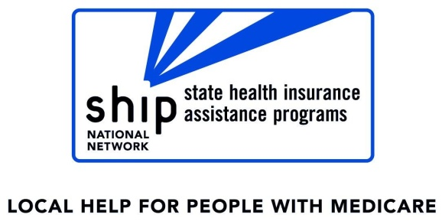
Many people are eligible for Medicare related programs designed to assist those with limited income and assets. For more information about these programs call the Elder Benefit Specialists at the number provided above.

