
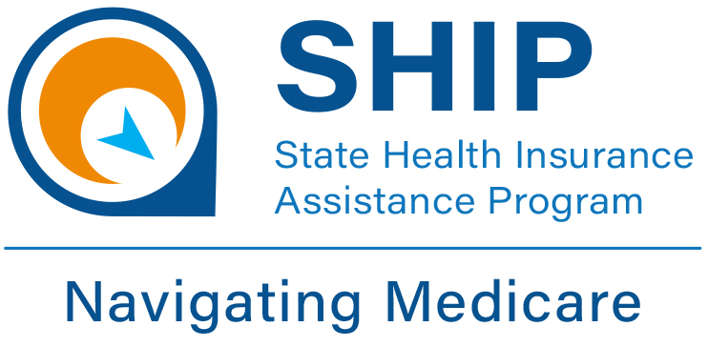



Medicare Open Enrollment
October 15 - December 7
**********************************
For help reviewing your plan or other Medicare questions,
please contact
SHIP Counselor

Insert your Agency Info here
(xxx) xxx-xxxx
DID YOU KNOW?
Every year, insurance
companies can
change their formularies,
premiums, deductibles
and copays!

MEDICARE OPEN ENROLLMENT
O Y A P O C I M P A E R Q P P
E P E L B I T C U D E D A R M
G D E Q P X C Z O V E H H E D
A E T N D R M X I B C Q D S Q
R S C R E P E E O I O I C C U
E A V N A N W M Q T C H N R C
V V G L A P R N I A L G F I L
O I A H N R A O T U V G K P R
C N Z A X L U I L F M O X T H
V G N C P W O S C L A W F I N
U S T G H N L U N S M Q O O Y
V V U P S G W C C I E E I N J
O R M E D I C A R E C U N S L
D Z F M K I R V K N V Q O T N
T J E T F N C U S O S D S V L

Time to review your Medicare Part D Prescription Drug Plan!

ALL Medicare Part D plans should be reviewed every year! Be sure to review your plan and make any changes by December 7th!
This project was supported by the Wisconsin Department of Health Services with financial assistance, in whole or in part, by grant number 90SAPG0091, from the U.S. Administration for Community Living, Department of Health and Human Services, Washington, D.C. 20201. Grantees undertaking projects with government sponsorship are encouraged to express freely their findings and conclusions. Points of view or opinions do not, therefore, necessarily represent official ACL policy. 2024
COPAY
COVERAGE
DEDUCTIBLE
DRUG PLAN
INSURANCE
MEDICARE
MEDICATIONS
OPEN ENROLLMENT
PART D
PREMIUM
PRESCRIPTIONS
REVIEW
SAVINGS
Four Reasons to Check Your Prescription Drug Plan

- Your plan may cost more next year due to changes in deductibles, premiums and co-pays.
- Your plan may no longer cover all your medications because insurance companies change their formularies.
- Your plan may have put restrictions on some of your medications such as preauthorization, quantity limits and step therapy.
- You may be taking different medications now.

