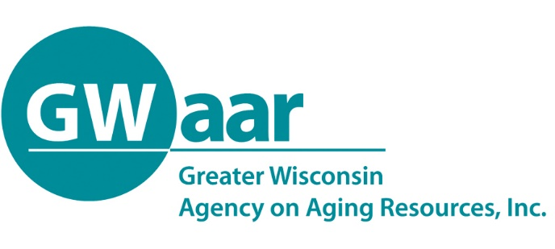

July 8, 2020

Dear Providers:
Hope this memo finds you all healthy and well. A newly updated GWAAR claim form is coming out this week with updated contract numbers for those who requested transfers and for those that applied for and received any special project funds. The SPAP error that many of you were seeing has also been fixed along with a few other formula fixes.

What you will also see in this updated form, is the service usage percentage requirements in the Title III-B services of:

- 6% of Access to Services – including services: Case Management, Assisted Transportation, Transportation, I&A and Outreach
- 5% of Legal/Ben. Assist – for the use of supporting the EBS position
- 7% of In-Home Services – including services: Personal Care, Homemaker, Chore, Temporary Respite, Home Security and Safety, Home Repair and Modifications and Visiting (note - these have expanded services)

also applies to the same service lines in the CARES B tab and can be exempted in the same fashion if being provided using other Title III funds or where no Title III funds are used to provide the service.

Under Title III-E where services are to be provided within the areas of: Case Management/I&A, Caregiver Counseling/Training/Support Groups, Respite Care, Supplemental Services and Information Services also applies to CARES E – and can also be exempted in the same fashion. At this time, the 20% maximum limit on Supplemental Services has been lifted for 2020.

As always, if you find an issue with the claim form, please email fiscal so that we can fix it for everyone.

Thank you.
Patrick

Patrick Metz, MA, MPH
Fiscal Manager
Greater Wisconsin Agency on Aging Resources, Inc.
1414 MacArthur Rd, Suite A
Madison, WI 53714
Cell # (608) 228-8089
patrick.metz@gwaar.org
www.gwaar.org

