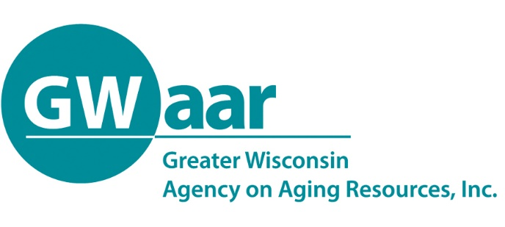

July 8, 2020

Dear Providers:
Hope this memo finds you all healthy and well.

DEADLINE #1 - Friday July 24, 2020. The first transfer request opportunity is done and in the process of receiving approval from the Feds. Don’t worry if you didn’t get a transfer request in during this 1st opportunity as a 2nd and FINAL transfer request is due to GWAAR Friday July 24th.

The same process used in the first transfer applies to the second request. You must use the official GWAAR transfer form on our website fiscal page. As stated, this will be your FINAL opportunity to request transfers for the OAA, FFCRA and CARES allocations in 2020.

In case you were still wondering about the original transfer requests made during last years budget process, those were nullified (cancelled, gotten rid of, etc.) due to the unfortunate pandemic we find ourselves in.

What happens if you don’t spend all of your 2020 awarded Title III allocations by 12/31/2020? Good question, the good news is they will all carry forward into 2021 but will have to be spent by September 30, 2021…yes and that does include your Title C allocations across all 3 pots of funding (OAA, FFCRA and CARES).

DEADLINE #2 – Monday August 10, 2020. As you may have guessed, it is the end of yet another quarter and that means we need ALL of your January through June of 2020 claim forms completed and submitted by 8/10/2020. No exceptions. We need them all, so you have plenty of time to work with the awesome GWAAR fiscal staff to get these caught up and turned in so that we can provide our State and Federal partners with a complete set of fiscal and SAMS data.

As always, should you have any questions or concerns, please call, email, or write a letter and put a $0.55 stamp on it and send it to GWAAR fiscal staff. We are here to help. I apologize if we may take a little time to get back to anyone but as you are incredibly busy with the business of caring for our oldest citizens, we’re trying to keep up with all of your great questions, so be patient yet persistent.

Thank you.

Patrick

Patrick Metz, MA, MPH
Fiscal Manager
Greater Wisconsin Agency on Aging Resources, Inc.
1414 MacArthur Rd, Suite A
Madison, WI 53714
Cell # (608) 228-8089
patrick.metz@gwaar.org
www.gwaar.org

